# CCT MSc Data Analytics

# S1 Data Preparation & Visualisation

## Week 1 – Data Management

### What is Data?

**Data:** are plain facts, when data is processed, organised, structured or presented in a given context they become ***information***

* Set of observations
* Set of variables, each of which has certain attributes (characteristics)
* Can be summarised to provide ‘information’
* Can be analysed to provide ‘evidence’

**Metadata:** Term used for structured data about a database (e.g., data dictionaries)

### Variables ***

**Types:**

* Qualitative or Quantitative
* Categorical or Numerical
* Discrete or Continuous
* Has an associated ‘level of measurement’

#### Qualitative

* Variables/data about qualities that cannot be **measured**
* Can be extremely varied, includes all captured data that isn’t numerical
* E.g., observations, descriptions, narrative, interview data, opinion, attitude, behaviour

#### Quantitative

* Any variable about a study subject that can be **measured**
* Variables with a numerical basis
* Variables for which the values which can be subjected to mathematical procedures

#### Categorical

* Variable with a no. of distinct & mutually exclusive categories
* Each observation can belong to only one category

#### Numerical

* Variable which can be described / measured & given a number
* Numbers can also be considered categorical, but the reverse isn’t true (i.e., categorical data are not numbered)

#### Discrete

* Categorical variables have discrete categories
* Numerical variables may also be ‘discrete’, if they of the kind that can only take on whole numbers, e.g., persons, episodes

#### Continuous

* Variables for which there is no limit to the possible values between two whole numbers, e.g., age, height, weight, distance

### Levels of Measurement

* Classification system that describes the nature of the values of variables
* Determining factor for the type of **descriptive** & **inferential** statistical procedures that can & cannot be used to summarise & analyse variables in a dataset

#### 4 Levels

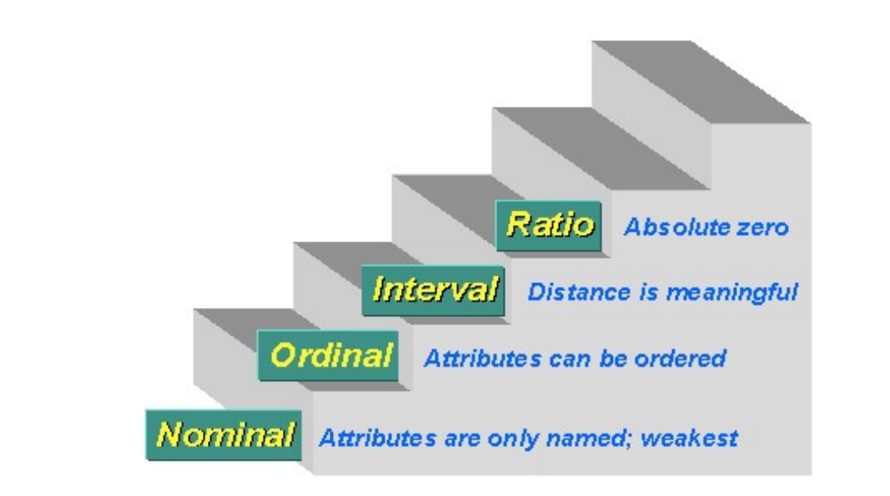

#### Nominal

* Weakest level of measurement
* A system for classifying / labelling categories of a variable e.g., gender, groups

#### Ordinal

* Values for the variable lie in Rank Order in relation to each other e.g., social class, pain scores, general health questions
* Ordinal variables are also Nominal

#### Interval

* Have an ordered relationship & constant intervals between values, but do not possess an inherent zero point e.g., temperature measurements, you can determine the difference between two temperatures, but it's not meaningful to say that 30°C is "twice as hot" as 15°C, because these scales don't start from absolute zero
* Important to understand the statistical distribution of Interval variables, specifically if it’s normally distributed or skewed

#### Ratio

* Possess all the characteristics of interval variables but also have a meaningful zero point that represents the absence of the attribute being measured. E.g, include height, weight, and age.
* Having an absolute zero point allows for the calculation of meaningful ratios. For example, it is meaningful to say that someone who is 40 years old is twice as old as someone who is 20 years old.
* Important to understand the statistical distribution of Interval variables, specifically if it’s normally distributed or skewed

### Variable Determination

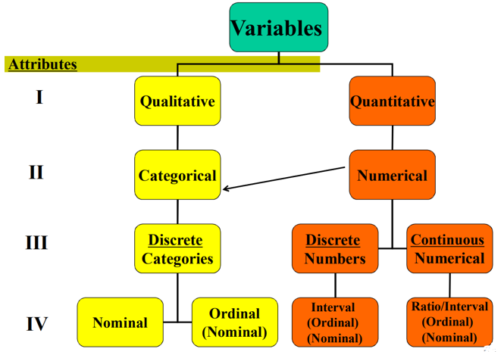

### Descriptive Statistics

* Obtain descriptive information about a population from which a sample is drawn

### Inferential Statistics

* To test hypotheses & draw inferences about the population from a sample

#### Qualitative Data for which LOM is Nominal

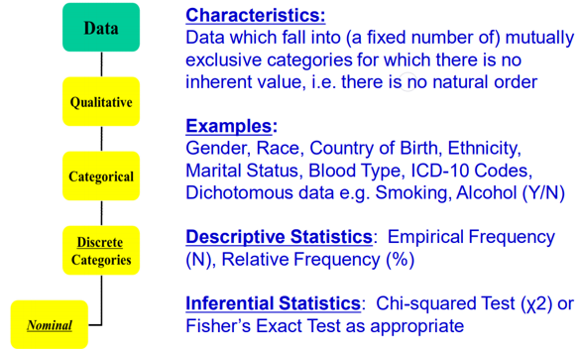

##### Appropriate Visualisations

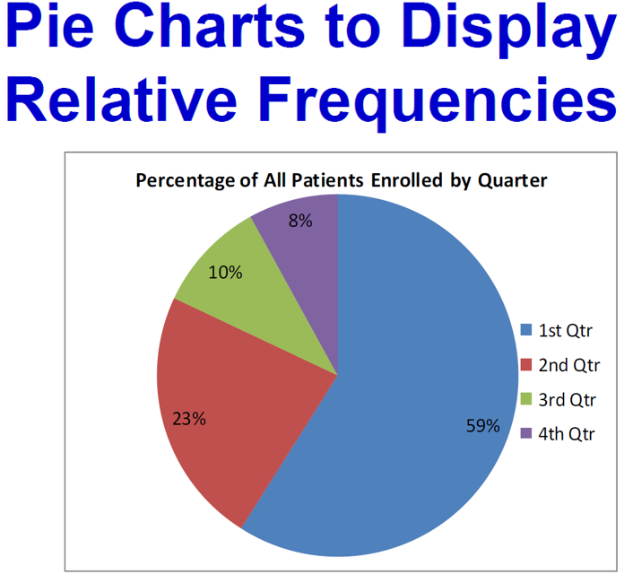

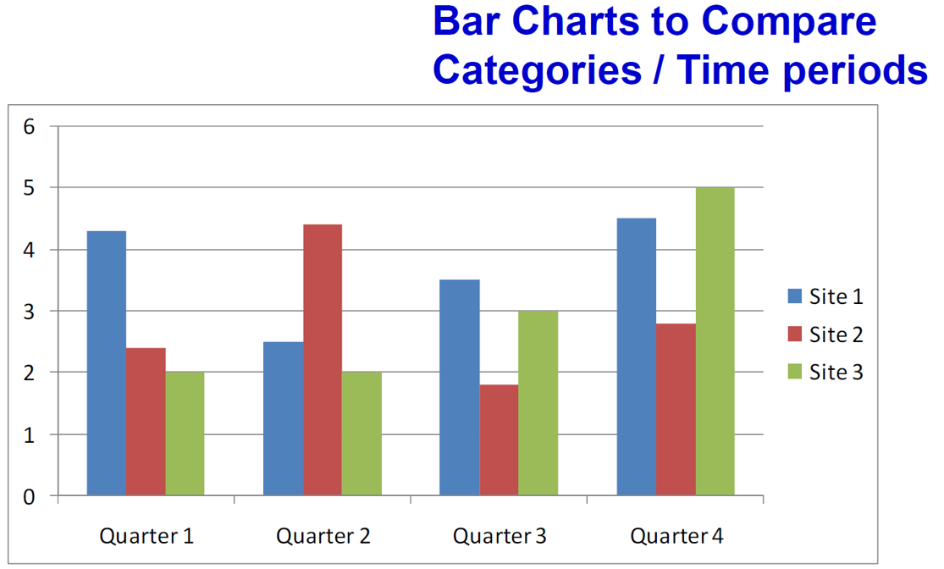

#### Qualitative Data for which LOM is Ordinal

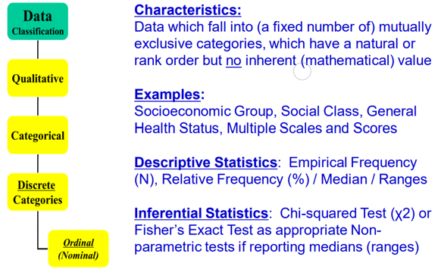

##### Appropriate Visualisations

* A box plot is constructed by drawing a box between the upper & lower quartiles (the Interquartile Range (IQR))
* The Interquartile Range (IQR) is a measure of statistical dispersion that describes the range within which the middle 50% of the data values fall. Specifically, the IQR is calculated as the difference between the third quartile (Q3) and the first quartile (Q1):
* The Maximum & Minimum values are indicated by horizontal lines
* The full range is given by the vertical distance between horizontal lines

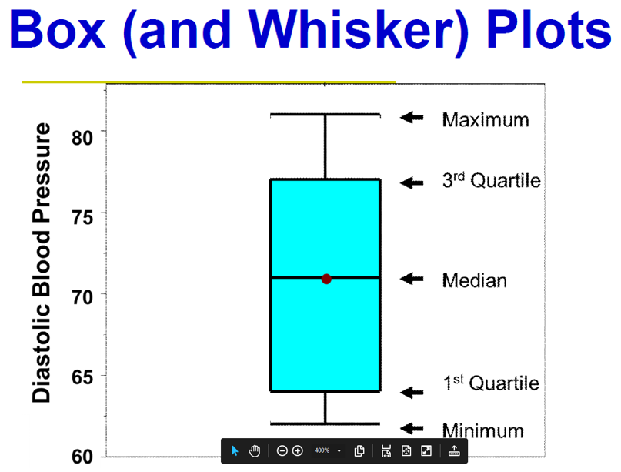

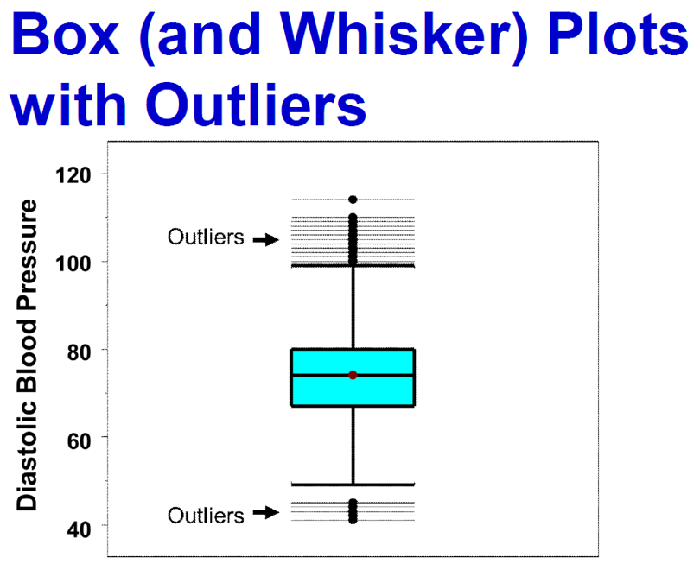

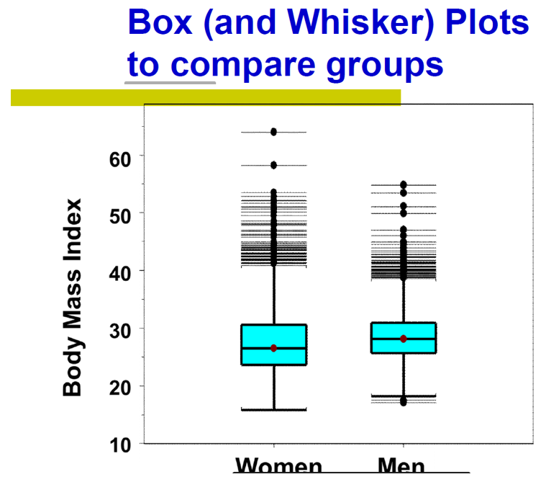

#### Quantitative Data which are Discrete & LOM is Interval

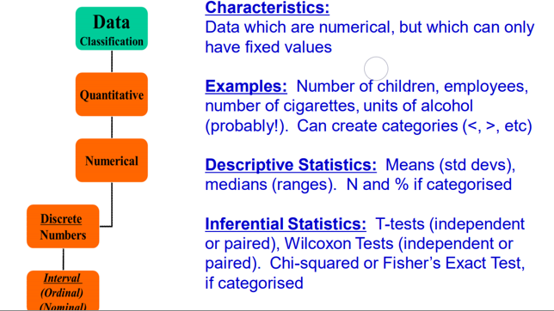

##### Appropriate Visualisations

A stem-and-leaf plot is a data visualization method used to display quantitative data in a way that retains the original data values while providing a graphic representation of the distribution. This method is often used for small to medium-sized datasets. A stem-and-leaf plot is similar to a histogram but has the advantage of preserving the individual data points.

**Structure**

* **Stem:** The 'stem' represents the leading digits of the data values.
* **Leaf:** The 'leaf' represents the trailing digits of the data values.

**Example:**

Suppose we have the following data set, which represents test scores:



Here is how to create a stem-and-leaf plot for this data:

1. **Organize Data:** Sort the data from least to greatest if it is not already sorted.
2. **Identify Stems and Leaves:** Determine what digits will act as the stem and which will be the leaves.
3. **Construct the Plot:** Write down the stems in a vertical line from least to greatest. Attach the leaves to the corresponding stems.

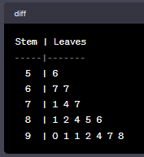

**Interpretation:**

* Scores in the 50s range only had one occurrence of 56
* Scores in the 90s range were more frequent and included scores from 90 to 98.

The plot helps us see the distribution, central tendency, and spread of the test scores more clearly than just the raw data alone.

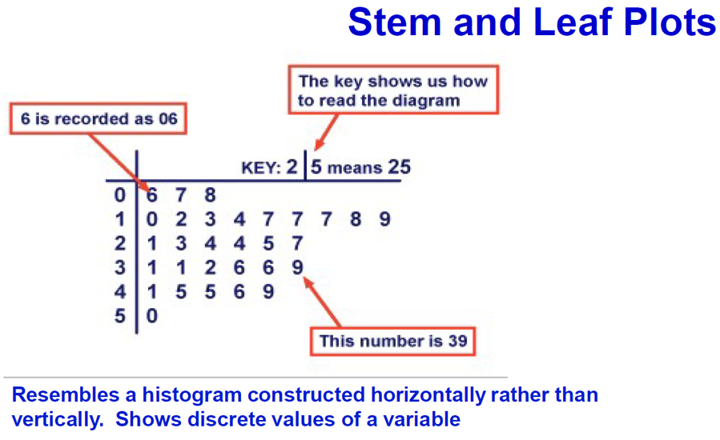

#### Quantitative Data which are Continuous & LOM is Interval

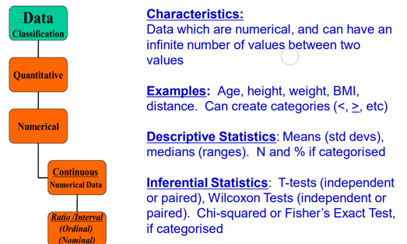

##### Appropriate Visualisations

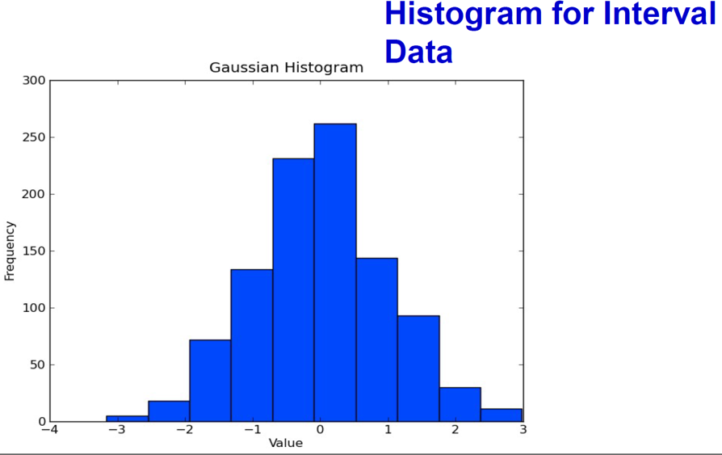

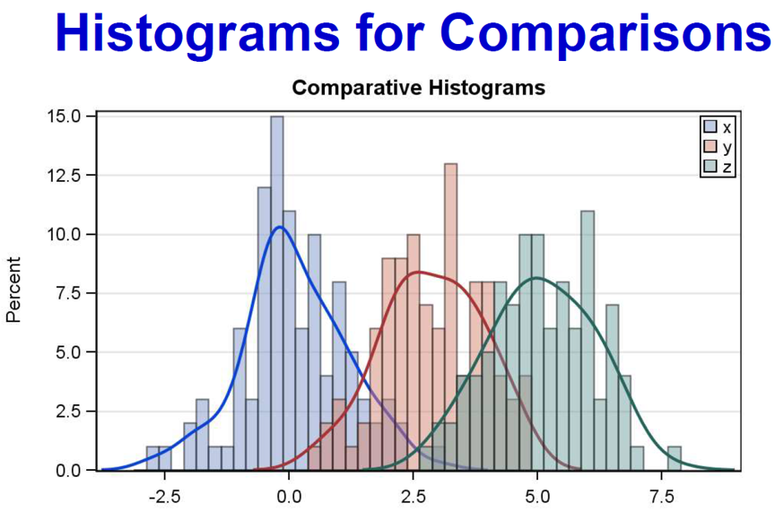

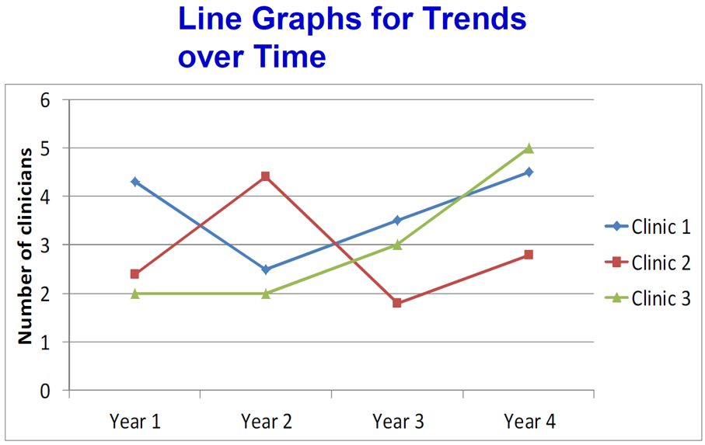

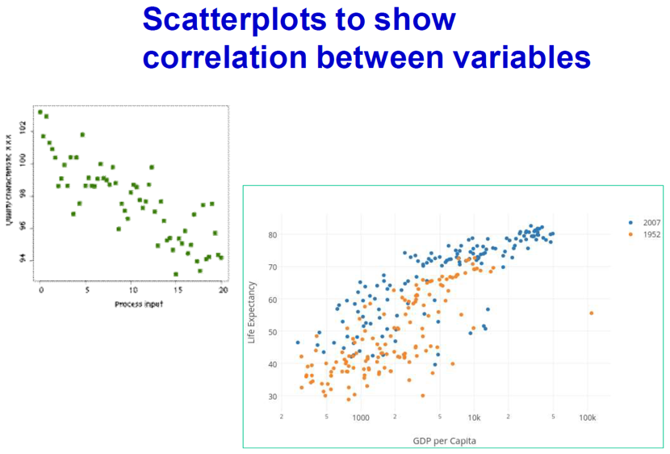

### Basic Data Management

1. What variables do you need for your study?
   1. Determined by your research question
2. Where will you find them?
   1. What is your study population / sample?
   2. Primary data collection or use of secondary data?
3. How will you collect them?
   1. What ‘study instruments’ will you use?
4. How will you ensure consistency in data collection?
   1. Do you have a data dictionary & study SOP’s?

#### Example

1. I am interested in the demographic profile of the students in my applied research methods module
   1. What variables do I need?
2. I would like to know something about their lifestyles, specifically their means of travel, whether they drink alcohol and how much, and perhaps their BMI.
   1. What variables do I need?
3. I would also like to know how they regard their general health, perhaps with a view to comparing it with similar information other groups
4. Finally, I would like to know the reasons why they are taking the module (important information for me)

### Study-Specific Data collection Instrument

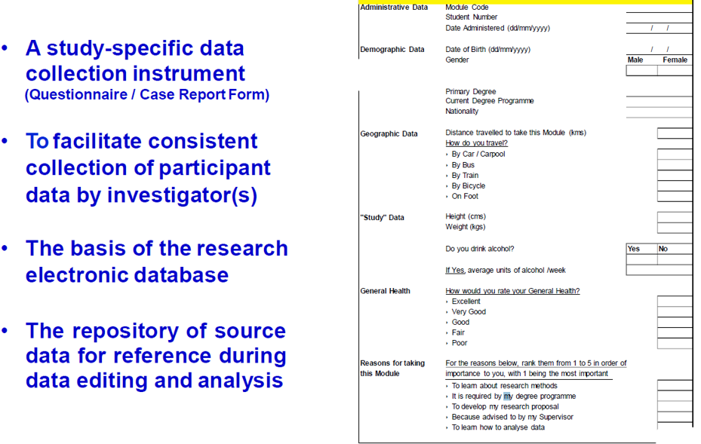

### Data Dictionary

* A critically important repository of information about the data in a database
* Specifically, a Data Dictionary is a written record of important and agreed information for each variable in your database
* See the template for the appropriate information to include in a Data Dictionary

#### Template

Found in the following folder

G:\My Drive\Documents\Education\Data Analytics\CCT MSc in Data Analytics\07 Practical Tools

[Data Dictionary Template](07%20Practical%20Tools/Data%20Dictionary%20Template.xlsx)

## Week 2 - Exploratory Data Analysis (EDA)

### Definition

* Exploratory Data Analysis or (EDA) is understanding the data set by summarizing its main characteristics and often plotting them visually
* This step is very important especially when we arrive at modelling the data to apply Machine learning. Plotting in EDA consists of Histograms, Box plot, Scatter plots and many more
* Through the process of EDA, we can also refine the problem statement or definition of our problem
* There is no one common method of performing EDA. Here we will perform some of the more common methods and plots that would be used in the EDA process

### Common Steps

#### Importing libraries

import pandas as pd

import numpy as np

import seaborn as sns #visualisation

import matplotlib.pyplot as plt #visualisation

%matplotlib inline

sns.set(color_codes=True)

#### Loading data into the dataframe

#### Checking the types of data

Here we check for the datatypes because sometimes features (variables) be stored as a string or an object.

In that case, we would have to convert any strings to integer data so that we could plot the data via a graph. In this case, the data is already in integer format so there’s nothing to worry about.

#### Dropping irrelevant columns

#### Renaming columns

#### Dropping duplicate rows

This is very similar to the previous step but here all the missing values are detected and are then dropped.

Now, this is a controversial step, many people just replace the missing values with the mean or the average of that column, but in this case, I am just dropping the rows with missing values. As there are approximately 100 missing values compared to over 10, 000 values in the whole dataset, this is negligible.

#### Dropping the missing or null values

#### Detecting outliers

An outlier is a datapoint or set of datapoints that are vastly different from other data points in your dataset. Sometimes they can be very high or very low.

It’s often a good idea to detect and remove the outliers because outliers are one of the primary reasons for models becoming less accurate. We are going to use the IQR (Interquartile Range) Scoring technique to detect and remove any outliers. Often outliers can be seen with visualizations such as a box plot. Shown below are the box plots of MSRP, Cylinders, Horsepower and EngineSize.

In all the plots, you can find some points are that outside the “box”. These are our outliers.

#### Plot different features against one another (scatter, against frequency (histogram)

### Describe Function

The df.describe() function in pandas provides summary statistics for numerical columns in a DataFrame. It is a valuable tool during the initial stages of exploratory data analysis (EDA). Here are the key aspects to consider upon initial inspection:

**Measures of Central Tendency**

**Mean**: Gives you an idea of the average value across the dataset.

**50% (Median):** Provides the middle value, useful for understanding the central tendency when the data is skewed.

**Measures of Spread**

**Std (Standard Deviation):** Indicates the amount of variation or dispersion in the dataset.

**Min and Max:** Show the range of the dataset.

**Quartiles**

25% (Q1), 75% (Q3): Offer insights into the distribution of the data. The Interquartile Range (IQR = Q3 - Q1) can be useful for identifying outliers.

**Count**

**Count:** Indicates the number of non-null observations. It can help you spot missing values.

**General Guidelines**

**Data Integrity:** Ensure that the min, max, and other statistics make sense within the context of the dataset. For example, a negative value for age would be a data integrity issue.

**Outliers:** If max or min values are exceptionally far from the rest of the data, they could be outliers.

**Skewness:** If mean and median are significantly different, the data may be skewed.

**Missing Values:** A count that is lower than expected may signal missing values.

This function is a starting point and should be supplemented with additional EDA techniques for a comprehensive analysis.

## Week 3 – How to Deal with Missing Data in Python

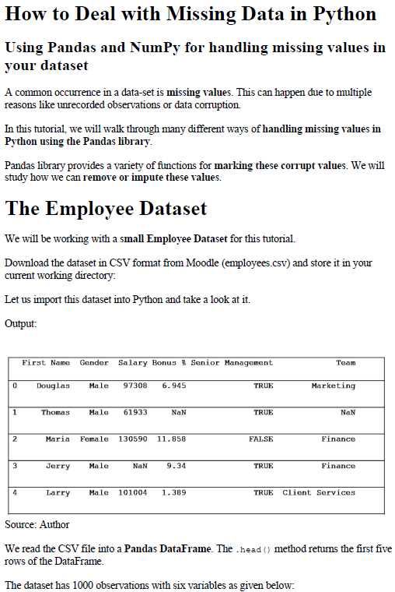

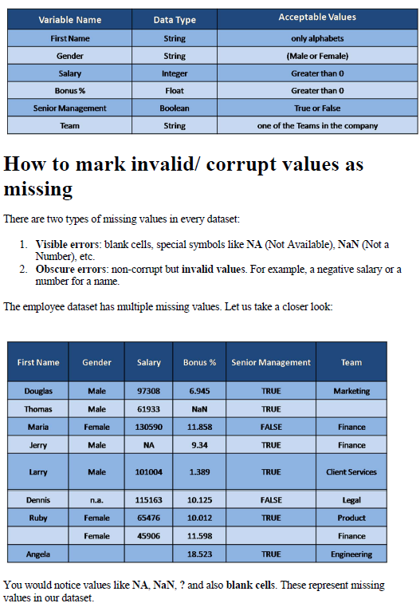

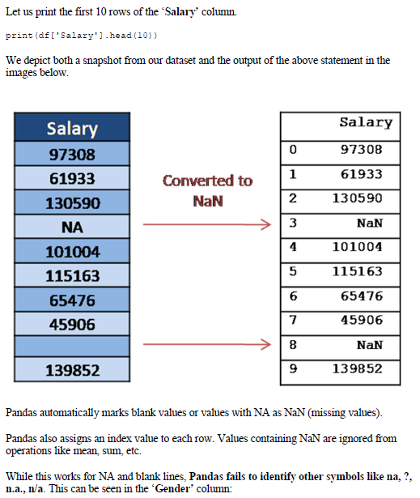

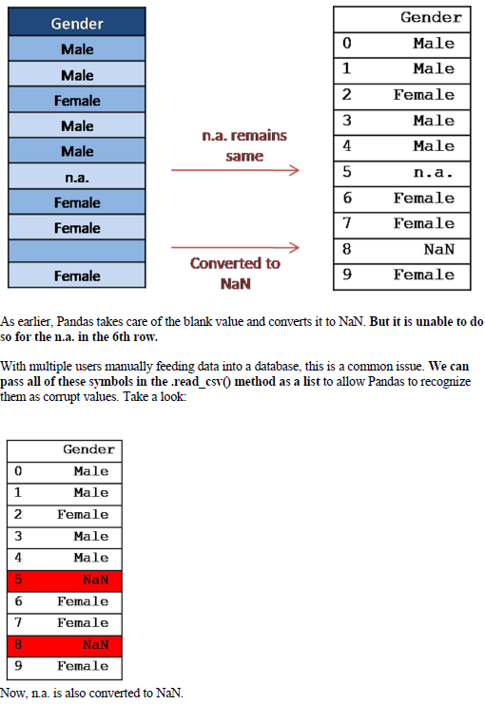

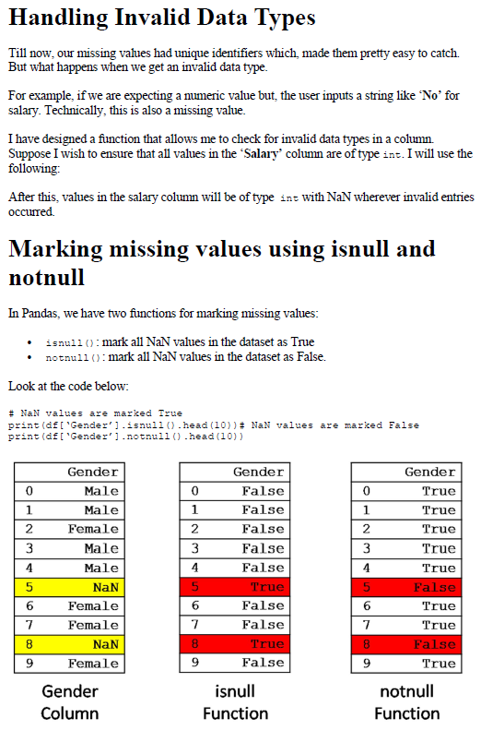

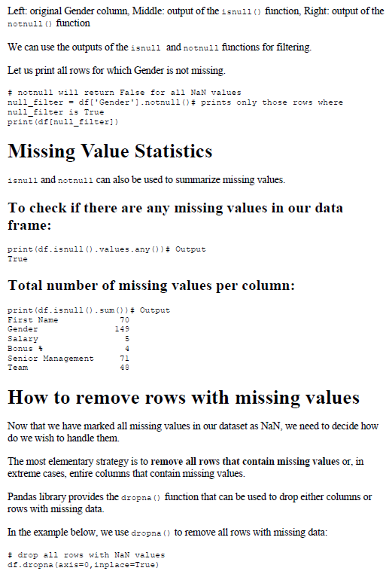

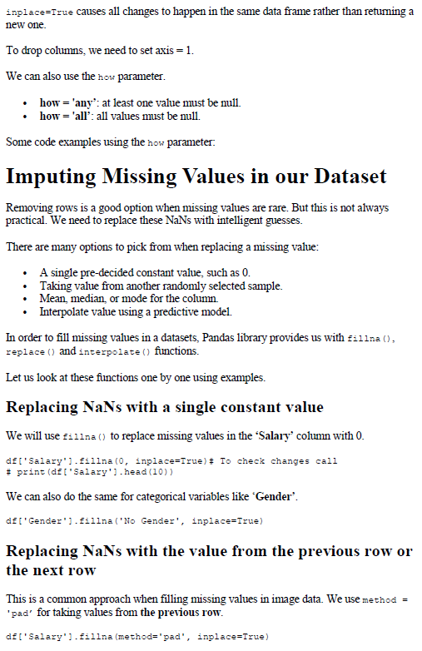

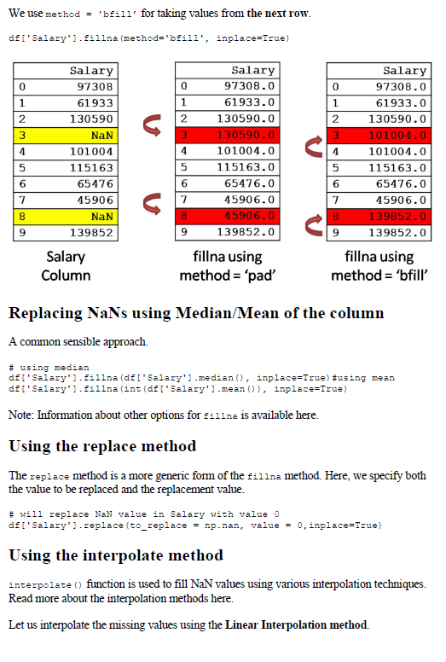

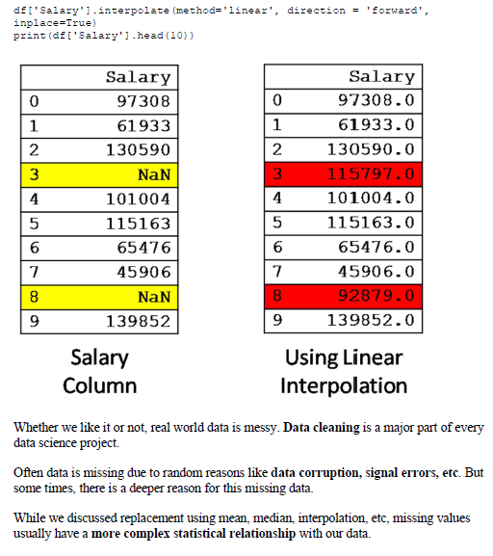

## Week 3 – Data Cleaning

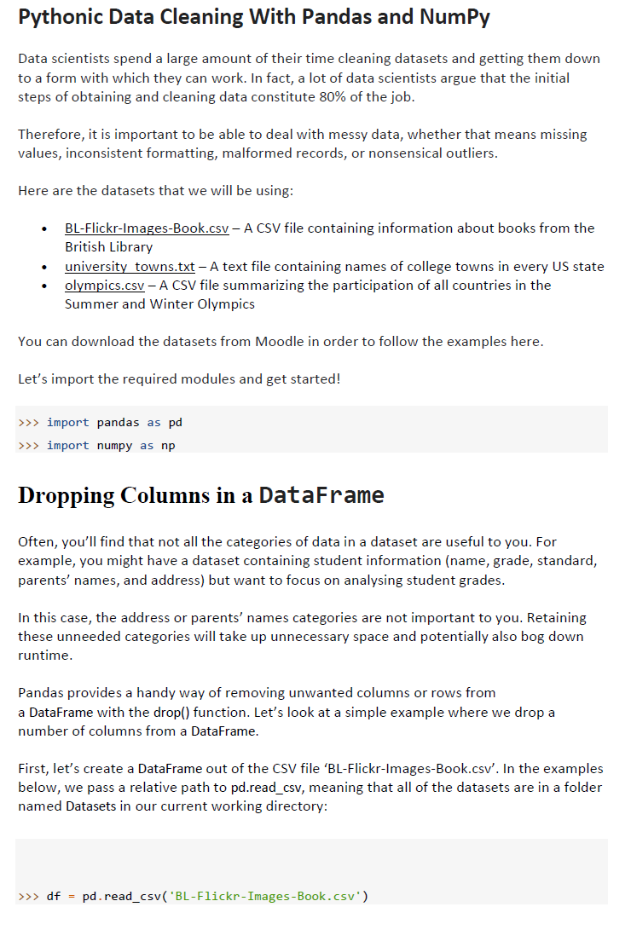

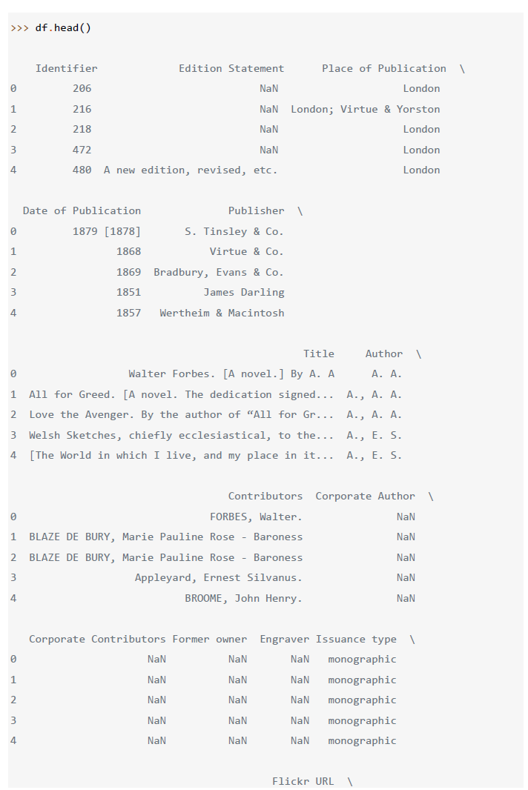

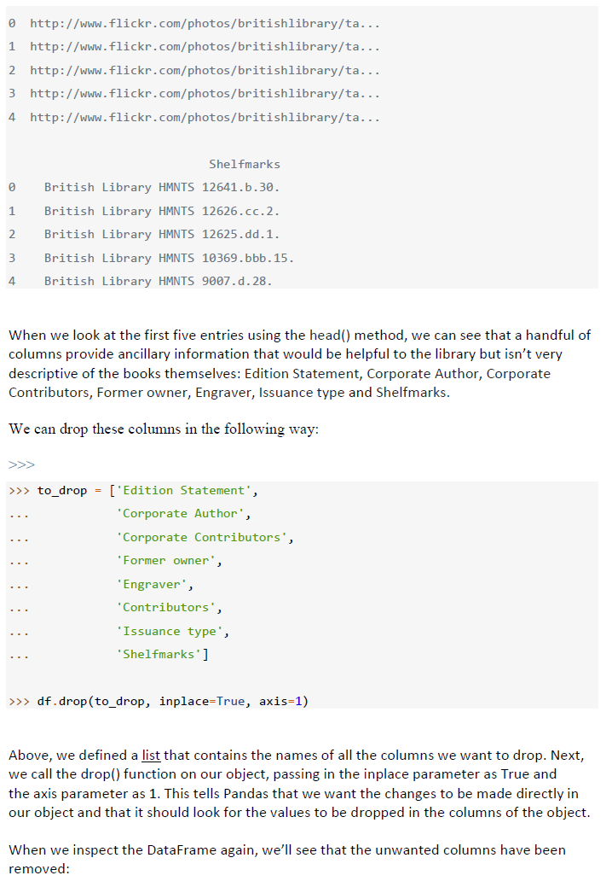

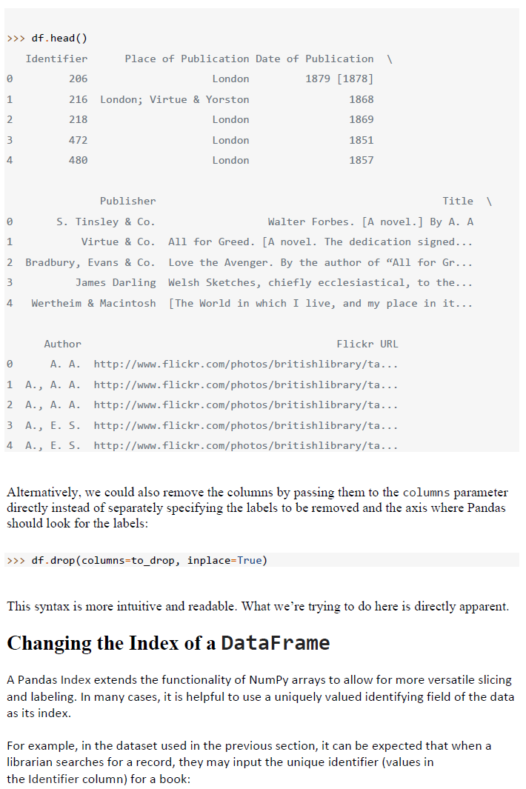

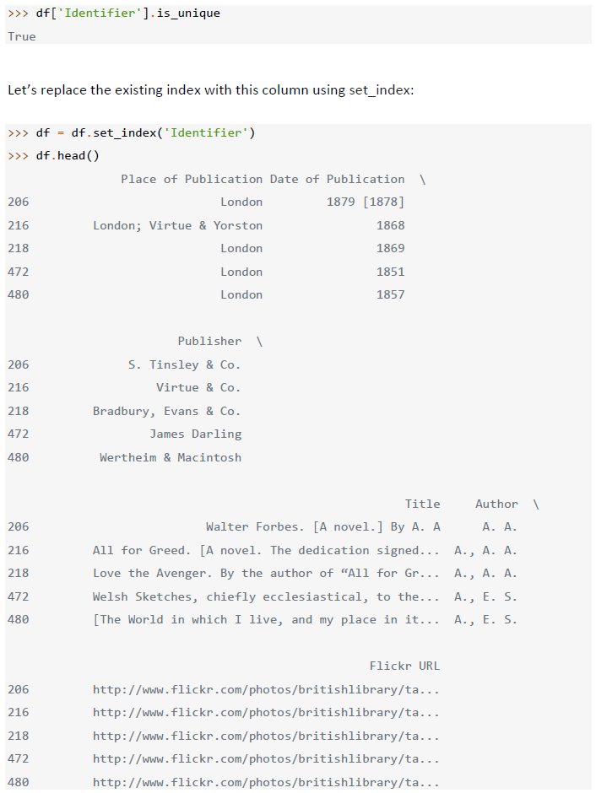

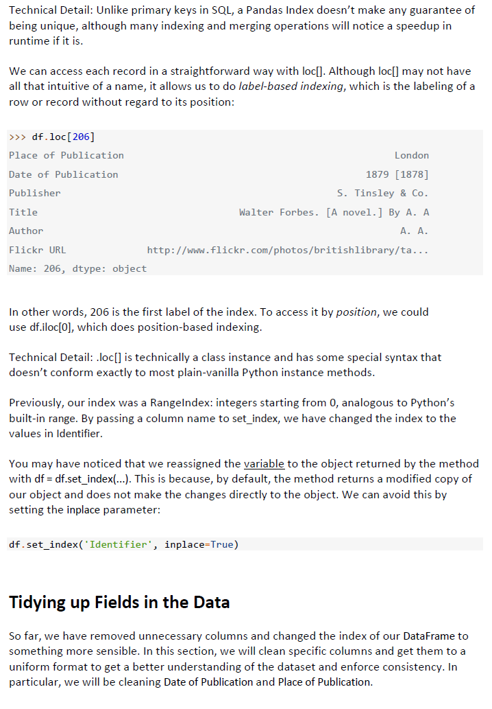

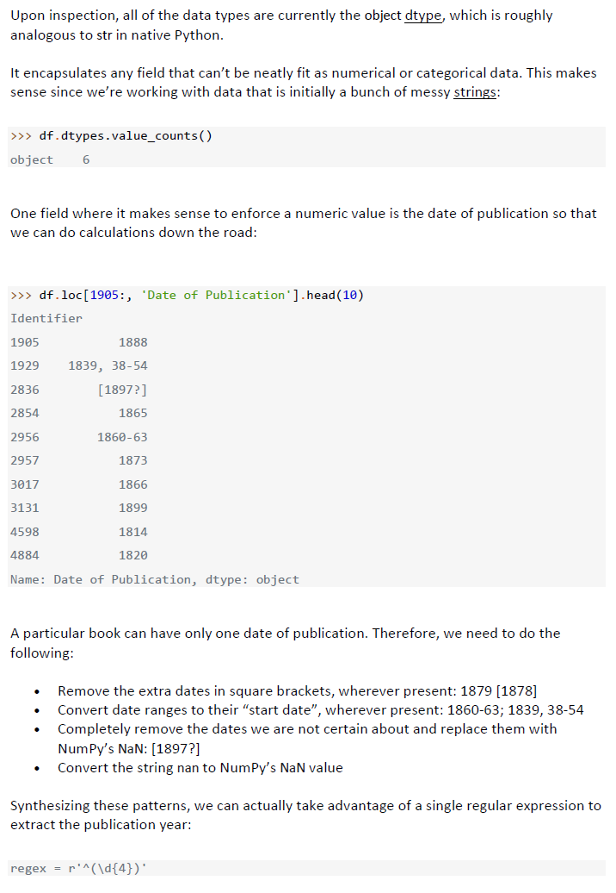

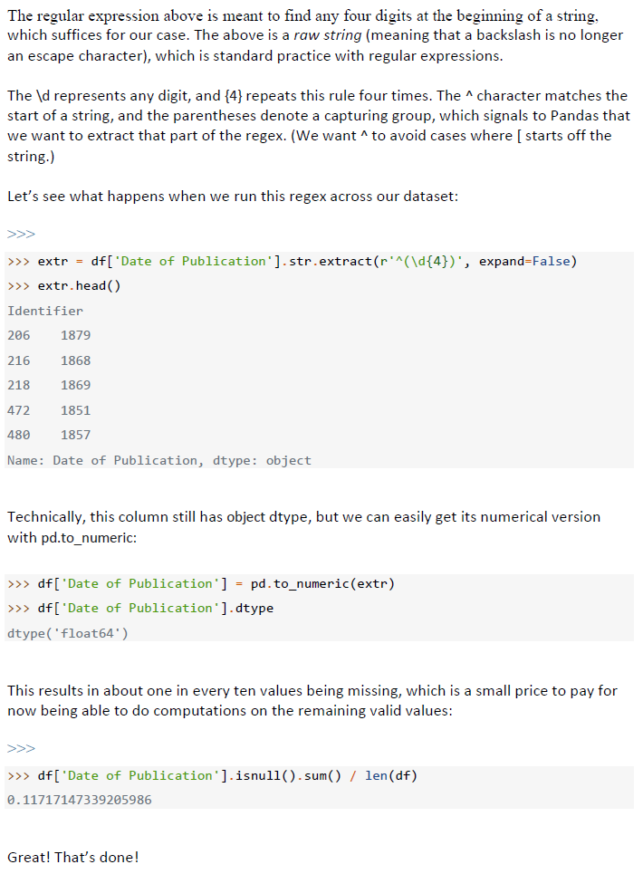

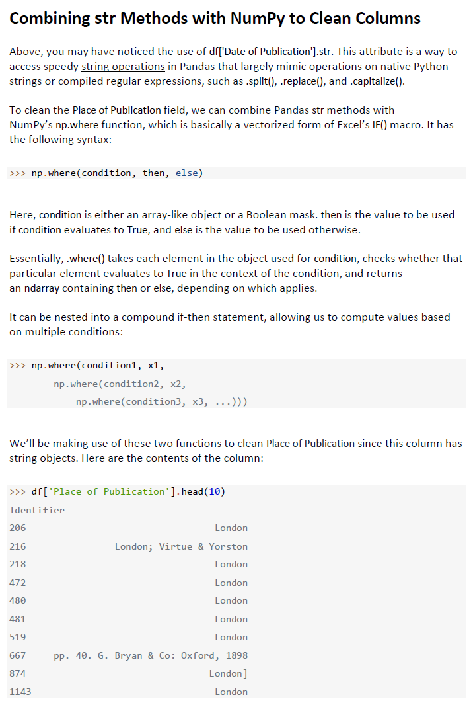

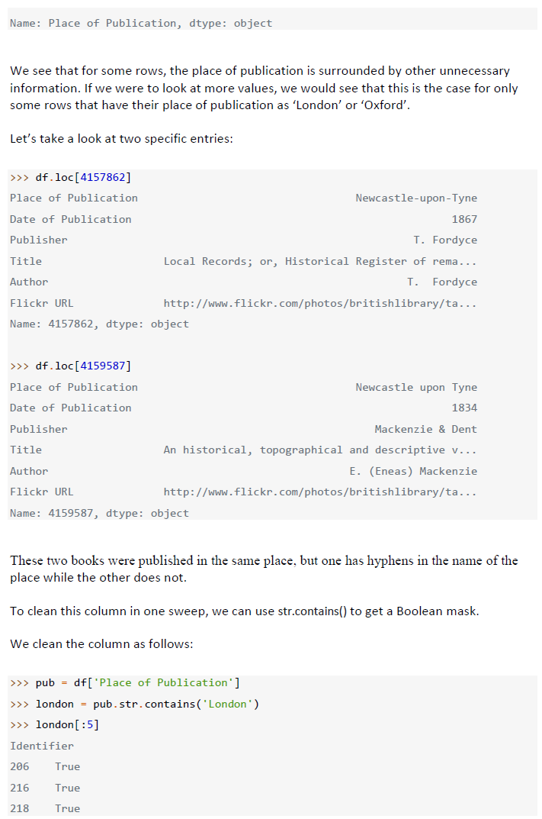

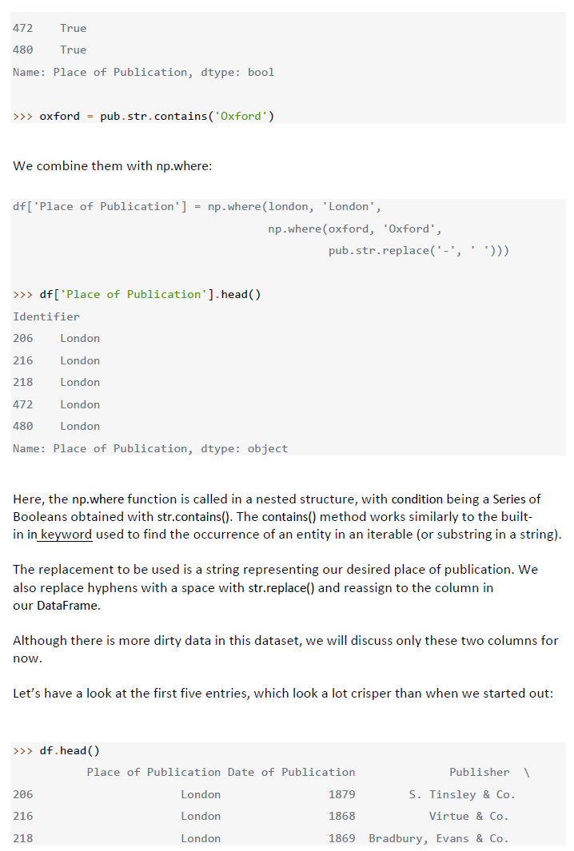

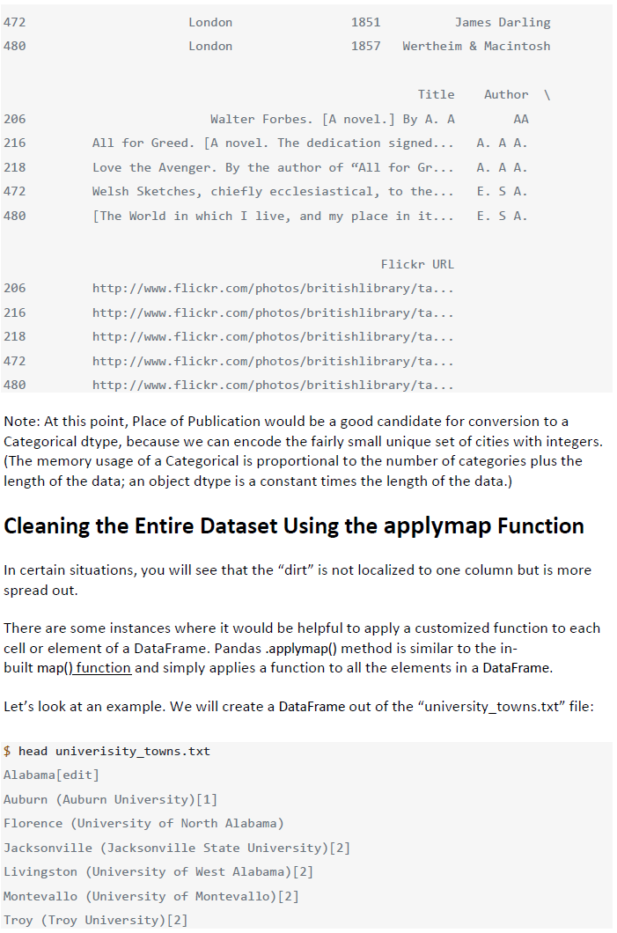

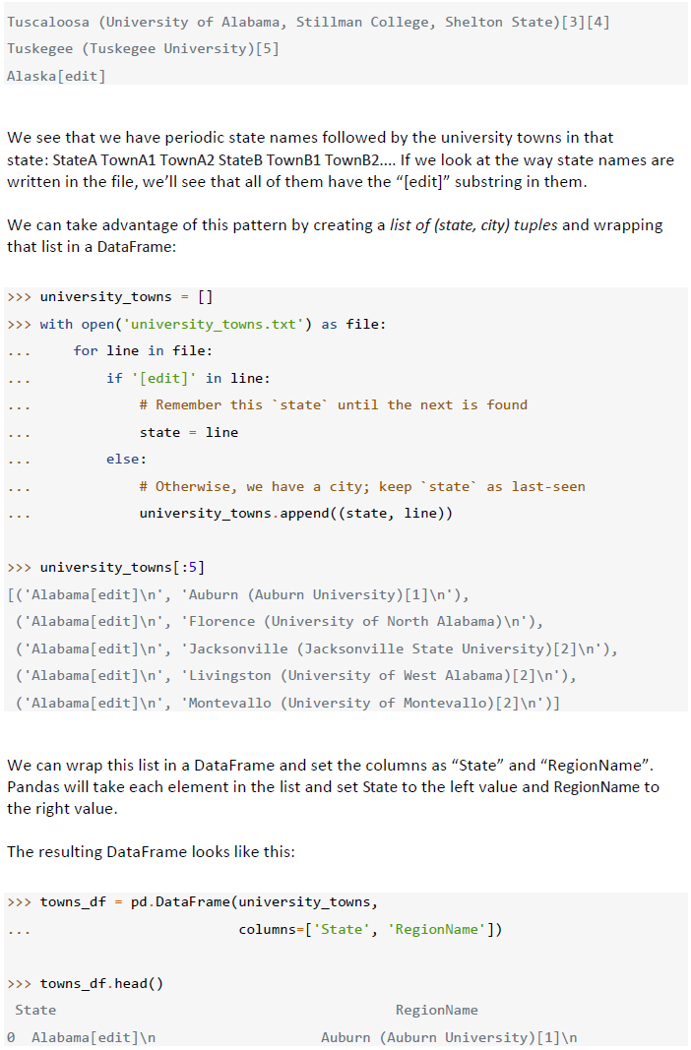

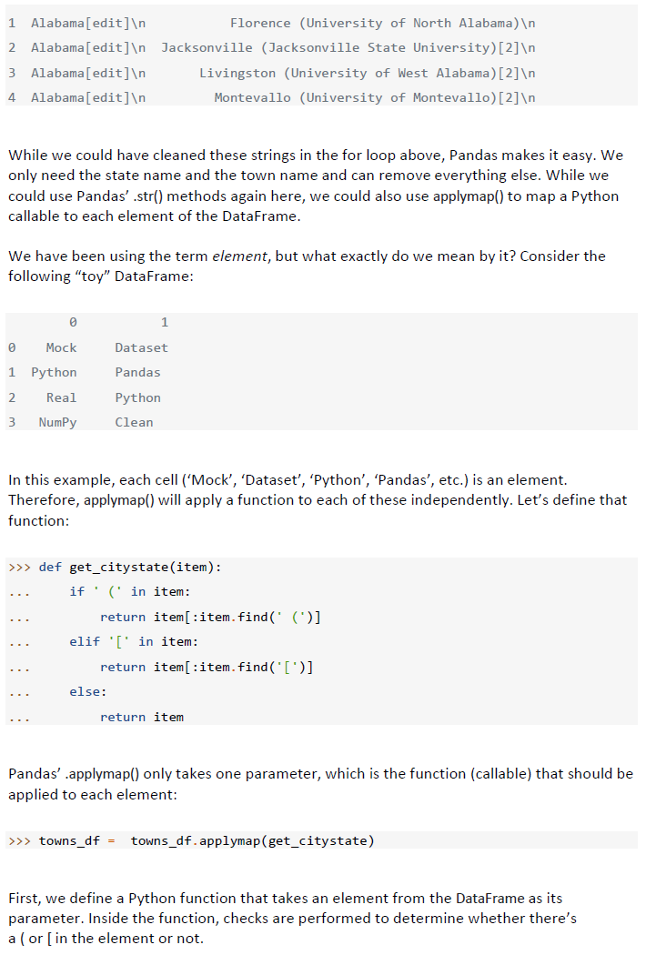

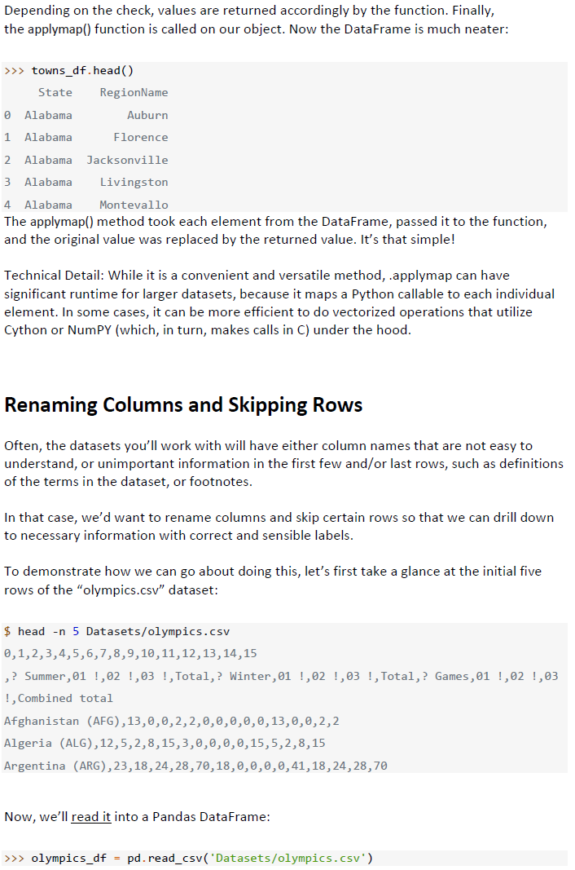

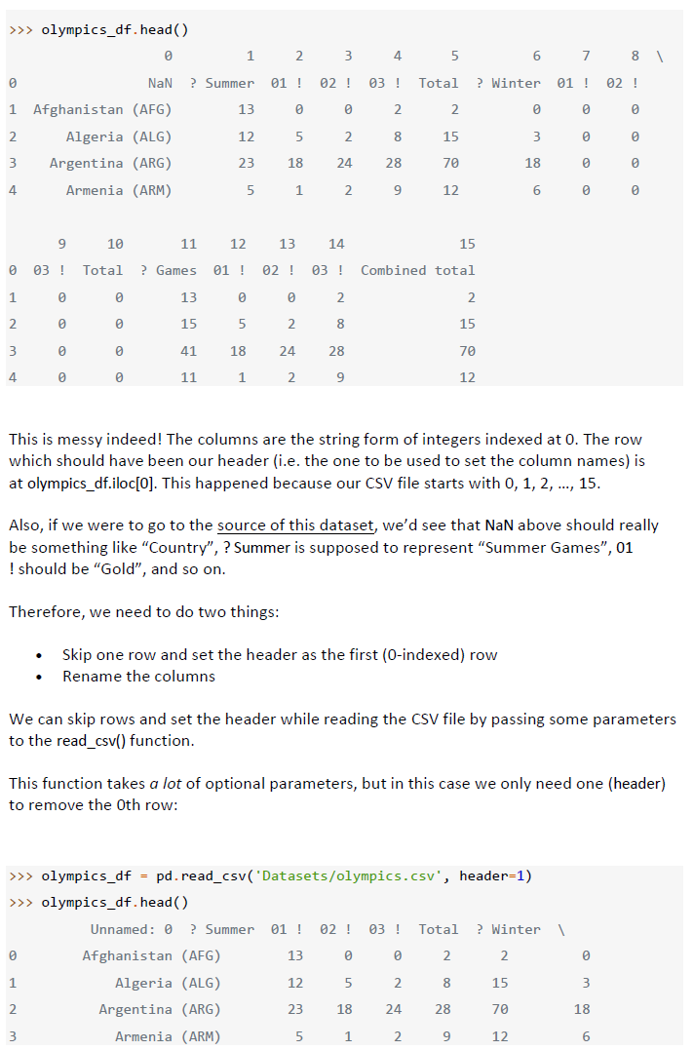

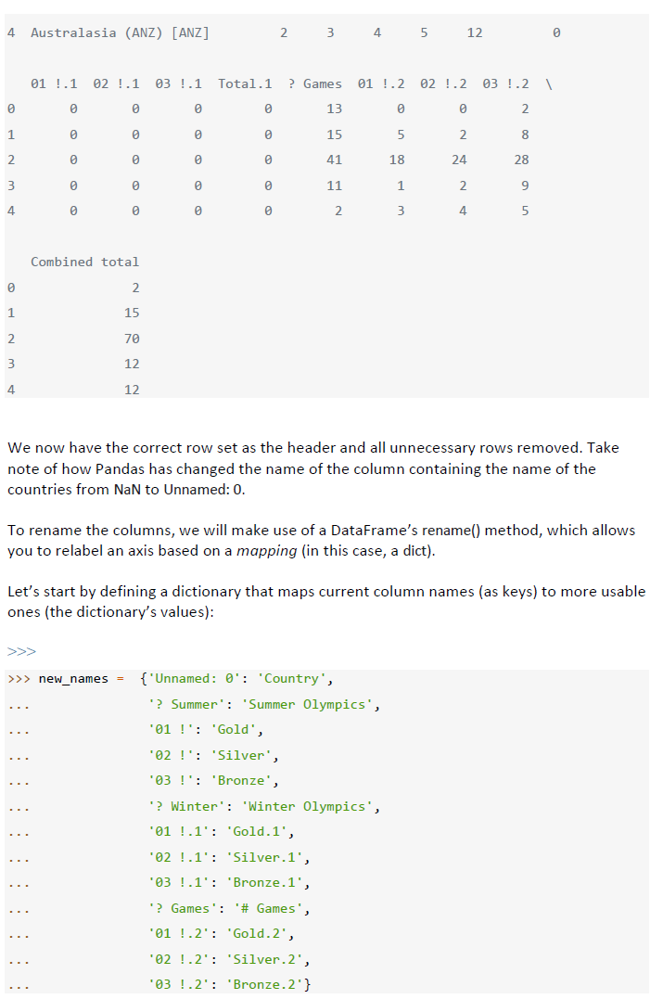

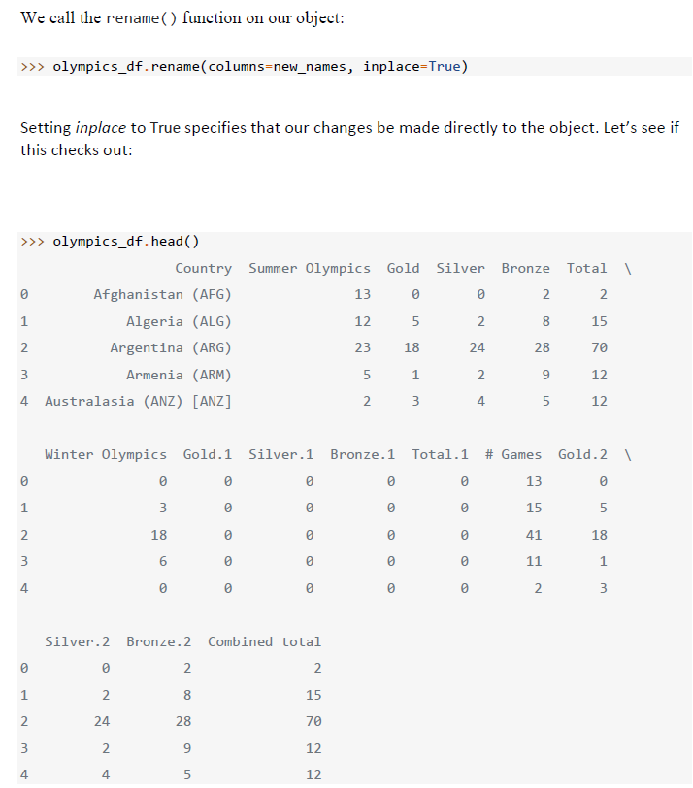

## Week 4 – Plotting with Pandas & Seaborn

### Plotting with pandas and seaborn

Now that we have a basic sense of how to load and handle data in a pandas DataFrame object, let's get started with making some simple plots from data. While there are several plotting libraries in Python (including matplotlib, plotly, and seaborn), in this chapter, we will mainly explore the pandas and seaborn libraries, which are extremely useful, popular, and easy to use.

### Creating Simple Plots to Visualize a Distribution of Variables

matplotlib is a plotting library available in most Python distributions and is the foundation for several plotting packages, including the built-in plotting functionality of pandas and seaborn. matplotlib enables control of every single aspect of a figure and is known to be verbose. Both seaborn and pandas visualization functions are built on top of matplotlib. The built-in plotting tool of pandas .is a useful exploratory tool to generate figures that are not ready for primetime but useful to understand the dataset you are working with. seaborn, on the other hand, has APIs to draw a wide variety of aesthetically pleasing plots.

To illustrate certain key concepts and explore the diamonds dataset, we will start with two simple visualizations—histograms and bar plots.

Histograms

A histogram of a feature is a plot with the range of the feature on the x-axis and the count of data points with the feature in the corresponding range on the y-axis.

### Plotting and Analysing a Histogram

We will create a histogram of the frequency of diamonds in the dataset with their respective carat specifications on the x-axis:

1. Import the necessary modules:

import seaborn as sns import pandas as pd

1. Import the diamonds dataset from seaborn:

diamonds_df = sns.load_dataset('diamonds')

1. Plot a histogram using the diamonds dataset where x axis = carat:

diamonds_df.hist(column='carat')

The output is as follows:

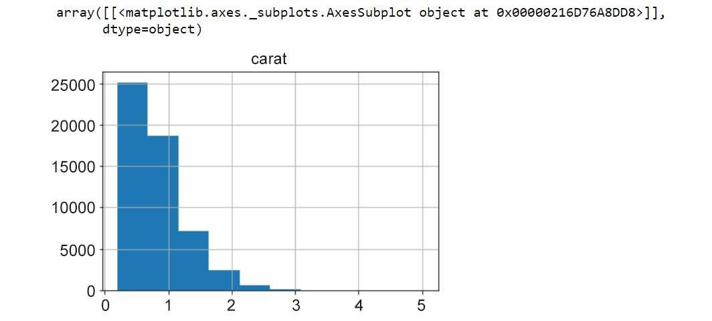

Figure 1.14: Histogram plot

The y axis in this plot denotes the number of diamonds in the dataset with the carat specification on the x-axis.

The hist function has a parameter called bins, which literally refers to the number of equally sized bins into which the data points are divided. By default, the bins parameter is set to 10 in pandas. We can change this to a different number, if we wish.

1. Change the bins parameter to 50:

diamonds_df.hist(column='carat', bins=50) The output is as follows:

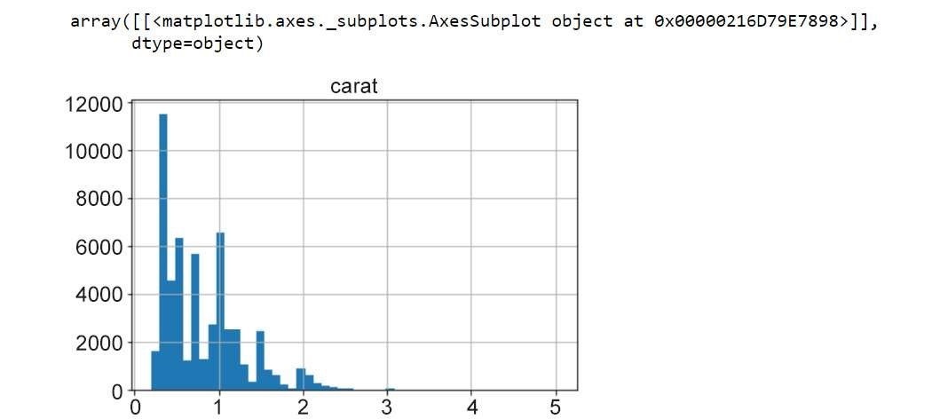

Figure 1.15: Histogram with bins = 50

This is a histogram with 50 bins. Notice how we can see a more fine-grained distribution as we increase the number of bins. It is helpful to test with multiple bin sizes to know the exact distribution of the feature. The range of bin sizes varies from 1 (where all values are in the same bin) to the number of values (where each value of the feature is in one bin).

1. Now, let's look at the same function using seaborn:

sns.distplot(diamonds_df.carat) The output is as follows:

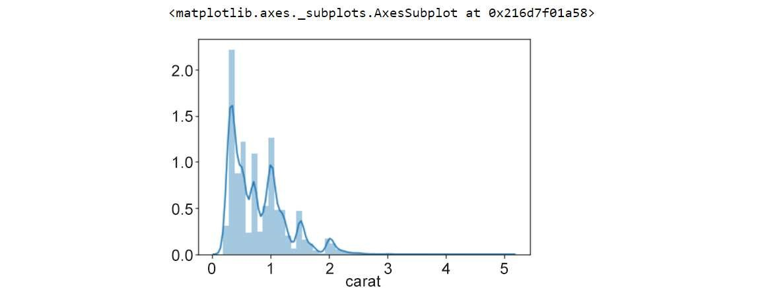

Figure 1.16: Histogram plot using seaborn

There are two noticeable differences between the pandas hist function and seaborn distplot:

* + pandas sets the bins parameter to a default of 10, but seaborn infers an appropriate bin size based on the statistical distribution of the dataset.
  + By default, the distplot function also includes a smoothed curve over the histogram, called a kernel density estimation.

The kernel density estimation (KDE) is a non-parametric way to estimate the probability density function of a random variable. Usually, a KDE doesn't tell us anything more than what we can infer from the histogram itself. However, it is helpful when comparing multiple histograms on the same plot. If we want to remove the KDE and look at the histogram alone, we can use the kde=False parameter.

1. Change kde=False to remove the KDE:

sns.distplot(diamonds_df.carat, kde=False)

The output is as follows:

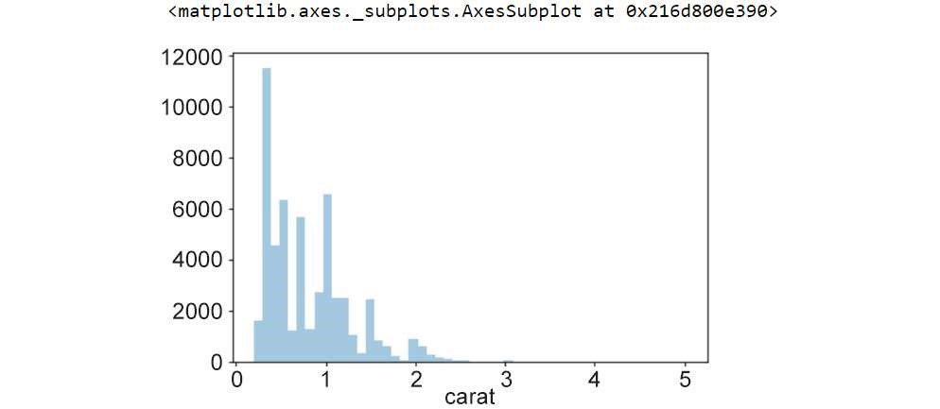

Figure 1.17: Histogram plot with KDE = false

Also note that the bins parameter seemed to render a more detailed plot when the bin size was increased from 10 to 50. Now, let's try to increase it to 100.

1. Increase the bins size to 100:

sns.distplot(diamonds_df.carat, kde=False, bins=100) The output is as follows:

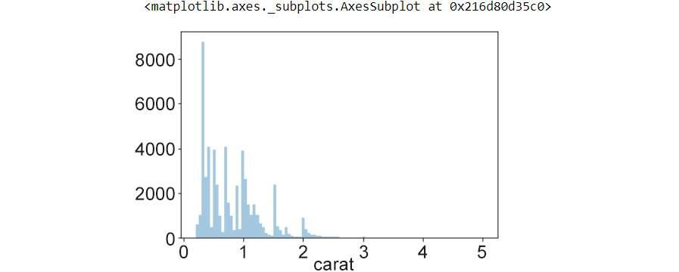

Figure 1.18: Histogram plot with increased bin size

The histogram with 100 bins shows a better visualization of the distribution of the variable—we see there are several peaks at specific carat values. Another observation is that most carat values are concentrated toward lower values and the tail is on the right—in other words, it is right-skewed.

A log transformation helps in identifying more trends. For instance, in the following graph, the x-axis shows log-transformed values of the price variable, and we see that there are two peaks indicating two kinds of diamonds—one with a high price and another with a low price.

1. Use a log transformation on the histogram:

import numpy as np sns.distplot(np.log(diamonds_df.price), kde=False) The output is as follows:

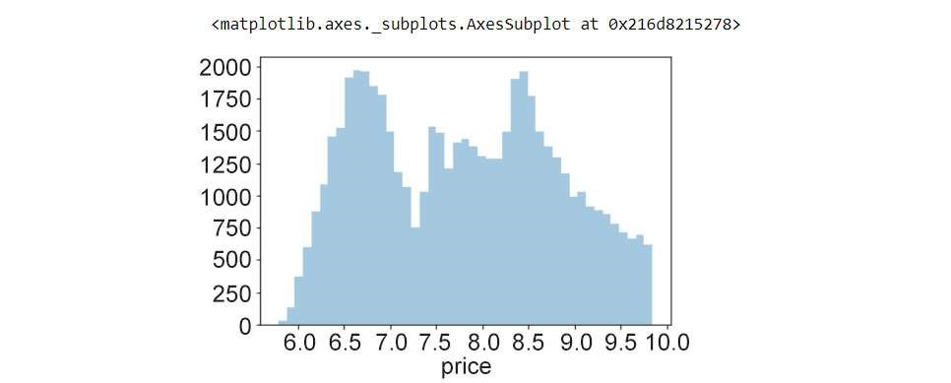

Figure 1.19: Histogram using a log transformation

That's pretty neat. Looking at the histogram, even a naive viewer immediately gets a picture of the distribution of the feature. Specifically, three observations are important in a histogram:

* Which feature values are more frequent in the dataset (in this case, there is a peak at around 6.8 and another peak between 8.5 and 9—note that log(price) = values, in this case,
* How many peaks exist in the data (the peaks need to be further inspected for possible causes in the context of the data)
* Whether there are any outliers in the data

### Bar Plots

In their simplest form, bar plots display counts of categorical variables. More broadly, bar plots are used to depict the relationship between a categorical variable and a numerical variable. Histograms, meanwhile, are plots that show the statistical distribution of a continuous numerical feature.

First, we shall present the counts of diamonds of each cut quality that exist in the data. Second, we shall look at the price associated with the different types of cut quality (Ideal, Good, Premium, and so on) in the dataset and find out the mean price distribution. We will use both pandas and seaborn to get a sense of how to use the built-in plotting functions in both libraries.

Before generating the plots, let's look at the unique values in the cut and clarity columns, just to refresh our memory.

### Creating a Bar Plot and Calculating the Mean Price Distribution

Here we'll learn how to create a table using the pandas crosstab function. We'll use a table to generate a bar plot. We'll then explore a bar plot generated using the seaborn library and calculate the mean price distribution. To do so, let's go through the following steps:

1. Import the necessary modules and dataset:

import seaborn as sns import pandas as pd

1. Import the diamonds dataset from seaborn:

diamonds_df = sns.load_dataset('diamonds')

1. Print the unique values of the cut column:

diamonds_df.cut.unique() The output will be as follows:

array(['Ideal', 'Premium', 'Good', 'Very Good', 'Fair'], dtype=object)

1. Print the unique values of the clarity column:

diamonds_df.clarity.unique() The output will be as follows: array(['SI2', 'SI1', 'VS1', 'VS2', 'VVS2', 'VVS1', 'I1', 'IF'], dtype=object) Note

unique() returns an array. There are five unique cut qualities and eight unique values in clarity. The number of unique values can be obtained using nunique() in pandas.

1. To obtain the counts of diamonds of each cut quality, we first create a table using the pandas crosstab() function:

cut_count_table = pd.crosstab(index=diamonds_df['cut'],columns='count') cut_count_table

The output will be as follows:

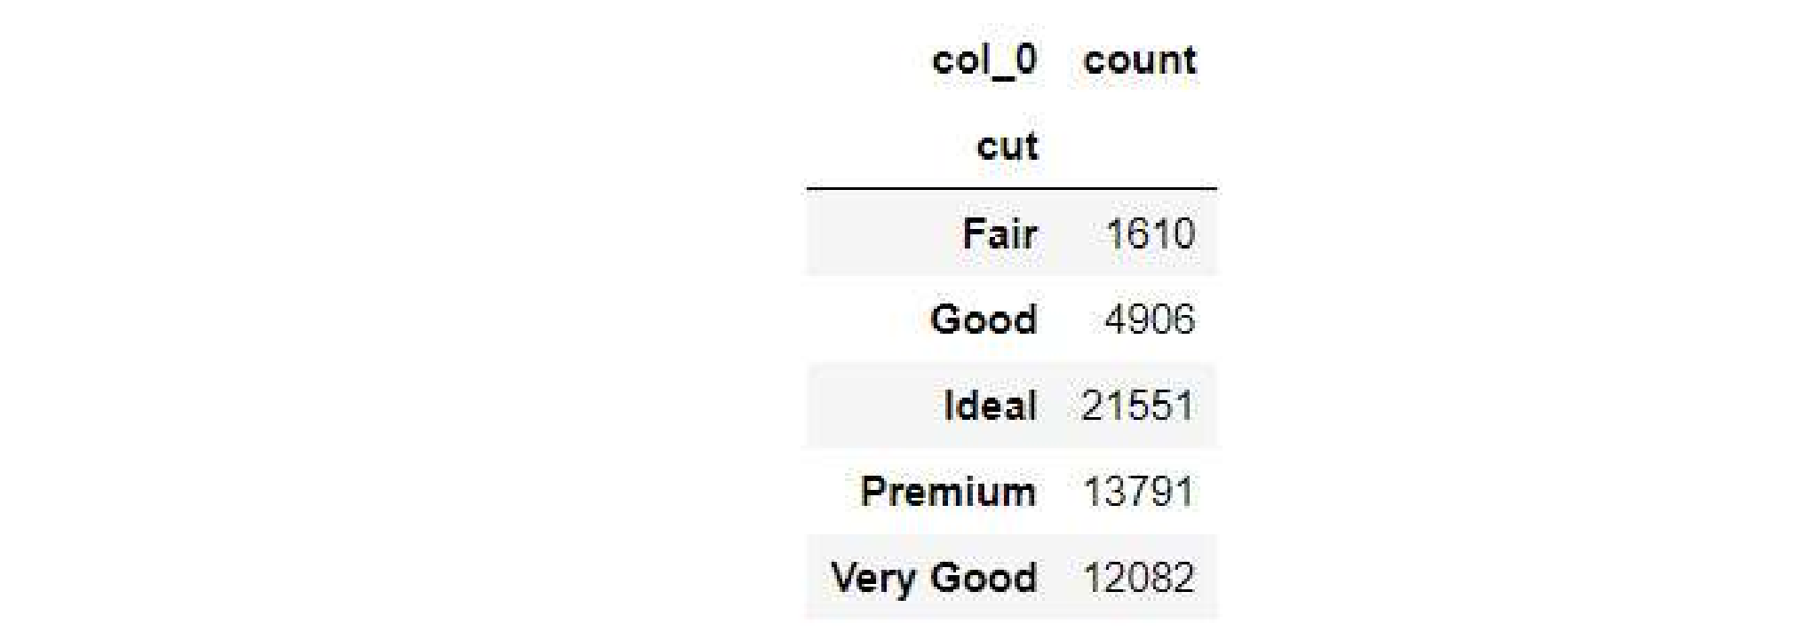Figure 1.20: Table using the crosstab function

1. Pass these counts to another pandas function, plot(kind='bar'):

cut_count_table.plot(kind='bar') The output will be as follows:

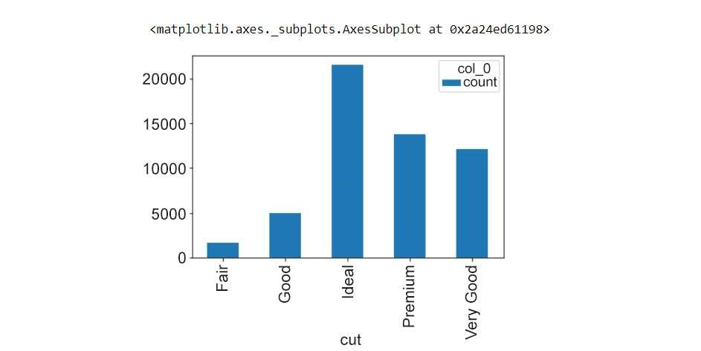

Figure 1.21: Bar plot using a pandas DataFrame

We see that most of the diamonds in the dataset are of the Ideal cut quality, followed by Premium, Very Good, Good, and Fair. Now, let's see how to generate the same plot using seaborn.

1. Generate the same bar plot using seaborn:

sns.catplot("cut", data=diamonds_df, aspect=1.5, kind="count", color="b") The output will be as follows:

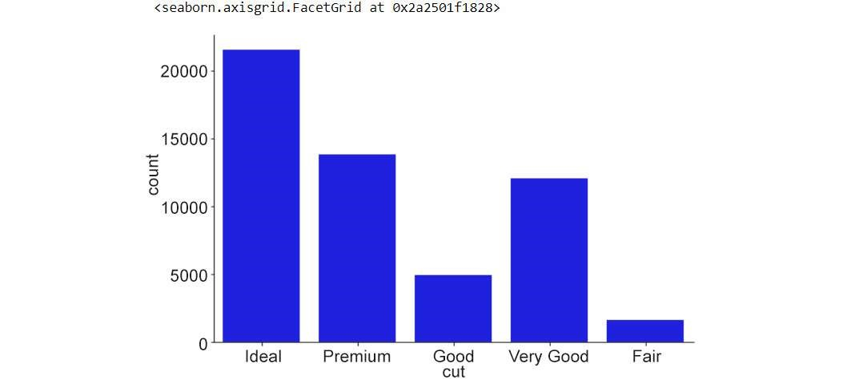

Figure 1.22: Bar plot using seaborn

Notice how the catplot() function does not require us to create the intermediate count table (using pd.crosstab()), and reduces one step in the plotting process.

1. Next, here is how we obtain the mean price distribution of different cut qualities using seaborn:

import seaborn as sns from numpy import median, mean sns.set(style="whitegrid") ax = sns.barplot(x="cut", y="price", data=diamonds_df,estimator=mean)

The output will be as follows:

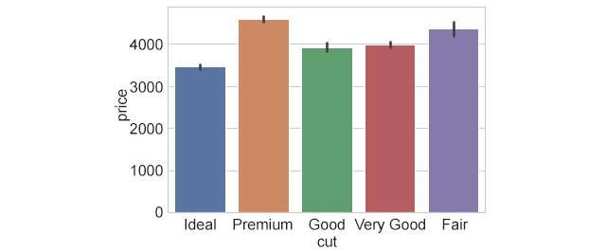

Figure 1.23: Bar plot with the mean price distribution

Here, the black lines (error bars) on the rectangles indicate the uncertainty (or spread of values) around the mean estimate. By default, this value is set to 95% confidence. How do we change it? We use the ci=68 parameter, for instance, to set it to 68%. We can also plot the standard deviation in the prices using ci=sd.

1. Reorder the x axis bars using order:

ax = sns.barplot(x="cut", y="price", data=diamonds_df, estimator=mean, ci=68, order=['Ideal','Good','Very Good','Fair','Premium']) The output will be as follows:

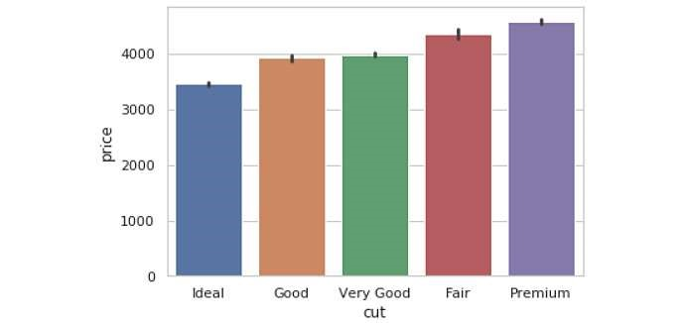

Figure 1.24: Bar plot with proper order

Grouped bar plots can be very useful for visualizing the variation of a particular feature within different groups. Now that you have looked into tweaking the plot parameters in a grouped bar plot, let's see how to generate a bar plot grouped by a specific feature.

### Creating Bar Plots Grouped by a Specific Feature

We will use the diamonds dataset to generate the distribution of prices with respect to color for each cut quality. In Creating a Bar Plot and Calculating the Mean Price Distribution, we looked at the price distribution for diamonds of different cut qualities. Now, we would like to look at the variation in each color:

1. Import the necessary modules—in this case, only seaborn: #Import seaborn import seaborn as sns
2. Load the dataset:

diamonds_df = sns.load_dataset('diamonds')

1. Use the hue parameter to plot nested groups:

ax = sns.barplot(x="cut", y="price", hue='color', data=diamonds_df) The output is as follows:

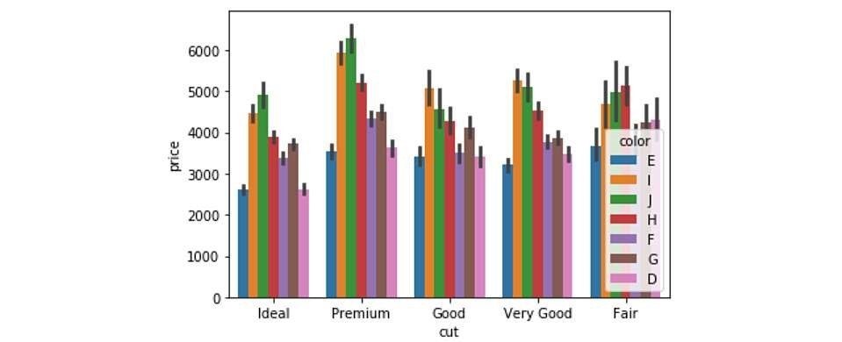

Figure 1.25: Grouped bar plot with legends

Here, we can observe that the price patterns for diamonds of different colours are similar for each cut quality. For instance, for Ideal diamonds, the price distribution of diamonds of different colours is the same as that for Premium, and other diamonds.

### Tweaking Plot Parameters

Looking at the last figure in our previous section, we find that the legend is not appropriately placed. We can tweak the plot parameters to adjust the placements of the legends and the axis labels, as well as change the font-size and rotation of the tick labels.

### Tweaking the Plot Parameters of a Grouped Bar Plot

Now, we'll tweak the plot parameters, for example, hue, of a grouped bar plot. We'll see how to place legends and axis labels in the right places and also explore the rotation feature:

1. Import the necessary modules—in this case, only seaborn: #Import seaborn import seaborn as sns
2. Load the dataset:

diamonds_df = sns.load_dataset('diamonds')

1. Use the hue parameter to plot nested groups:

ax = sns.barplot(x="cut", y="price", hue='color', data=diamonds_df) The output is as follows:

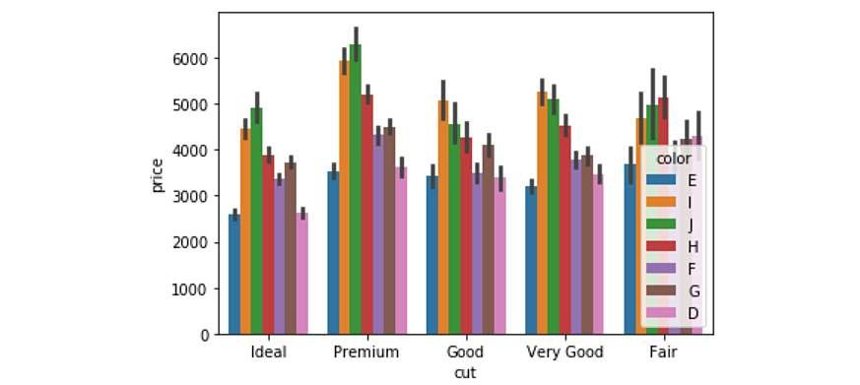

Figure 1.26: Nested bar plot with the hue parameter

1. Place the legend appropriately on the bar plot:

ax = sns.barplot(x='cut', y='price', hue='color', data=diamonds_df) ax.legend(loc='upper right',ncol=4)

The output is as follows:

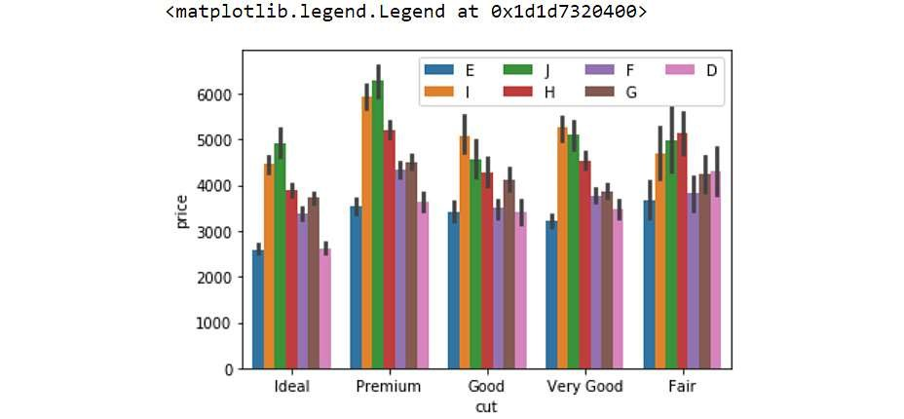

Figure 1.27: Grouped bar plot with legends placed appropriately

In the preceding ax.legend() call, the ncol parameter denotes the number of columns into which values in the legend are to be organized, and the loc parameter specifies the location of the legend and can take any one of eight values (upper left, lower center, and so on).

1. To modify the axis labels on the x axis and y axis, input the following code:

ax = sns.barplot(x='cut', y='price', hue='color', data=diamonds_df) ax.legend(loc='upper right', ncol=4) ax.set_xlabel('Cut', fontdict={'fontsize' : 15}) ax.set_ylabel('Price', fontdict={'fontsize' : 15}) The output is as follows:

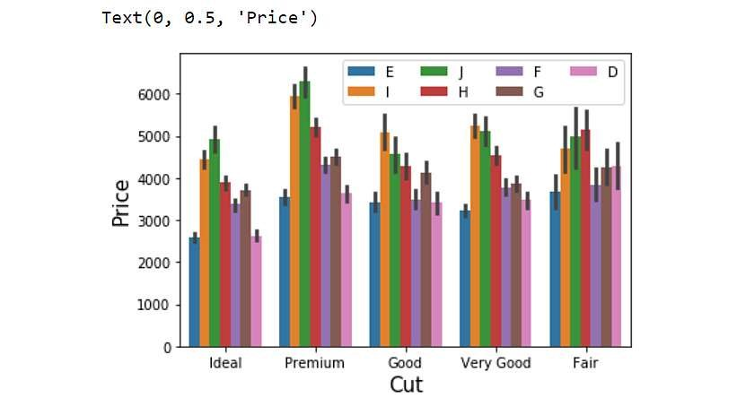

Figure 1.28: Grouped bar plot with modified labels

1. Similarly, use this to modify the font-size and rotation of the x axis of the tick labels:

ax = sns.barplot(x='cut', y='price', hue='color', data=diamonds_df) ax.legend(loc='upper right',ncol=4)

# set fontsize and rotation of x-axis tick labels ax.set_xticklabels(ax.get_xticklabels(), fontsize=13, rotation=30) The output is as follows:

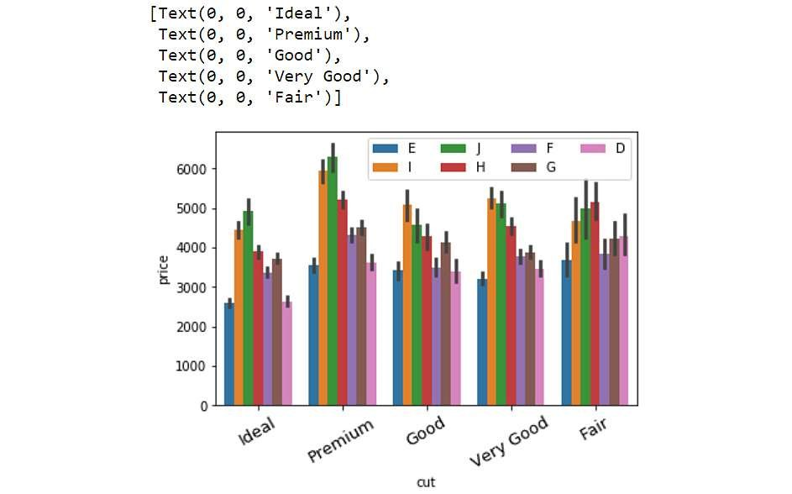

Figure 1.29: Grouped bar plot with the rotation feature of the labels

The rotation feature is particularly useful when the tick labels are long and crowd up together on the x axis.

### Annotations

Another useful feature to have in plots is the annotation feature. In the following exercise, we'll make a simple bar plot more informative by adding some annotations.Suppose we want to add more information to the plot about ideally cut diamonds.

### Annotating a Bar Plot

We will annotate a bar plot, generated using the catplot function of seaborn, using a note right above the plot. Let's see how:

1. Import the necessary modules:

import matplotlib.pyplot as plt import seaborn as sns

1. Load the diamonds dataset:

diamonds_df = sns.load_dataset('diamonds')

1. Generate a bar plot using catplot function of the seaborn library:

ax = sns.catplot("cut", data=diamonds_df, aspect=1.5, kind="count", color="b") The output is as follows:

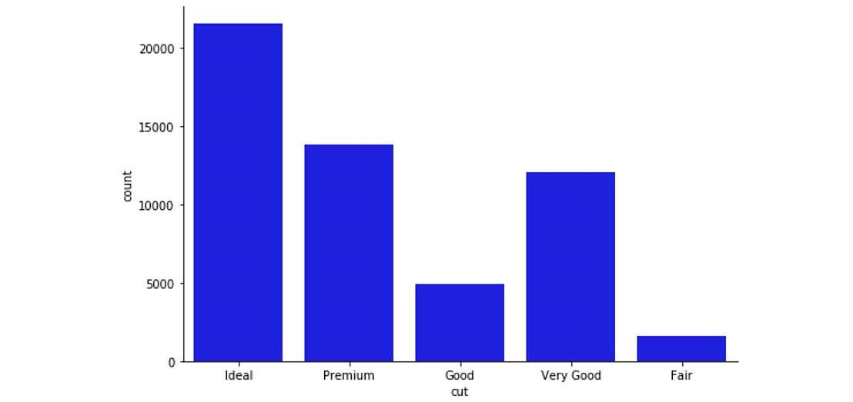

Figure 1.30: Bar plot with seaborn's catplot function

1. Annotate the column belonging to the Ideal category: # get records in the DataFrame corresponding to ideal cut ideal_group = diamonds_df.loc[diamonds_df['cut']=='Ideal']
2. Find the location of the x coordinate where the annotation has to be placed: # get the location of x coordinate where the annotation has to be placed x = ideal_group.index.tolist()[0]
3. Find the location of the y coordinate where the annotation has to be placed: # get the location of y coordinate where the annotation has to be placed y = len(ideal_group)
4. Print the location of the x and y co-ordinates:

print(x) print(y)

The output is:

0

21551

1. Annotate the plot with a note:

# annotate the plot with any note or extra information sns.catplot("cut", data=diamonds_df, aspect=1.5, kind="count", color="b")

plt.annotate('excellent polish and symmetry ratings;\nreflects almost all the light that enters it', xy=(x,y), xytext=(x+0.3, y+2000), arrowprops=dict(facecolor='red')) The output is as follows:

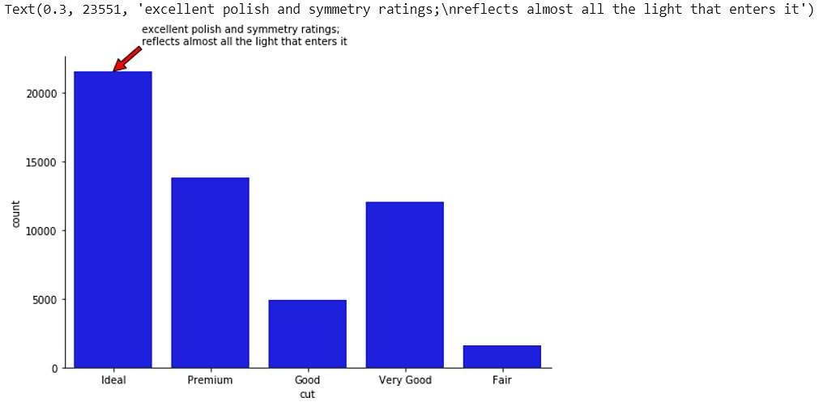

Figure 1.31: Annotated bar plot

Now, there seem to be a lot of parameters in the annotate function, but worry not! Matplotlib's https://matplotlib.org/3.1.0/api/_as_gen/matplotlib.pyplot.annotate.html official documentation covers all the details. For instance, the xy parameter denotes the point (x,y) on the figure to annotate. xytext denotes the position (x,y) to place the text at. If None, it defaults to xy. Note that we added an offset of .3 for x and 2000 for y (since y is close to 20,000) for the sake of readability of the text. The colour of the arrow is specified using the arrowprops parameter in the annotate function.

There are several other bells and whistles associated with visualization libraries in Python, some of which we will see as we progress in the book. At this stage, we will go through a chapter activity to revise the concepts in this chapter.

So far, we have seen how to generate two simple plots using seaborn and pandas—histograms and bar plots:

* Histograms: Histograms are useful for understanding the statistical distribution of a

numerical feature in a given dataset. They can be generated using the hist() function in pandas and distplot() in seaborn.

* Bar plots: Bar plots are useful for gaining insight into the values taken by a categorical feature in a given dataset. They can be generated using the plot(kind='bar') function in pandas and the catplot(kind='count'), and barplot() functions in seaborn.

With the help of various considerations arising in the process of plotting these two types of visualizations, we presented some basic concepts in data visualization:

* Formatting legends to present labels for different elements in the plot with loc and other parameters in the legend function
* Changing the properties of tick labels, such as font-size, and rotation, with parameters in the set_xticklabels() and set_yticklabels() functions
* Adding annotations for additional information with the annotate() function

### Summary

In this tutorial, we covered the basics of handling pandas DataFrames to format them as inputs for different visualization functions in libraries such as pandas , seaborn and more, and we covered some essential concepts in generating and modifying plots to create pleasing figures.

The pandas library contains functions such as read_csv(), read_excel(), and read_json() to read structured text data files. Functions such as describe() and info() are useful to get information on the summary statistics and memory usage of the features in a DataFrame. Other important operations on pandas DataFrames include subletting based on user-specified conditions/constraints, adding new columns to a DataFrame, transforming existing columns with built-in Python functions as well as user-defined functions, deleting specific columns in a DataFrame, and writing a modified DataFrame to a file on the local system.

Once equipped with knowledge of these common operations on pandas DataFrames, we went over the basics of visualization and learned how to refine the visual appeal of the plots. We illustrated these concepts with the plotting of histograms and bar plots. Specifically, we learned about different ways of presenting labels and legends, changing the properties of tick labels, and adding annotations.

## Week 4 - Simple tips for prettier and customised plots in Seaborn (Python)

Simple tips for prettier and customised plots in Seaborn (Python)

In this tutorial, we will look at simple ways to customise your plots to make them aesthetically more pleasing. I hope these simple tricks will help you get better-looking plots and save you time from adjusting individual plots.

### Baseline plot

Let’s use Seaborn’s built-in dataset on penguins as our sample data:

# Import packages import matplotlib.pyplot as plt import seaborn as sns

# Import data

df = sns.load_dataset('penguins').rename(columns={'sex': 'gender'}) df

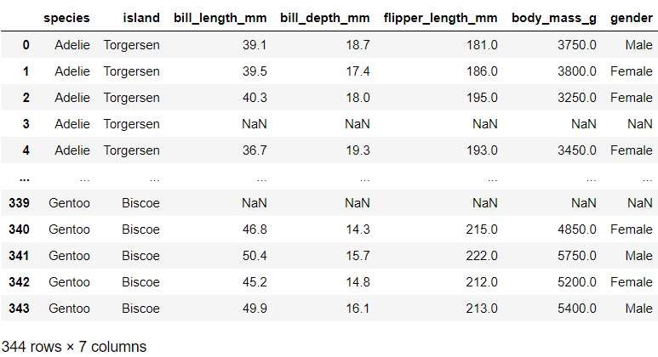

We will build a standard scatter plot with the default chart settings to use it as our baseline:

# Plot

sns.scatterplot(data=df, x='body_mass_g', y='bill_length_mm', alpha=0.7, hue='species', size='gender')

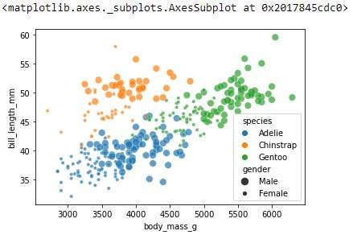

We will see the journey of how this plot alters with each tip.

### Tips

You will see that the first two tips are for individual plots whereas the remaining four tips are for changing the default settings for all charts.

#### Tip #1: Semicolon

Did you notice the text output right above the chart in the previous plot? A simple way to suppress this text output is to use ; at the end of your plot.

# Plot

sns.scatterplot(data=df, x='body_mass_g', y='bill_length_mm', alpha=0.7, hue='species', size='gender');

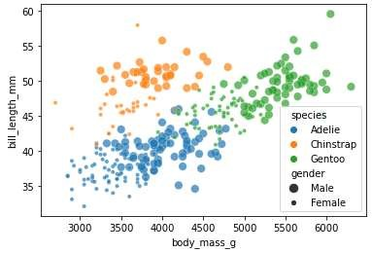

By only adding ; at the end of our code, we get a cleaner output.

#### Tip #2: plt.figure()

Plots can often benefit from resizing. If we wanted to resize, this is how we would do it:

# Plot

plt.figure(figsize=(9, 5))

sns.scatterplot(data=df, x='body_mass_g', y='bill_length_mm', alpha=0.7, hue='species', size='gender');

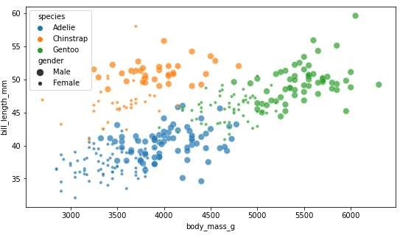

When we resized, the legend moved to the upper left corner. Let’s move the legend outside the chart so that it doesn’t accidentally cover data points:

# Plot

plt.figure(figsize=(9, 5))

sns.scatterplot(data=df, x='body_mass_g', y='bill_length_mm', alpha=0.7, hue='species', size='gender')

plt.legend(loc='upper right', bbox_to_anchor=(1.2, 1));

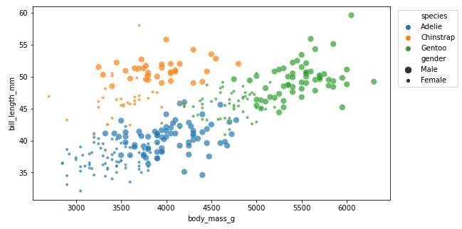

If you are wondering how to know what number combinations to use for figsize() or bbox_to_anchor(), you will need to trial and error which numbers work best for the plot.

#### Tip #3: sns.set_style()

This function helps to change the overall style of the plots if we don’t like the default style. This includes things like the aesthetics of the axis colours and background. Let’s change the style to whitegrid and see how the plot appearance changes:

# Change default style sns.set_style('whitegrid')

# Plot

plt.figure(figsize=(9, 5))

sns.scatterplot(data=df, x='body_mass_g', y='bill_length_mm', alpha=0.7, hue='species', size='gender')

plt.legend(loc='upper right', bbox_to_anchor=(1.2, 1));

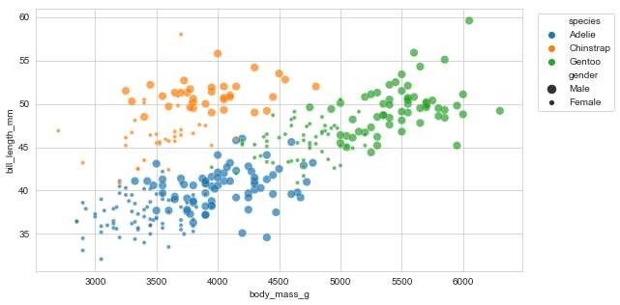

Here are some more other options to try out: 'darkgrid', 'dark' and 'ticks' to find the one you fancy more.

#### Tip #4: sns.set_context()

The label sizes look quite small in the previous plot. With sns.set_context(), we could change the context parameters if we don’t like the default settings. I use this function mainly to control the default font size for labels in the plots. By changing the default, we can save time from not having to tweak the font size for different elements (e.g. axis label, title, legend) of individual plots. Let’s change the context to 'talk' and look at the plot again:

# Change default context sns.set_context('talk')

# Plot

plt.figure(figsize=(9, 5))

sns.scatterplot(data=df, x='body_mass_g', y='bill_length_mm', alpha=0.7, hue='species', size='gender')

plt.legend(loc='upper right', bbox_to_anchor=(1.3, 1));

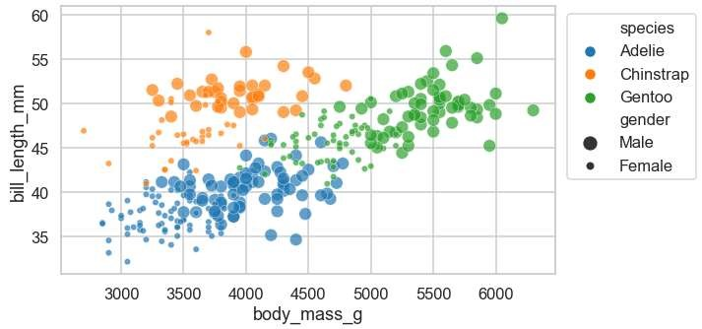

It’s more easily legible, isn’t it? Another option to try out is: 'poster' which will increase the default size even more.

#### Tip #5: sns.set_palette()

If you ever want to customise the default colour palette to your preferred colour combinations, this function comes in handy. We can use colourmaps from Matplotlib. Let’s change the palette to 'rainbow' and look at the plot again:

# Change default palette sns.set_palette('rainbow')# Plot plt.figure(figsize=(9, 5))

sns.scatterplot(data=df, x='body_mass_g', y='bill_length_mm', alpha=0.7, hue='species', size='gender')

plt.legend(loc='upper right', bbox_to_anchor=(1.3, 1));

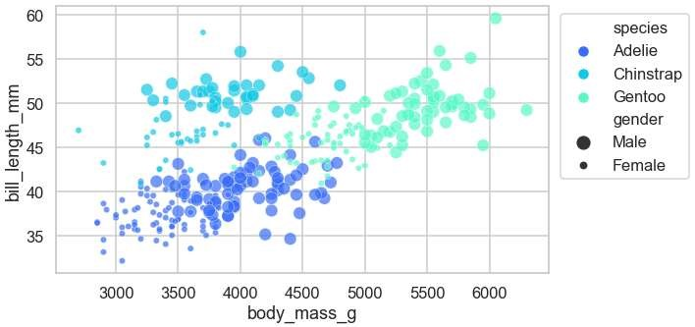

If you can’t find a Matplotlib colourmap that you like, you can hand pick colours to create your own unique colour palette. One way to create your own palette is to pass a list of colour names to the function like in the example below.

# Change default palette

sns.set_palette(['green', 'purple', 'red'])

# Plot

plt.figure(figsize=(9, 5))

sns.scatterplot(data=df, x='body_mass_g', y='bill_length_mm', alpha=0.7, hue='species', size='gender')

plt.legend(loc='upper right', bbox_to_anchor=(1.3, 1));

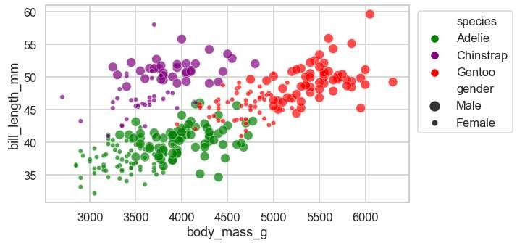

If the colour names don’t quite capture what you are after, you can build your own palette using hexadecimal colours to access a wider range of options (over 16 million colours!). Let’s see an example:

# Change default palette

sns.set_palette(['#62C370', '#FFD166', '#EF476F'])# Plot plt.figure(figsize=(9, 5))

sns.scatterplot(data=df, x='body_mass_g', y='bill_length_mm', alpha=0.7, hue='species', size='gender')

plt.legend(loc='upper right', bbox_to_anchor=(1.3, 1));

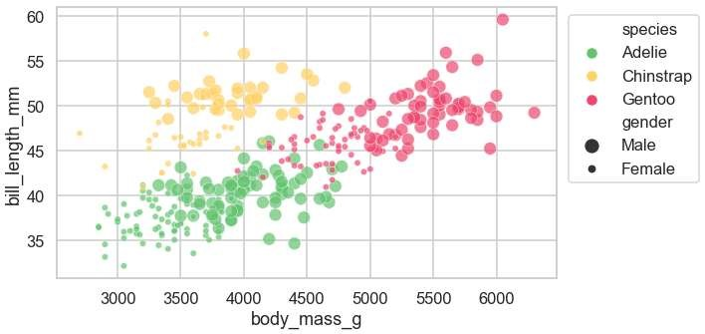

#### Tip #6: sns.set()

From the previous three tips, I hope you will find your favourite combination (in some cases, it could be leaving the default as is). If we were to update chart default settings, it’s better to do it just after importing the visualisation packages. This means we will have a snippet like this at the beginning of our scripts:

# Import packages import matplotlib.pyplot as plt import seaborn as sns# Change defaults

sns.set_style('whitegrid') sns.set_context('talk') sns.set_palette('rainbow')

Updating multiple defaults like above can be done more succinctly with sns.set(). Here’s the succinct version of the same code:

# Import packages import matplotlib.pyplot as plt import seaborn as sns# Change defaults

sns.set(style='whitegrid', context='talk', palette='rainbow')

These were the six tips. These are the comparison of the plots before and after tweaking:

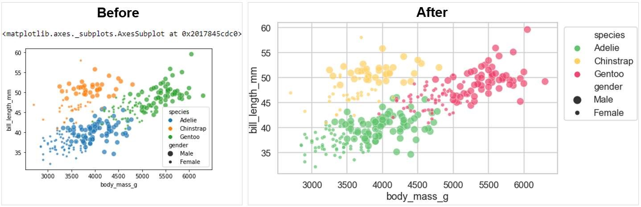

## Week 4 – Principles of Data Visualisation

We begin with some basic ideas about data visualization from

Edward Tufte (*The Visual Display of Quantitative Information (2nd ed.)*)

He gives six principles of graphical integrity

The first two are (quoted directly from page 56):

1. The representation of numbers, as physically measured on the surface of the graphic itself, should be directly proportional to the numerical quantities measured.
2. Clear, detailed, and thorough labeling should be used to defeat graphical distortion and ambiguity. Write out explanations of the data on the graphic itself. Label important events in the data.

The classic example to avoid: adding 3d where it isn’t necessary

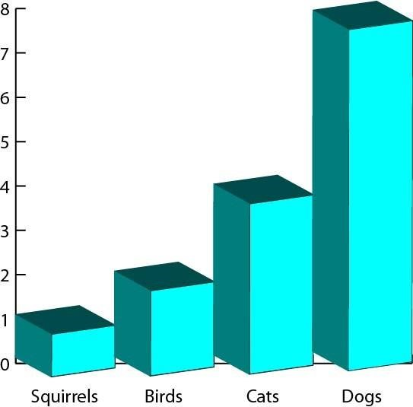

“The Lie Factor” is defined as:

size of effect shown in graphic

lie factor = size of effect in data

When this isn’t 1, it is not uncommon to be as large as 2 to 5

It is less usual to see a lie factor of less than 1

The third principle of graphical integrity (page 61): Show data variation, not design variation

For example, avoid things like this:

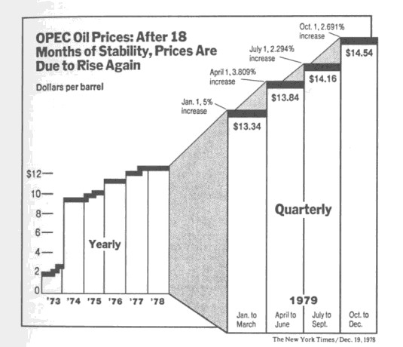

The fourth principle of graphical integrity (page 68): In time-series displays of money, deflated and standardized units of monetary measurement are nearly always better than nominal units.

The fifth (page 71): The number of information-carrying (variable) dimensions depicted should not exceed the number of dimensions in the data

In general it implies that you should not use 3d to represent something that only needs to be 2d, etc.

Tufte’s sixth principle of graphical integrity is: Graphics must not quote data out of context (page 74).

To evaluate the information content, a useful measure (page 93) is:

data ink

Data ink ratio = total ink used in the graphic

This is the same as: the proportion of a graphic’s ink devoted to the non-redundant display of data information

It is also the same as: 1 minus the proportion of a graphic that can be erased without the loss of data information

One of Tufte’s principles for graphical excellence (page 96): Maximize the data ink ratio, within reason.

This is why Tufte frowns on heavy grid lines in the background (or even horizontal reference lines)

He extends this principle with two guidelines for how to achieve it

1. Erase non-data ink, within reason (page 96).
2. Erase redundant data ink, within reason (page 100).

To summarize Tufte’s principles of how to achieve graphical excellence (page 105):

1. Above all else show the data.
2. Maximize the data-ink ratio.
3. Erase non-data ink.
4. Erase redundant data ink.
5. Revise and edit.

A useful term coined by Tufte (page 107): “*chartjunk* refers to all visual elements in charts and graphs that are not necessary to comprehend the information represented on the graph, or that distract the viewer from this information” Common types of chartjunk:

1. Vibrating chartjunk, which is cross-hatching or other patterns that distract the mind from the information being presented
2. Grids (according to Tufte) — make them a lighter gray, not black, if you are going to use them
3. Self-promoting graphics (“The Duck”), where color schemes and patterns are introduced for artistic appeal rather than information content.

Tufte gives one other useful pair of principles on the aspect ratio of a display:

► If the nature of the data suggests the shape of the graphic, follow that suggestion.

► Otherwise, move toward horizontal graphics about 50 percent wider than tall (approximately a 3:2 aspect ratio).

We now describe some principles given by William S. Cleveland in his book *The Elements of Graphing Data* (1985)

Many (but not all) of these are quite similar to those of Tufte, although his work in this area preceded Tufte’s work

His four major categories in the principles of graph construction:

► Clear vision

► Clear understanding

► Scales

► General strategy

Clear vision

► Make the data stand out. Avoid superfluidity.

► Use visually prominent graphical elements to show the data.

► Do not clutter the data region.

► Use a reference line when there is an important value that must be seen across the entire graph, but do not let the line interfere with the data.

► Do not allow data labels in the data region to interfere with the quantitative data or to clutter the graph.

► Avoid putting notes, keys, and markers in the data region. Put keys and markers just outside the data region and put notes in the legend or in the text.

► Overlapping plotting symbols must be visually distinguishable.

► Superposed data sets must be readily visually discriminated.

► Visual clarity must be preserved under reduction and reproduction.

Clear understanding

► Put major conclusions into graphical form. Make legends comprehensive and informative.

► Error bars should be clearly explained.

► Proofread graphs.

► Strive for clarity.

Scales

► Choose the range of the tick marks to include or nearly include the range of data.

► Subject to the constraints that scales have, choose the scales so that the data fill up as much of the region as possible.

► It is sometimes helpful to use the pair of scale lines for a variable to show two different scales.

► Choose appropriate scales when graphs are compared.

► Do not insist that zero always be included on a scale showing magnitude.

► Use a logarithmic scale when it is important to understand percent change or multiplicative factors.

► Showing data on a logarithmic scale can improve resolution.

General strategy

► A large amount of quantitative information can be packed into a small region.

► Graphing data should be an interative, experimental process.

► Graph data two or more times when it is needed.

► Many useful graphs require careful, detailed study.

# S1 Machine Learning for Data Analytics

## Week 1 – Introduction to Machine Learning

**Machine Learning**

*“Machine Learning is the field of study that gives computers the ability to learn without being explicitly programmed. Arthur Samuel, 1959”*

* A set of tools for making inferences & predictions from data
* **Predict** future events
  + Will it rain tomorrow?
    - Yes (70% probability)
* **Infer** the causes of events & behaviours
  + Why does it rain?
    - Time of the year, humidity levels, temperature, location etc.
* **Infer** patterns
  + What are the different types of weather conditions?
    - Rain, sunny, overcast, fog, etc.
* Relationships between AI, Machine Learning, Deep Learning & Data Science are overlapping
* **Machine learning** is a subset of AI that consists of techniques enabling computers to identify patterns in data and to deliver AI applications.
* **Deep learning** is a subset of machine learning that enables computers to solve more complex problems.
* **Data Science** combines Machine Learning, Deep Learning & AI along with other disciplines e.g., Big Data Analytics & Cloud Computing to analyse data & reach actionable conclusions

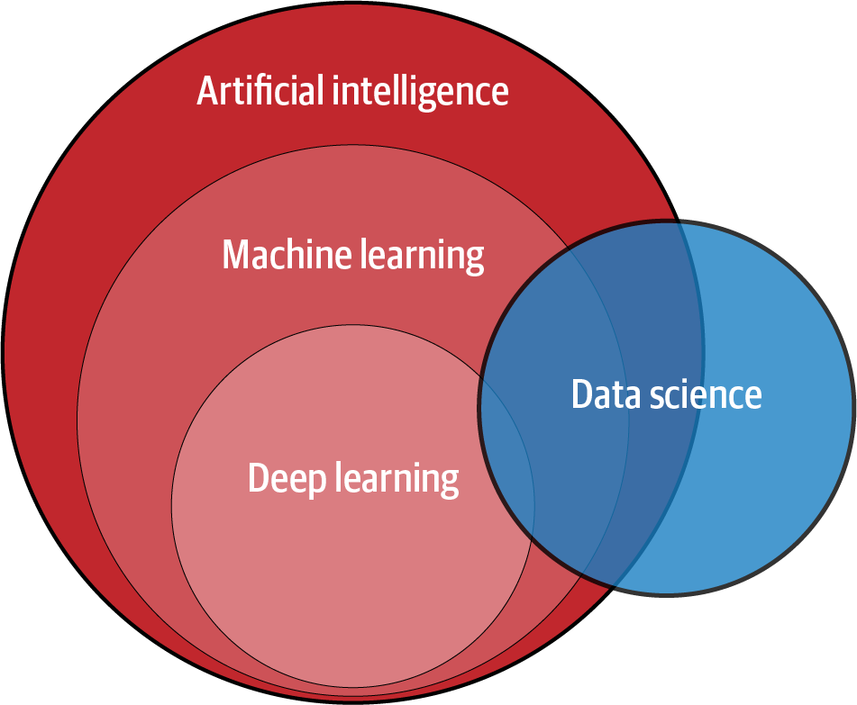

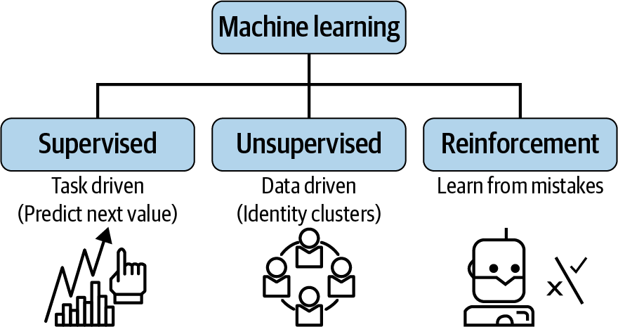

### Traditional Programming (TP) vs Machine Learning (ML)

**Traditional Programming**: Rules & Data are provided to a program which will produce an output based on the data structure

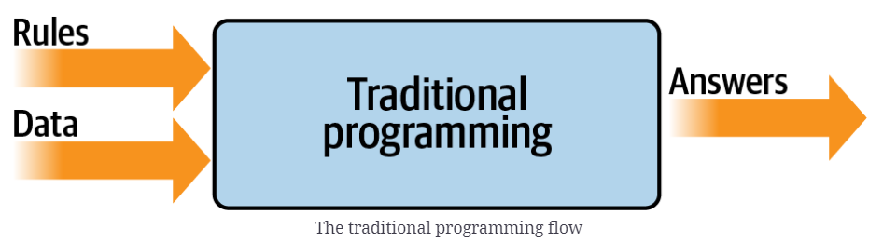

**Machine Learning:** Lots of Data & Answers are labelled and provided to a computer, which can figure out what the rules are that make one piece of data match a particular label and another piece of data match a different label.

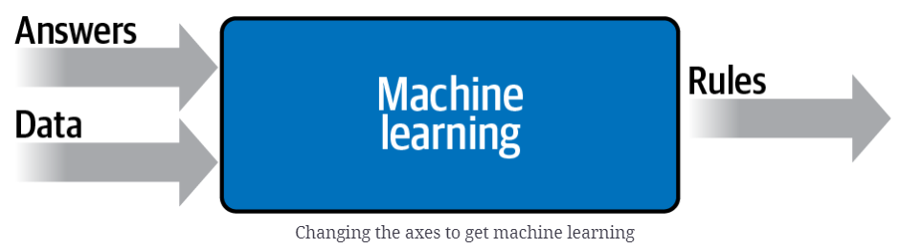

E.g., Suppose we collect a lot of instances of this data while they’re doing different activities. We end up with a scenario of having data that says “This is what walking looks like,” “This is what running looks like,” and so on

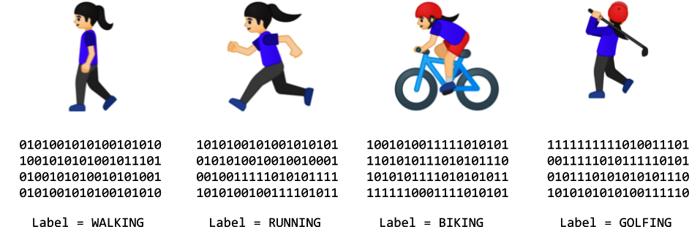

#### Spam Folder Example

**Traditional Approach:**

* First, we would consider what spam typically looks like. We might notice that some words or phrases (such as “win,” “credit card,” “free,” and “amazing”) tend to come up a lot in the subject line.

1. We would notice a few other patterns in the sender’s name, the email’s body, and other parts of the email.
2. We would write a detection algorithm for each of the patterns that we noticed, and your program would flag emails as spam if a number of these patterns were detected.
3. We would test the program and repeat steps 1 and 2 until it was good enough to launch.

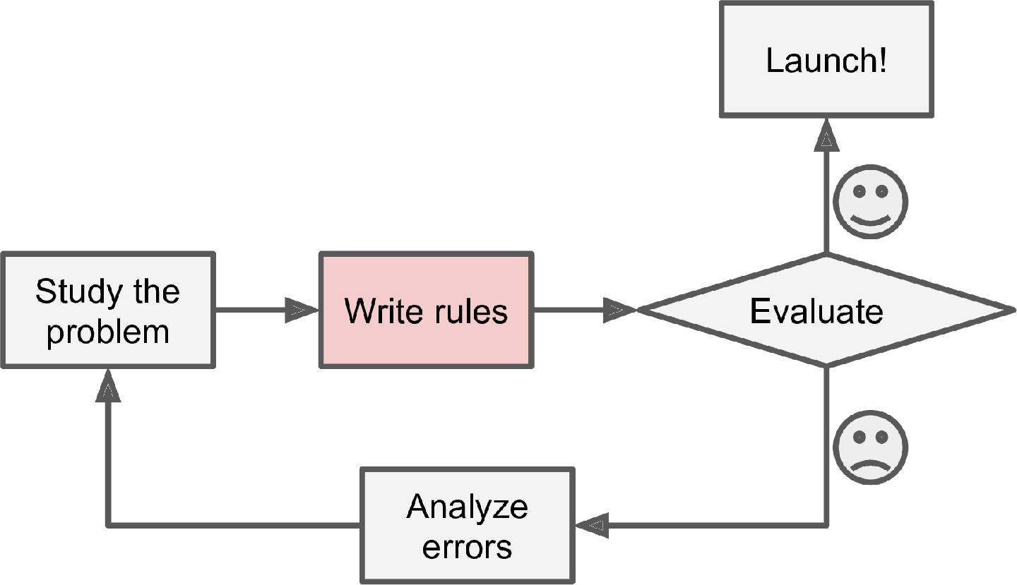

**Machine Learning Approach:**

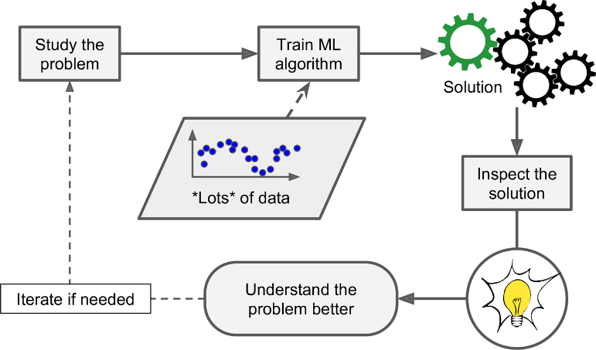

### Machine Learning Framework

* Machine learning is a unified algorithmic framework designed to identify computational models that accurately describe empirical data and the phenomena underlying it, with little or no human involvement.

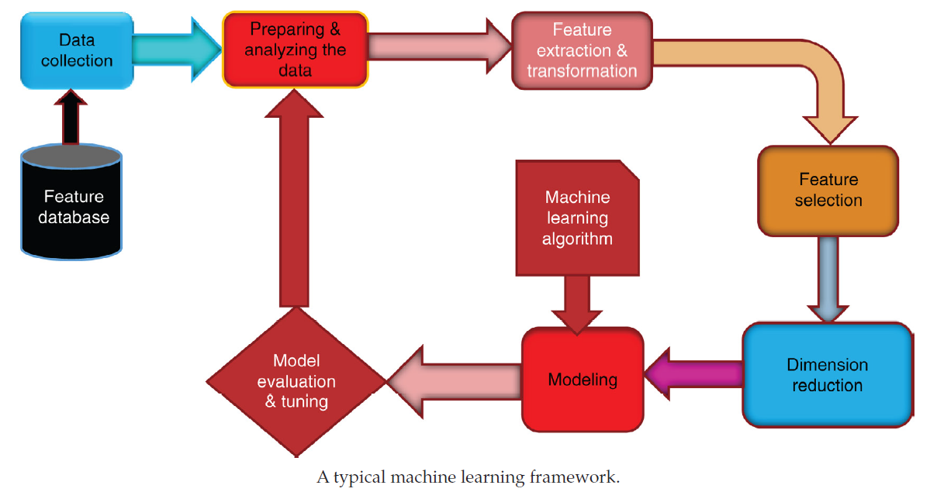

### Application Areas of Machine Learning

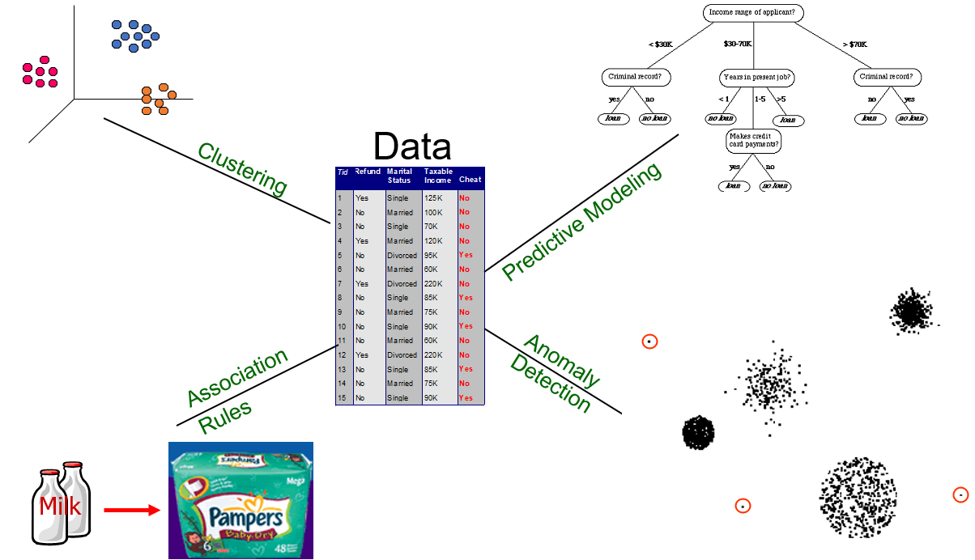

### Branches of Machine Learning

**Supervised Learning Algorithms**are trained with labelled data. In other words, data composed of examples of the desired answers. For instance, a model that identifies fraudulent credit card use would be trained from a dataset with labelled data points of known fraudulent and valid charges. Most machine learning is supervised.

**Unsupervised Learning Algorithms**are used on data with no labels, and the goal is to find relationships in the data. For instance, we might want to find groupings of customer demographics with similar buying habits.

**Semi-supervised Learning**is a machine learning branch that tries to solve problems with both labelled and unlabelled data with an approach that employs concepts belonging to clustering and classification methods.

**Reinforcement Learning (RL)**is a popular and promising branch of AI that involves making smarter models and agents that can automatically determine ideal behaviour based on changing requirements.

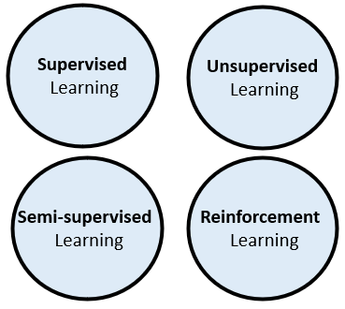

### Machine Learning Modelling

#### Supervised Learning

##### Regression

* Predict a value of a given continuous valued variable based on the values of other variables, assuming a linear or nonlinear model of dependency.
* Extensively studied in statistics and neural network fields.
* [**Bootstrap aggregation**](https://www.quantstart.com/articles/bootstrap-aggregation-random-forests-and-boosted-trees/)(Bagging) is an ensemble learning method that is commonly used to reduce variance within a noisy dataset.
* [**Boosting**](https://arxiv.org/abs/1403.1452) refers to the process of sequentially training weak learners to build a model.

**Examples:**

* Predicting sales amounts of new product based on advertising expenditure.
* Predicting wind velocities as a function of temperature, humidity, air pressure, etc.
* Time series prediction of stock market indices.

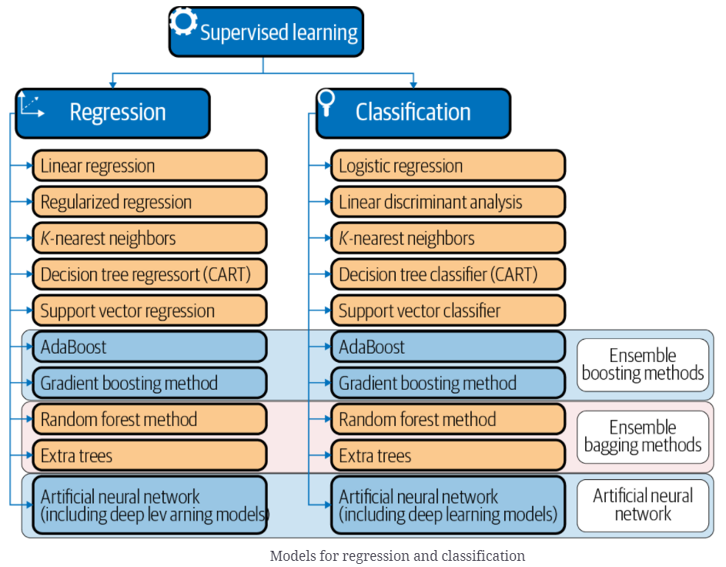

##### Classification

* Find a model for class attribute as a function of the values of other attributes

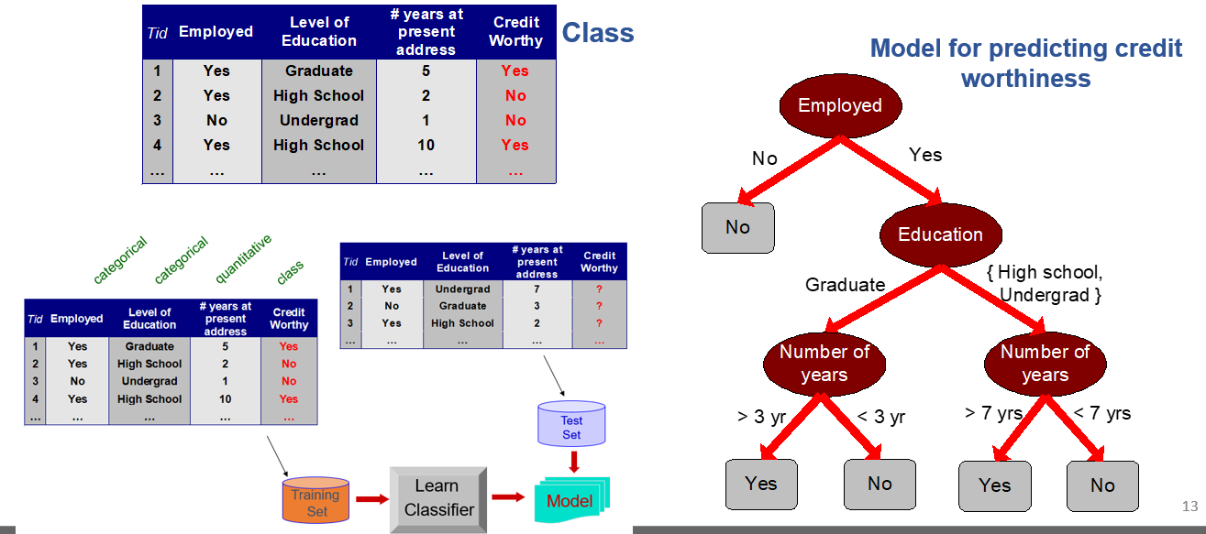

###### Applications

Fraud Detection

**Goal:**

* Predict fraudulent cases in credit card transactions.

**Approach**:

* Use credit card transactions and the information on its account-holder as attributes.
  + When does a customer buy, what does he/ she buy, how often he/ she pays on time, etc.
* Label past transactions as fraud or fair transactions. This forms the class attribute.
* Learn a model for the class of the transactions.
* Use this model to detect fraud by observing credit card transactions on an account.

Churn prediction for telephone customers

**Goal:**

* To predict whether a customer is likely to be lost to a competitor.

**Approach:**

* Use detailed record of transactions with each of the past and present customers, to find attributes.
* How often the customer calls, where he/ she calls, what time-of-the day he/ she calls most, his financial status, marital status, etc.
* Label the customers as loyal or disloyal.
* Find a model for loyalty.

#### Unsupervised Learning

##### Clustering

* Finding groups of objects such that the objects in a group will be similar (or related) to one another and different from (or unrelated to) the objects in other groups.
* **In unsupervised learning, as we might guess, the training data is unlabelled. The system tries to learn without a teacher.**
* The most important unsupervised learning algorithms.
* **Clustering**: kNN, K-Means, DBSCAN and Hierarchical Cluster Analysis (HCA).
* **Anomaly Detection and Novelty Detection:** One-class SVM and Isolation Forest.
* **Visualization and Dimensionality Reduction:** Principal Component Analysis (PCA), Locally Linear Embedding (LLE) and t-Distributed Stochastic Neighbour Embedding (t-SNE).

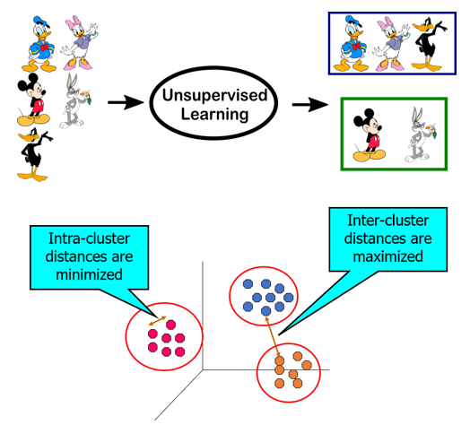

###### Applications

Market Segmentation:

**Goal**:

* subdivide a market into distinct subsets of customers where any subset may be selected as a market target to be reached with a distinct marketing mix.

**Approach**:

* Collect different attributes of customers based on their geographical and lifestyle related information.
* Find clusters of similar customers.
* Measure the clustering quality by observing buying patterns of customers in the same cluster vs. those from different clusters.

Document Clustering:

**Goal**:

* To find groups of documents that are similar to each other based on the important terms appearing in them.

**Approach**:

* To identify frequently occurring terms in each document. Form a similarity measure based on the frequencies of different terms. Use it to cluster.

##### Association Rule Discovery

* **Given a set of records each of which contain some number of items from a given collection**
* Produce dependency rules which will predict occurrence of an item based on occurrences of other items.

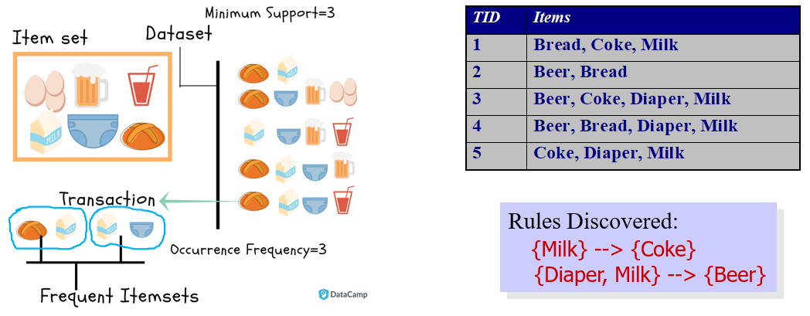

###### Applications

**Market-basket analysis**

* Rules are used for sales promotion, shelf management, and inventory management.

**Telecommunication alarm diagnosis**

* Rules are used to find combination of alarms that occur together frequently in the same time period.

**Medical Informatics**

* Rules are used to find combination of patient symptoms and test results associated with certain diseases.

##### Deviation/Anomaly/Change Detection

* Detect significant deviations from normal behaviour

###### Applications:

* Credit Card Fraud Detection
* Network Intrusion Detection
* Identify anomalous behaviour from sensor networks for monitoring and surveillance.
* Detecting changes in the global forest cover

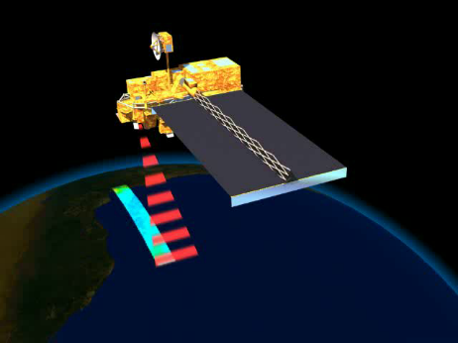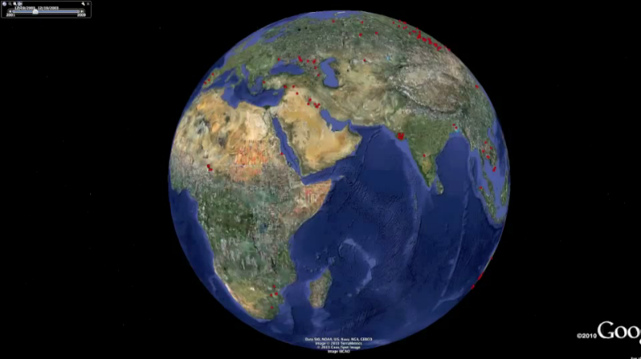

#### Semi-Supervised Learning

* Since labelling data is time-consuming and costly, we have plenty of unlabelled instances, and few labelled instances.
* Some algorithms can deal with data that’s partially labelled. This is called as the Semi-supervised learning.
* Some photo-hosting services, such as Google Photos, are good examples of this.
* Once you upload all of your family photos to the service, it automatically recognizes that the same person A shows up in photos 1, 5, and 11, while another person B shows up in photos 2, 5, and 7.
* This is the unsupervised part of the algorithm (clustering). Now all the system needs is for you to tell it who these people are. Add one label per person and it is able to name everyone in every photo, which is useful for searching photos.

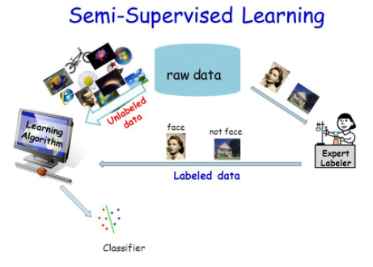 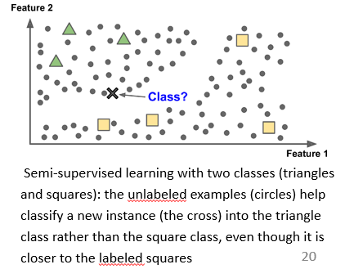

#### Reinforcement Learning

* Consider we are teaching the dog to catch a ball, when we throw a ball, the dog catches a ball, we will give a cookie. If it fails to catch the ball, we will not give a cookie. So, the dog will figure out what actions it does that made it receive a cookie and repeat that action.
* Similarly, in an **RL environment**, we will not teach the **agent** what to do or how to do, but we will give feedback to the agent for each **action** it does. The feedback may be positive (**reward**) or negative (**punishment**).
* The learning system which receives the punishment will improve itself. It is a trial-and-error process. The reinforcement learning algorithm retains outputs that maximize the received reward over time.
* In the above analogy, the **dog** represents the **agent**, giving a **cookie** to the dog on catching a ball is a **reward** and not giving a cookie is **punishment**.
* It depends on out policy that we should give a reward after each step or after completion of some number of steps.
* A RL agent can explore for different actions which might give a good reward, or it can (exploit) use the previous action which resulted in a good reward. If the RL agent explores different actions, there is a great possibility to get a poor reward.

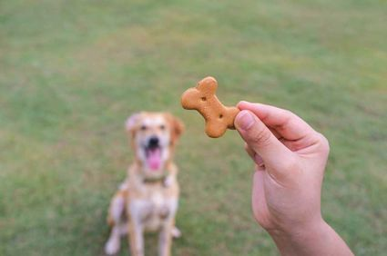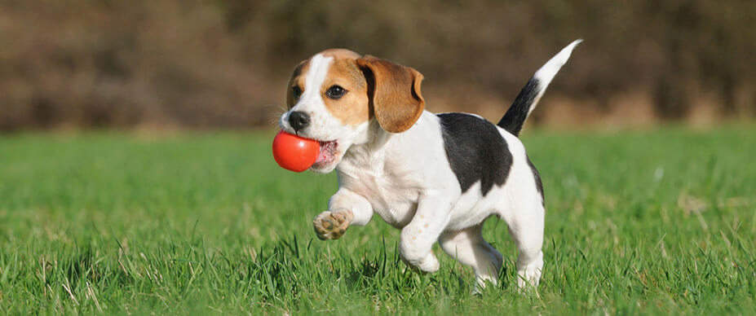

### Machine Learning Algorithm Selection **

* The flow chart is used to show the selection of Machine learning algorithm based on the data.
* It is clear from the flow chart that the three major kinds of algorithms are considered as important in the machine learning.
* It is the responsibility of Data Scientist to select an appropriate ML algorithm to provide an accurate result for the relevant problem.

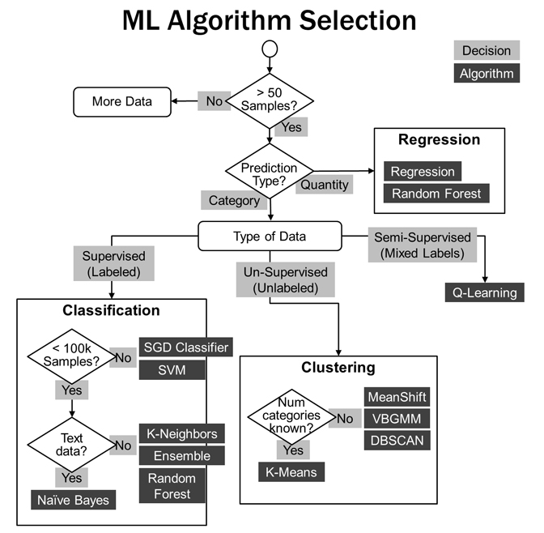

### Cross Industry Standard Process for Data Mining (CRISP-DM)

* Developed in 1996
* Fits data mining into the general problem-solving strategy of business/ research unit
* Industry, tool and application neutral
* Data mining projects follow iterative, adaptive life cycle consisting of 6 phases
* Iterative **CRISP-DM** process is shown in outer circle
* Most significant dependencies between phases shown
* Next phase depends on results from preceding phase
* Returning to earlier phase possible before moving forward

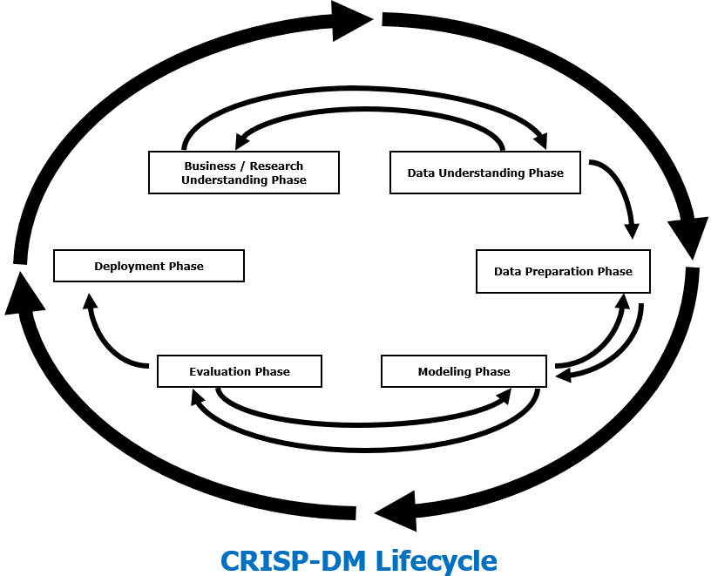

1. **Business/ Research Understanding Phase**

* Define project requirements and objectives
* Translate objectives into data exploration problem definition
* Prepare preliminary strategy to meet objectives

1. **Data Understanding Phase**

* Collect data
* Perform exploratory data analysis (EDA)
* Assess data quality
* Optionally, select interesting subsets

1. **Data Preparation Phase**

* Prepares for modelling in subsequent phases
* Select cases and variables appropriate for analysis
* Cleanse and prepare data so it is ready for modeling tools
* Perform transformation of certain variables, if needed

1. **Modelling Phase**

* Select and apply one or more modelling techniques
* Calibrate model settings to optimize results

1. **Evaluation Phase**

* Evaluate one or more models for effectiveness
* Determine whether defined objectives achieved
* Make decision regarding data exploration results before deploying to field

1. **Deployment Phase**

* Make use of models created
* Simple deployment example: generate report
* Complex deployment example: implement parallel data exploration effort in another department
* In businesses, customer often carries out deployment based on your model

## Week 2 – Underfitting & Overfitting

### Classification & Regression **

* In classification, the goal is to predict a **class label**, which is a choice from a predefined list of possibilities.
* We used an example of classifying **irises** into one of three possible species.
* Classification is separated into **binary classification**, which is the special case of distinguishing between exactly two classes, and **multiclass classification**, which is classification between more than two classes.
* We can think of binary classification as trying to answer a **yes/no** question.
* Classifying emails as either **spam or not spam** is an example of a binary classification problem.
* In this binary classification task, the **yes/no question** being asked would be “Is this email spam?”
* A clear way to distinguish between classification and regression tasks is to ask whether there is some kind of continuity in the output.
* If there is continuity between possible outcomes, then the problem is a regression problem.
* Think about predicting annual income. There is a clear continuity in the output.
* Whether a person makes $40,000 or $40,001a year does not make a tangible difference, even though these are different amounts of money; if our algorithm predicts $39,999 or $40,001 when it should have predicted $40,000, we don’t mind that much.
* If we consider the language of a website (which is a classification problem), there is no matter of degree. A website is in one language, or it is in another. There is no continuity between languages, and there is no language that is **between** English and French.

### Generalisation, Overfitting & Underfitting

* In supervised learning, we want to build a model on the training data and then be able to make accurate predictions on new, unseen data that has the same characteristics as the training set that we used.
* If a model is able to make accurate predictions on unseen data, we say that it is able to **generalize** from the training set to the test set.
* In ML models, our objective is to build a model that is able to generalize as accurately as possible.
* If the training and test sets have enough in common, we expect the model to be accurate on the test set.
* However, there are some cases where this can go wrong. For example, if we allow ourselves to build very complex models, we can always be as accurate as we like on the training set.

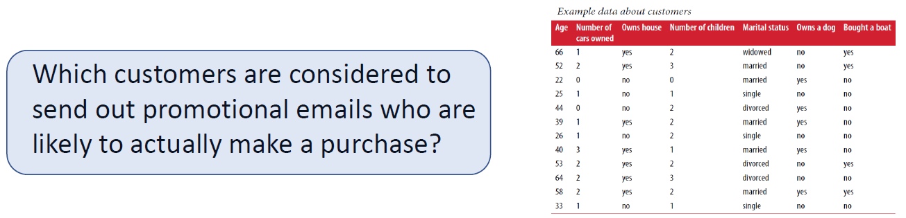

* Let’s take a novice data scientist that wants to predict whether a customer will buy a boat, given records of previous boat buyers and customers that were interested in buying a boat or not.
* The novice data scientist comes up with the following rule:
* **“If the customer is older than 45, and has less than 3 children or is not divorced, then they want to buy a boat.”**
* When asked how well this rule of his does, the data scientist answers, “It’s 100 percent accurate!” On the data present in the table, the rule is perfectly accurate.
* As the age data appears only once, we could say people who are 66, 52, 53, or 58 years old want to buy a boat, while all others don’t. We are not interested in making predictions for this dataset as It is clear from this dataset.
* **We want to know if new customers are likely to buy a boat.**
* We need to find a rule that will work well for new customers, and achieving 100 percent accuracy on the training set does not help us there.
* It seems too complex, and it is supported by very little data. For example, the “or is not divorced” part of the rule hinges on a single customer.

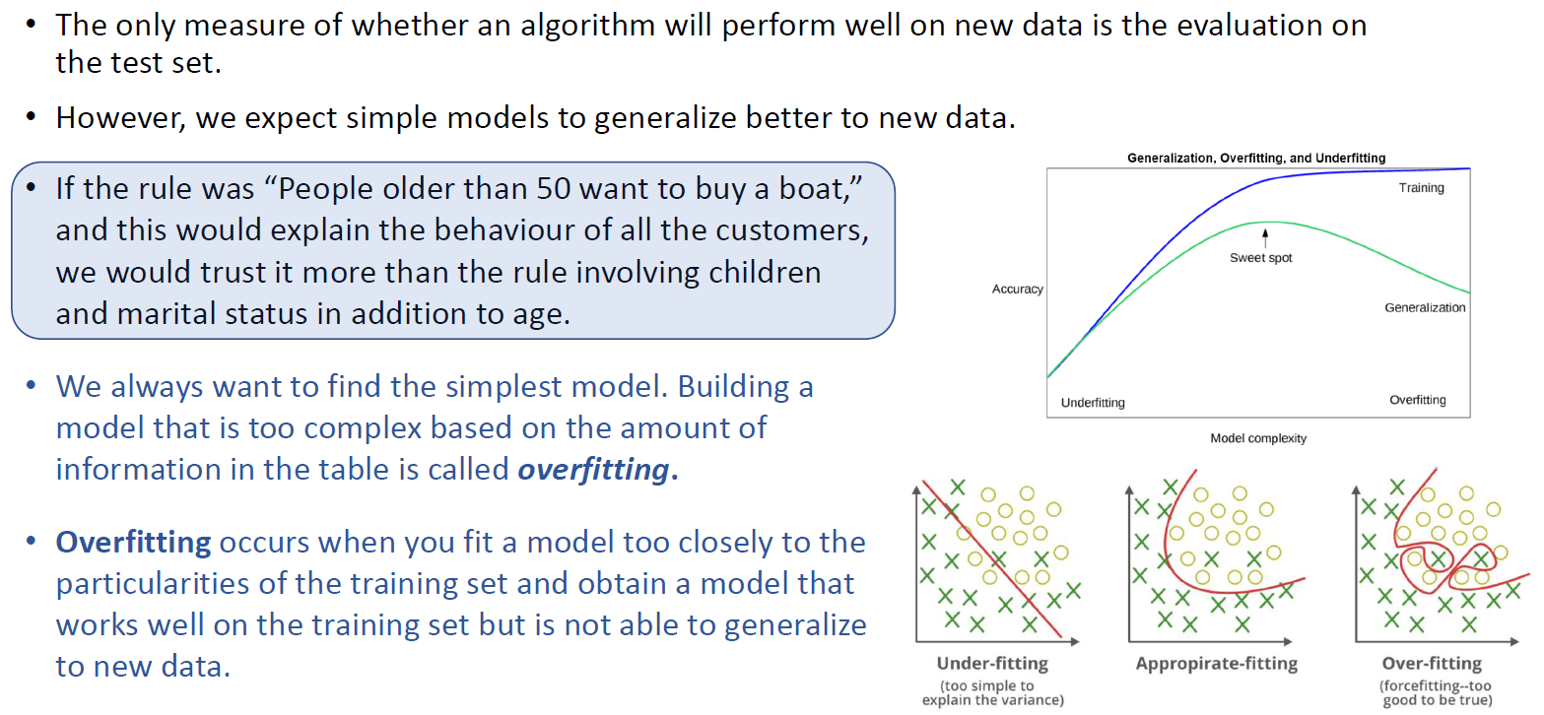

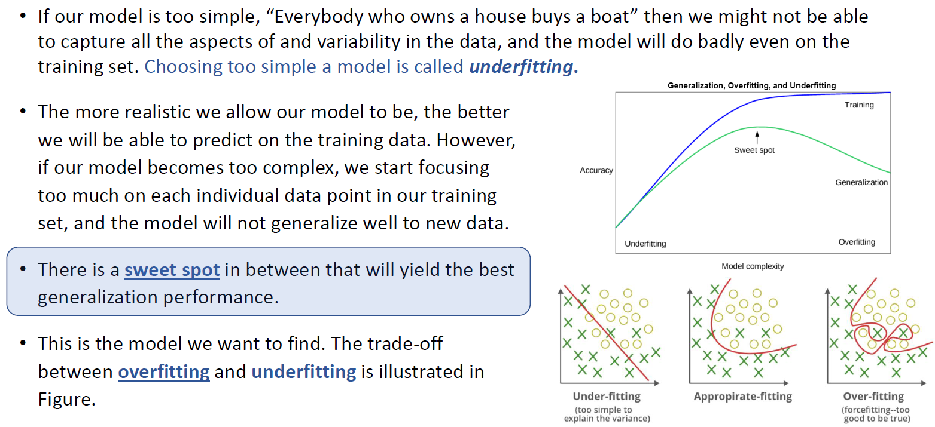

### Relation of Model Complexity to Dataset Size

* It’s important to note that model complexity is linked with the variation of **inputs contained in your training dataset:** If the dataset contains a larger variety of data points, we can construct a more realistic and complex ML model without overfitting.
* The more complex models can be formed appropriately in the case of supervised learning tasks having more data.
* In the real world, we have the ability to decide how much data to collect, which might be more beneficial than tweaking and tuning our model.
* Based on the conceptual understanding of Underfitting and Overfitting, Machine Learning modellers should check the model complexity to the available side of the data.

## Week 2 - Classification using Decision Trees & Random Forests (RF)

**Classification:**

Classification is a subcategory of supervised learning in which the goal is to predict the categorical class labels of new instances based on past observations

**Regression**

Regression is another subcategory of supervised learning used in the prediction of continuous outcomes. In regression, we are given a number of predictor (explanatory) variables and a continuous response variable (outcome or target), and we try to find a relationship between those variables that allows us to predict an outcome

### Classification

### Classification Methods

**Given a collection of records (training set)**

Each record is characterized by a tuple (x, y), where x is the attribute set and y is the class label

* x: attribute, predictor, independent variable, input
* y: class, response, dependent variable, output

**Base Classifiers**

* Decision Tree based Methods
* Rule-based Methods
* Nearest-neighbor
* Neural Networks
* Naïve Bayes and Bayesian Belief Networks
* Support Vector Machines

**Ensemble Classifiers**

* Boosting
* Bagging
* Random Forests

**Task**

* Learn a model that maps each attribute set **x** into one of the predefined class labels y

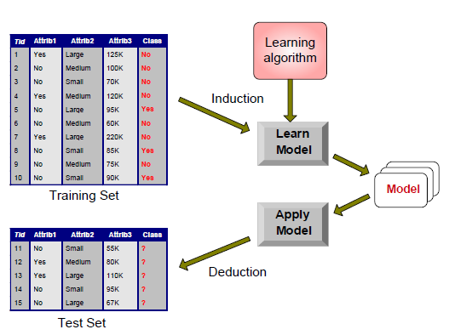

### Example

* Decision trees are widely used models for classification and regression tasks. They learn a hierarchy of if/else questions, leading to a decision.
  + These questions are similar to the questions that you might ask in a game of 20 Questions.
  + Suppose you want to distinguish between the following four animals: bears, hawks, penguins, and dolphins.
  + Your goal is to get to the right answer by asking as few if/else questions as possible. You might start off by asking whether the animal has feathers, a question that narrows down your possible animals to just two.
  + If the answer is “yes,” you can ask another question that could help you to distinguish between hawks and penguins.
  + For example, you could ask whether the animal can fly. If the animal doesn’t have feathers, your possible animal choices are dolphins and bears, and you will need to ask a question to distinguish between these two animals. For example, asking whether the animal has fins.

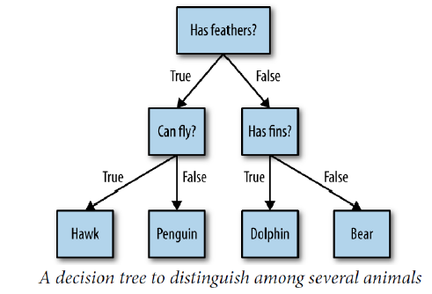

* In this illustration, each node in the tree either represents a question or a terminal node (also called a leaf) that contains the answer.
* The edges connect the answers to a question with the next question you would ask.

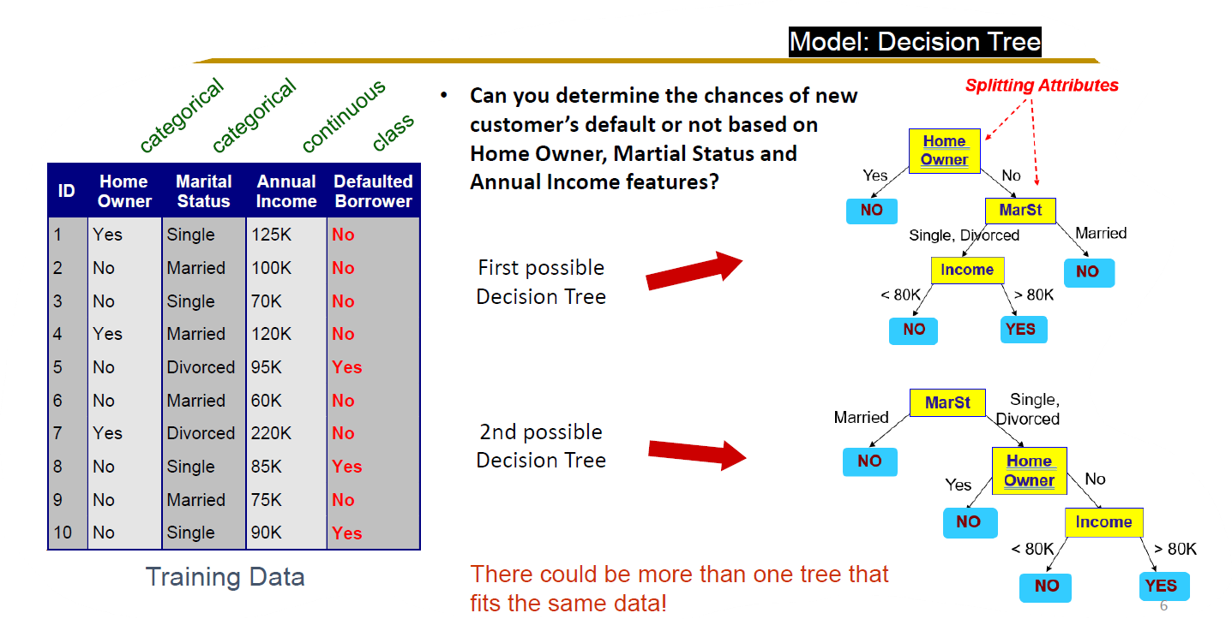

*We don’t care about unique value columns in ML*

**Categorical data:** Categorical data represent characteristics such as a person’s gender, marital status, hometown, or the types of movies they like. Categorical data can take on numerical values (such as “1” indicating male and “2” indicating female), but those numbers don’t have mathematical meaning. You couldn’t add them together, for example. (Other names for categorical data are qualitative data, or Yes/No data.)

**Ordinal data** mixes numerical and categorical data. The data fall into categories, but the numbers placed on the categories have meaning. For example, rating a restaurant on a scale from 0 (lowest) to 4 (highest) stars gives ordinal data. Ordinal data are often treated as categorical, where the groups are ordered when graphs and charts are made. However, unlike categorical data, the numbers do have mathematical meaning. For example, if you survey 100 people and ask them to rate a restaurant on a scale from 0 to 4, taking the average of the 100 responses will have meaning. This would not be the case with categorical data.

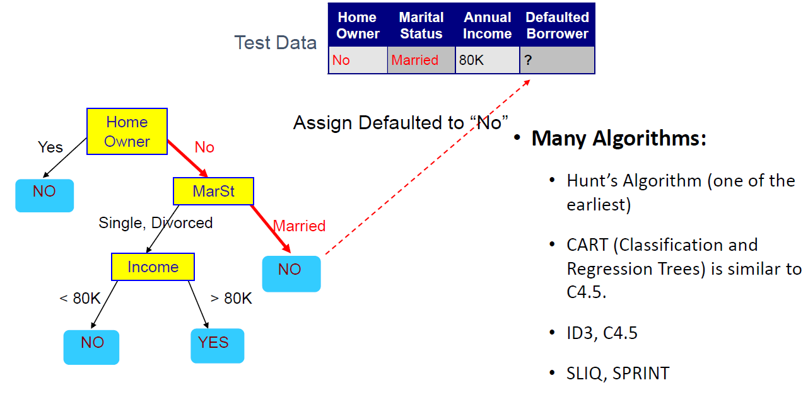

### Algorithms

* **Hunt’s Algorithm:** A decision tree is grown in a recursive fashion by partitioning the training records into successively purer subsets.
* **Classification and Regression Tree (CART):** It constructs the tree using binary splitting, which we will discuss in detail shortly.
* **Iterative Dichotomiser 3 (ID3):** This algorithm uses a greedy search in a top-down manner by selecting the best attribute to split the dataset on each iteration without backtracking.
* **C4.5:** An improved version on ID3 that introduces backtracking; it traverses the constructed tree and replaces branches with leaf nodes if purity is improved this way.
* **CHi-squared Automatic Interaction Detector (CHAID):** This algorithm is used in direct marketing. It involves complicated statistical concepts, but basically determines the optimal way of merging predictive variables in order to best explain the outcome.
* **SLIQ:** A Fast Scalable Classifier for Data Mining

### Hunt’s Algorithm

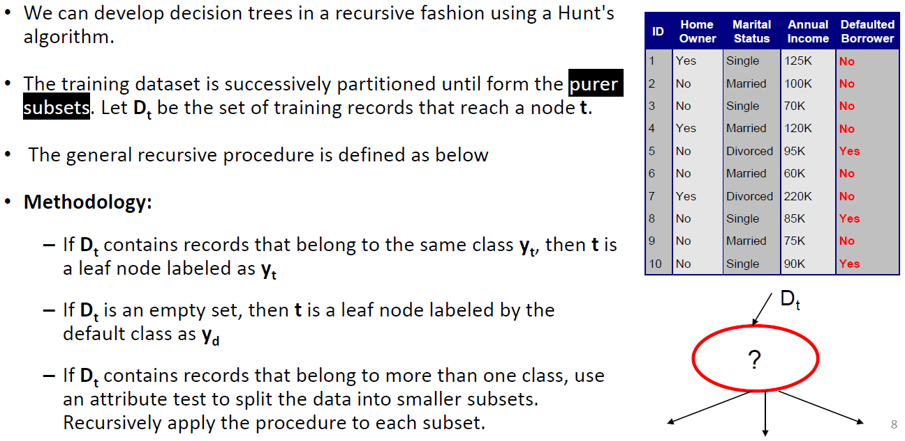

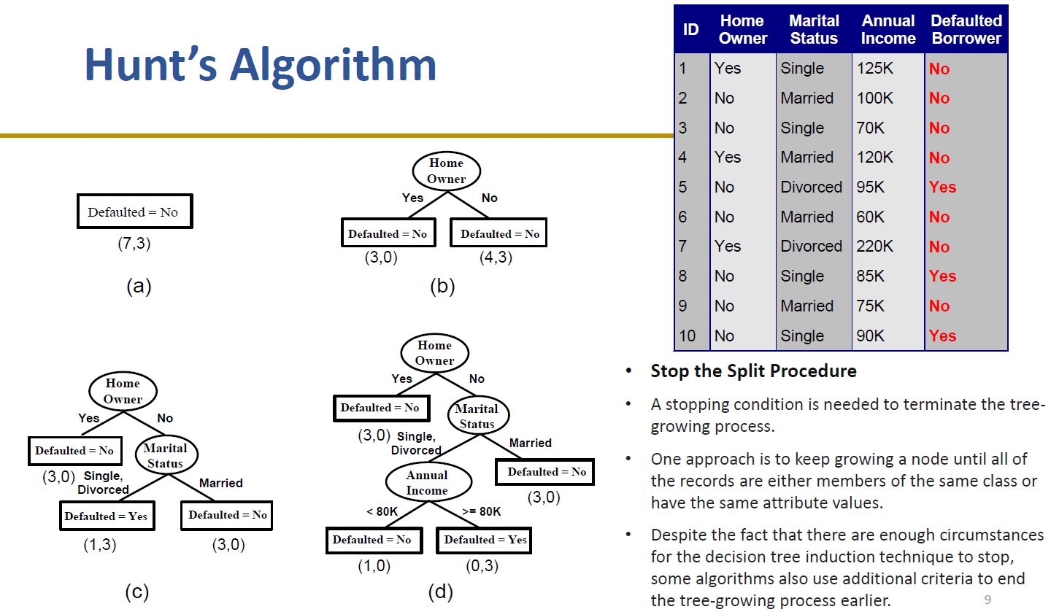

**Example:**

* Home Owner = “No” –> Count = 7
* Home Owner = “No” AND Defaulted Borrower = “No” –> Count = 4
* Home Owner = “No” AND Defaulted Borrower = “Yes” –> Count = 3

### Node Splitting (Splitting)

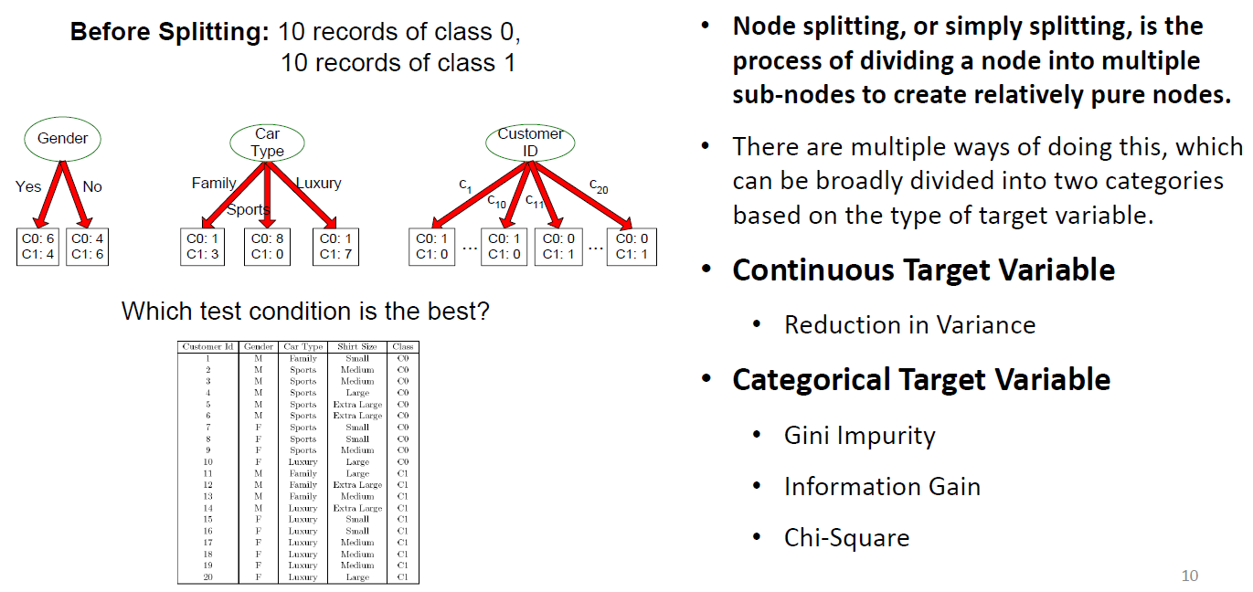

#### Measures of Node Impurity

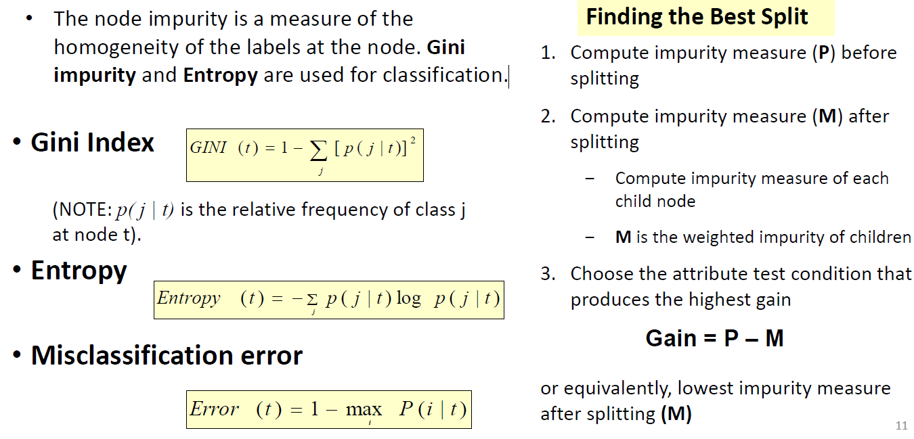

The node impurity is **a measure of the homogeneity of the labels at the node**. The current implementation provides two impurity measures for classification (Gini impurity and entropy) and one impurity measure for regression (variance).

##### GINI

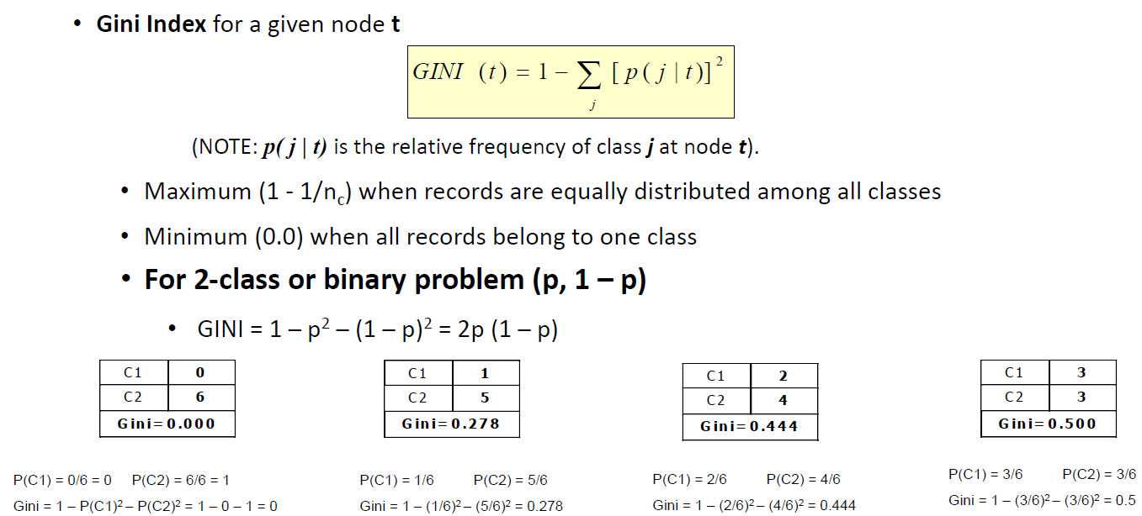

C = Class

* The goal is to keep trying to reduce the Gini as close to 0 as possible, in that instances all records belong to one class
* With a decision tree the Gini is calculated before and after separating, if a gain exists we can separate/split further
* The highest Gini value = 0.5

###### Calculation of GINI Index

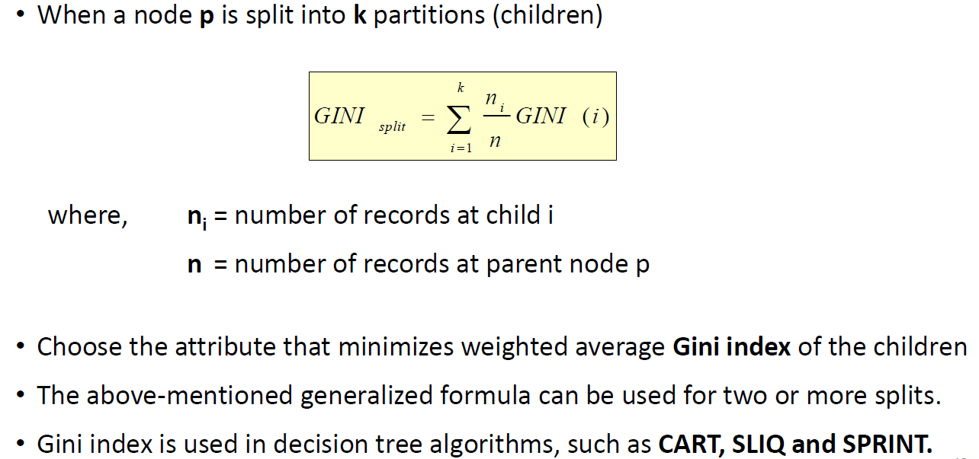

Binary Attributes

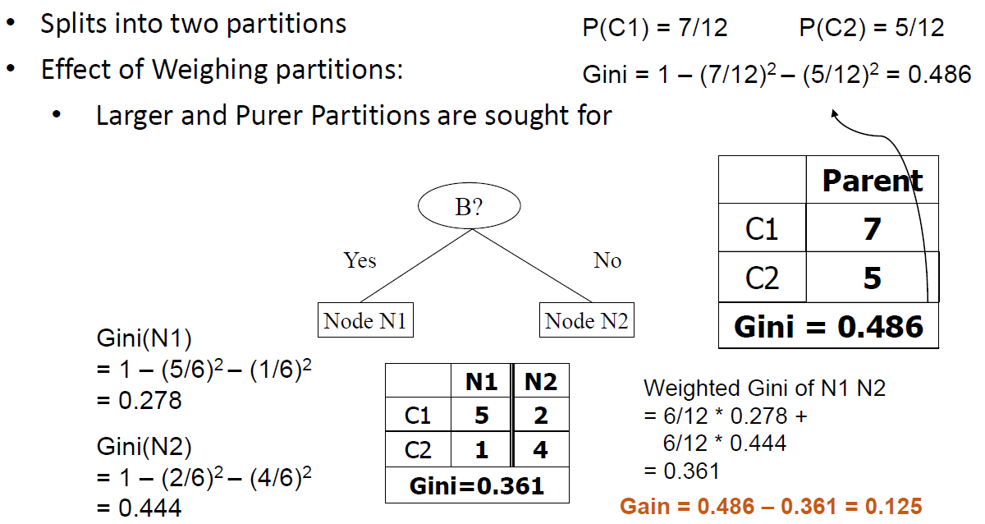

* The splits themselves aren’t decided by you, the model shows what the split is
* Then you calculate if splitting actually provides a gain in terms of Gini
* Whilst a gain exists, keep going, you want to get to ‘0’ or as close as possible to 0

Gain after splitting = 0.486 – 0.361 = 0.125

###### Calcaultion of Error – Single Node

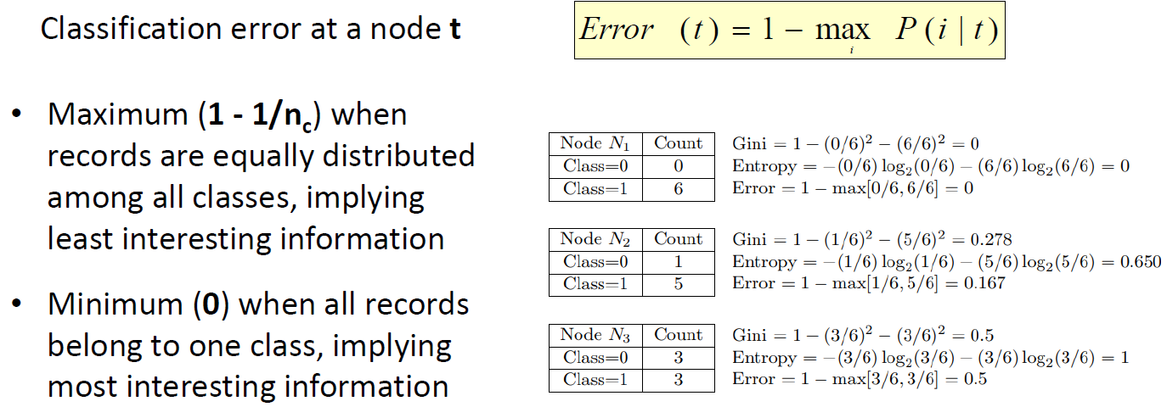

##### Comparison – Impurity Measures

For a 2-class problem:

* The Gini Index and the Entropy have two main differences
* Gini Index has values inside the interval [0, 0.5] whereas the interval of the Entropy is [0, 1].
* Misclassification error has also values in the interval [0, 0.5].
* Ensure you know what high/low values are based on what methods you use
* Gini & miscalculation = 0.5
* Entropy = 1

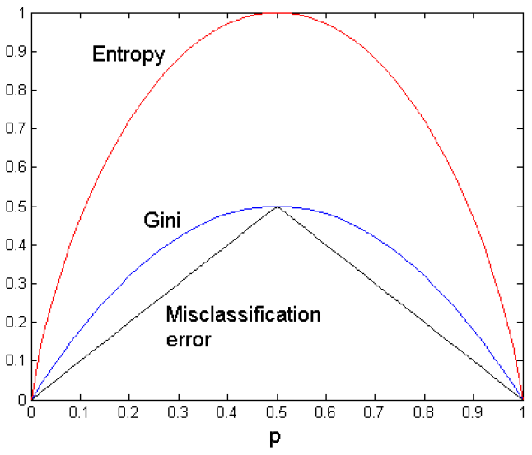

### Limitations Single Attribute-based Decision Boundaries

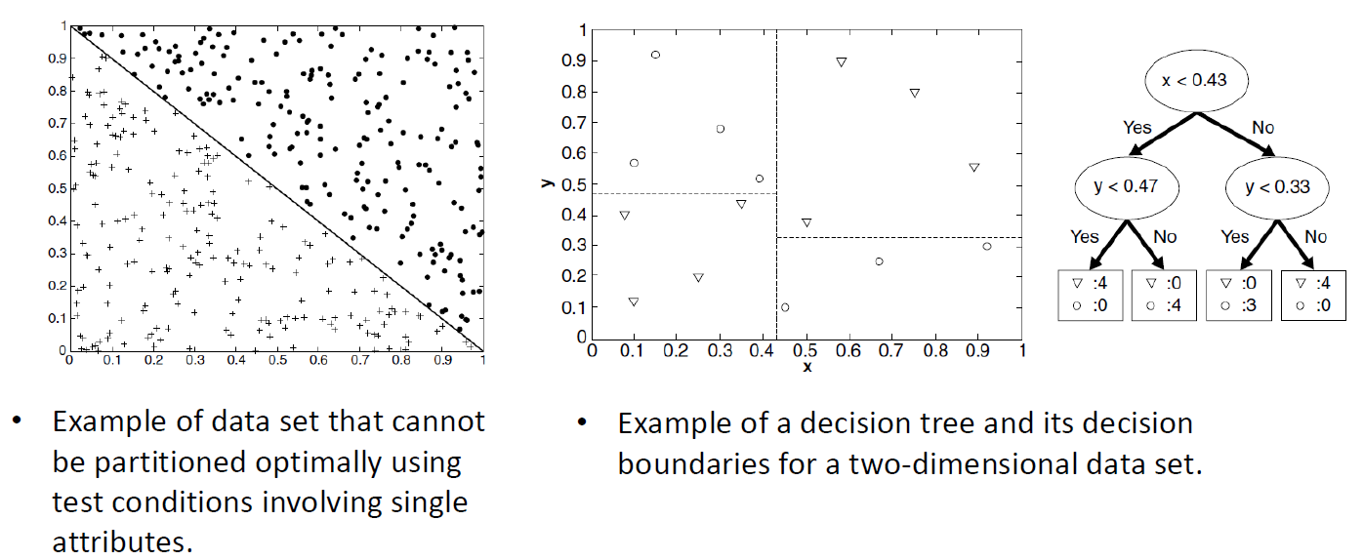

Consider that you want to divide a one-dimensional dataset of people's ages into two categories: "Young" and "Old." However, because of the age distribution, there is a significant amount of overlap between the two classifications. For example, Ages between 20 and 35 comprise the "young" class. Ages between 30 and 60 comprise the "Old" class. It is difficult to determine the best split in this dataset if you try to use a single threshold or test condition on age to divide the two classes: If you set the cutoff at 35, some people who are considered "Young" will actually be considered "Old.“ If you use 30 as the cutoff, some people who are considered "Old" will actually be considered "Young."

### Requirements for Usage – Decision Trees

* Decision Tree is supervised classification method
* The target variable must be categorical
* Pre-classified target variable must be included in the training set
* Decision trees learn by example, so training set should contain records with varied attribute values
* If the training set systematically lacks definable subsets, classification becomes problematic
* There are different measures for leaf node purity
* Classification and Regression Trees (CART)and C4.5are two leading algorithms used in the machine learning
* Information Gain
* C4.5’s uses Information Gain
* gain(S) = H(T) – HS(T)
* Represents increase in information by partitioning training data T according to candidate split S
* For each candidate split, C4.5 chooses split that has maximum information gain, gain(S)
* Example
* C4.5 illustrated with example

 CART algorithm uses Gini Index criterion to split a node to a sub-node. It start with the training set as a root node, after successfully splitting the root node in two, it splits the subsets using the same logic & again split the sub-subsets, recursively until it finds further splitting will not give any pure sub-nodes or maximum number of leaves in a growing tree or termed it as a Tree pruning.

### Classification & Regression Trees

* In machine learning, pruning is a data compression technique that shrinks the size of decision trees by eliminating parts of the tree that are unnecessary and redundant for classifying instances.
* Pruning is a method for getting rid of the Decision Tree's components that keep it from developing to its maximum depth. The portions of the tree that lack the ability to classify instances are the portions that are removed. Pruning is crucial because training a decision tree to its maximum depth will certainly result in overfitting the training set.
* **To put it simply, Decision Tree Pruning aims to build an algorithm that performs worse on training data but performs better on test data in terms of generalization.**
* There are two common strategies to prevent overfitting
* Stopping the creation of the tree early (also called pre-pruning)
* Building the tree but then removing or collapsing nodes that contain little information (also called post-pruning or just pruning).
* Possible criteria for pre-pruning include limiting the maximum depth of the tree, limiting the maximum number of leaves, or requiring a minimum number of points in a node to keep splitting it

### Decision Tree Based Classification

#### Advantages

* Inexpensive to construct
* Extremely fast at classifying unknown records
* Easy to interpret for small-sized trees
* Robust to noise (especially when methods to avoid overfitting are employed)
* Can easily handle redundant or irrelevant attributes (unless the attributes are interacting)

#### Disadvantages

* Space of possible decision trees is exponentially large. Greedy approaches are unable to find the best tree
* Does not take into account interactions between attributes
* Each decision boundary involves only a single attribute 20

### Ensemble Classifiers

**Types of Ensemble Methods**

* Manipulate data distribution
  + Example: **bagging, boosting**
* Manipulate input features
  + Example: **random forests**
* Manipulate class labels
  + Example: **error-correcting output coding**
* In ML, multiple instances of the same model are trained on various subsets of the training data using the ensemble technique known as **bagging (Bootstrap Aggregating)**, and then the predictions from all of the instances are combined to get the final prediction. The procedure of **bootstrapping** is used to produce the data subsets from random sampling with replacement.
* In boosting, the weak learners are instructed one after the other while concentrating on the errors of the prior learners. In boosting, each repetition gives the misclassified cases more weight.

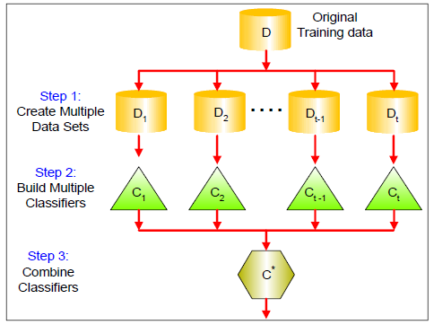

### Random Forest (RF)

* Random Forest is a supervised learning algorithm. It can be used both for Classification and Regression.
* A forest is comprised of trees. It has been observed that more trees can form a forest rapidly.
* Random forest creates decision trees on randomly selected data samples, gets prediction from each tree and selects the best solution by means of voting.
* It also provides a pretty good indicator of the feature importance.
* Random forests have a variety of applications, such as recommendation engines, image classification and feature selection.
* It can be used to classify loyal loan applicants, identify fraudulent activity and predict diseases.

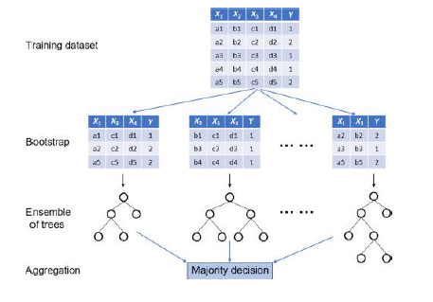

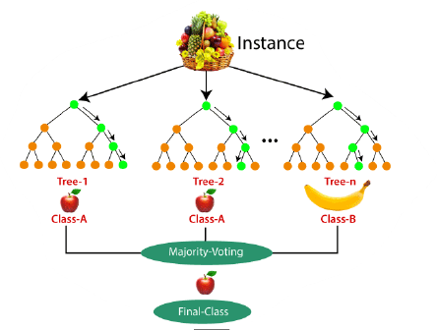

The **Boruta algorithm** is a wrapper built around the random forest classification **algorithm**. It tries to capture all the important, interesting features you might have in your dataset with respect to an outcome variable. First, it duplicates the dataset, and shuffle the values in each column.

The sklearn.ensemble module includes two averaging algorithms based on randomized decision trees: the RandomForest algorithm and the Extra-Trees method. Both algorithms are perturb-and-combine techniques [B1998] specifically designed for trees. This means a diverse set of classifiers is created by introducing randomness in the classifier construction. The prediction of the ensemble is given as the averaged prediction of the individual classifiers.

#### Example

* Suppose you want plan a trip and you would like to travel to a specific destination but not sure.
* How to find a place that you will like? You can search online, read reviews on travel blogs and portals, or you can also ask to your friends.
* Let’s suppose you have decided to ask your friends and talked with them about their past travel experience to various places. You will get some recommendations from every friend. Now you have to make a list of those recommended places. Then, you ask them to vote (or select one best place for the trip) from the list of recommended places you made. The place with the highest number of votes will be your final choice for the trip.
* In the above decision process, there are two parts. **First**, asking your friends about their individual travel experience and getting one recommendation out of multiple places they have visited.
* This part is like using the decision tree algorithm. In this scenario, each friend makes a selection of the places he or she has visited so far.
* **The second part**, after collecting all the recommendations, is the voting procedure for selecting the best place in the list of recommendations. This whole process of getting recommendations from friends and voting on them to find the best place is known as the random forest algorithm.

#### Random Forst Algorithm **

It works in four steps:

1. Select random samples from a given dataset.
2. Construct a decision tree for each sample and get a prediction result from each decision tree.
3. Perform a vote for each predicted result.
4. Select the prediction result with the most votes as the final prediction.

#### Random Forests vs Decision Trees **

* Random Forests are a set of multiple decision trees.
* Deep decision trees may suffer from overfitting, but the random forests prevent overfitting by creating trees on random subsets.
* Decision trees are computationally faster.
* Random forests are difficult to interpret, while a decision tree is easily interpretable and can be converted to rules.

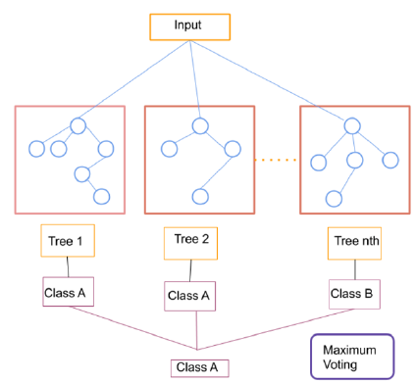

### Classification Reports

The classification report contains metrics that help evaluate the performance of a classification model. Here is a breakdown of each column header:

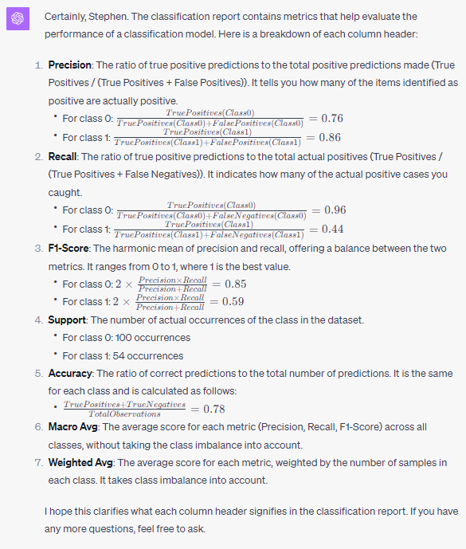

## Week 3 – Linear Models for Regression & Classification

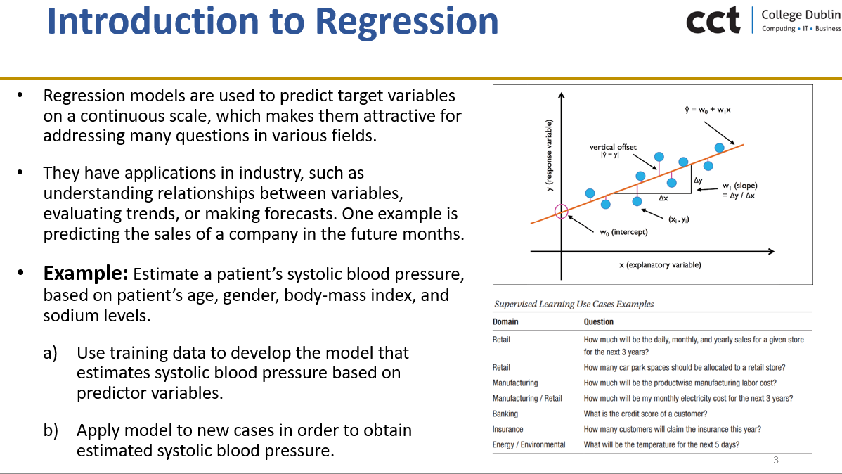

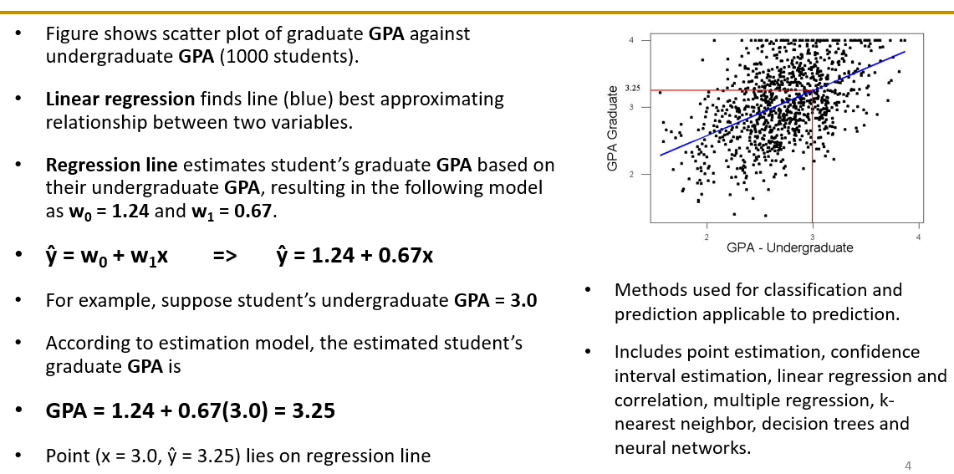

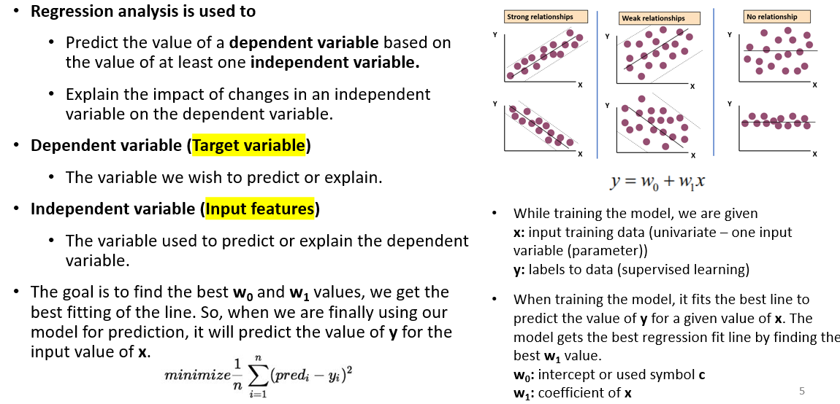

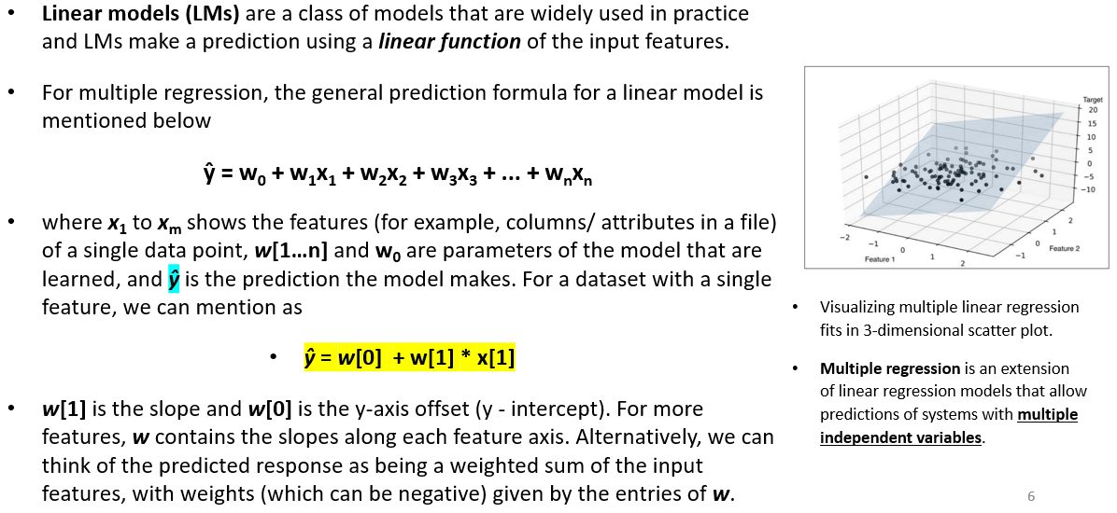

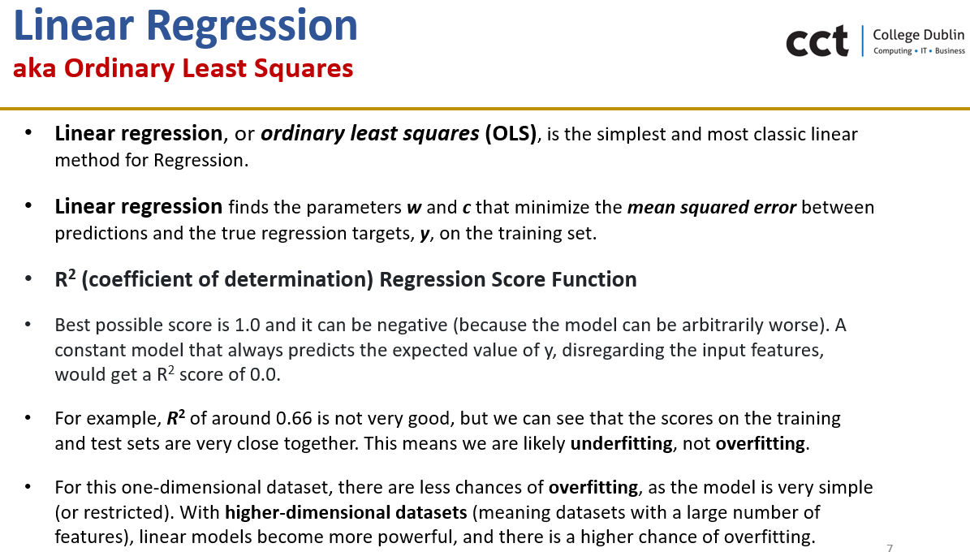

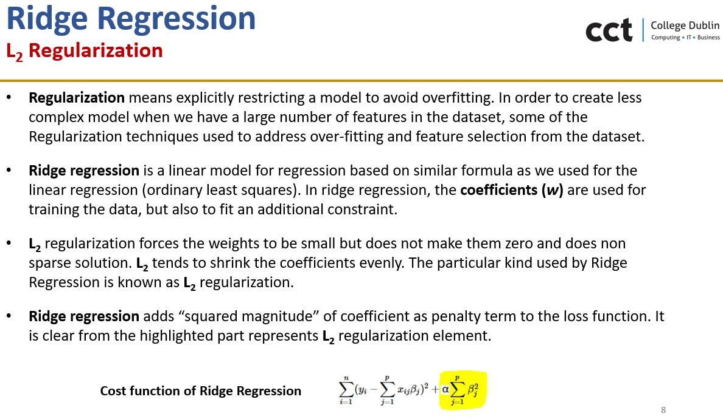

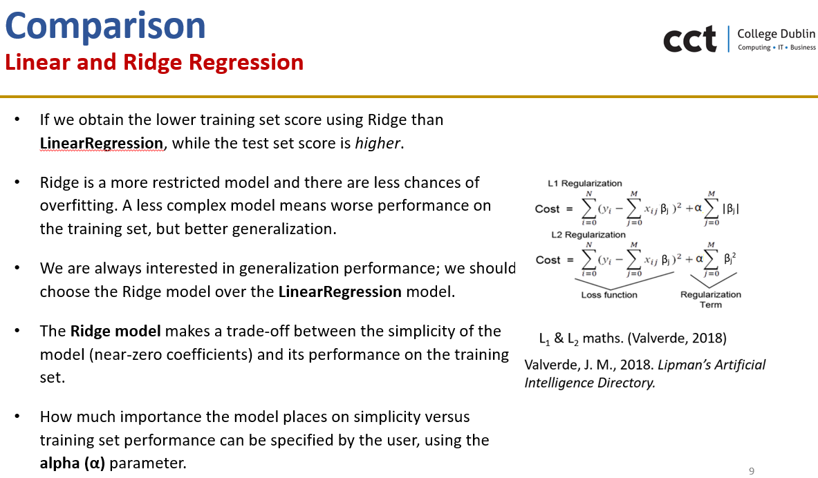

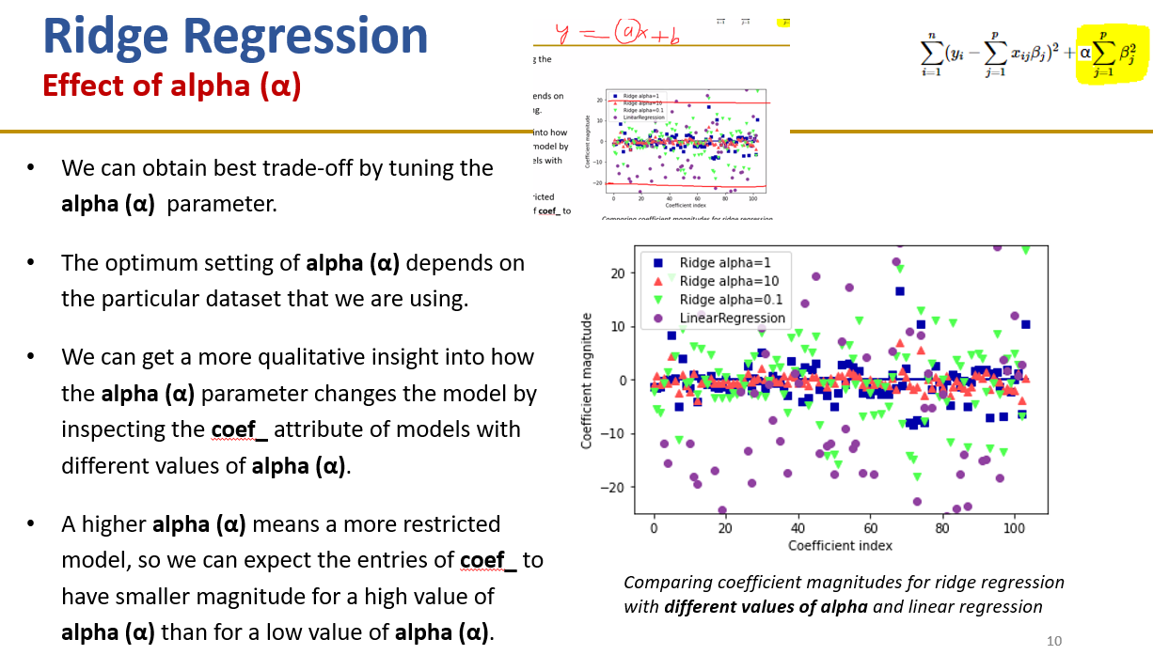

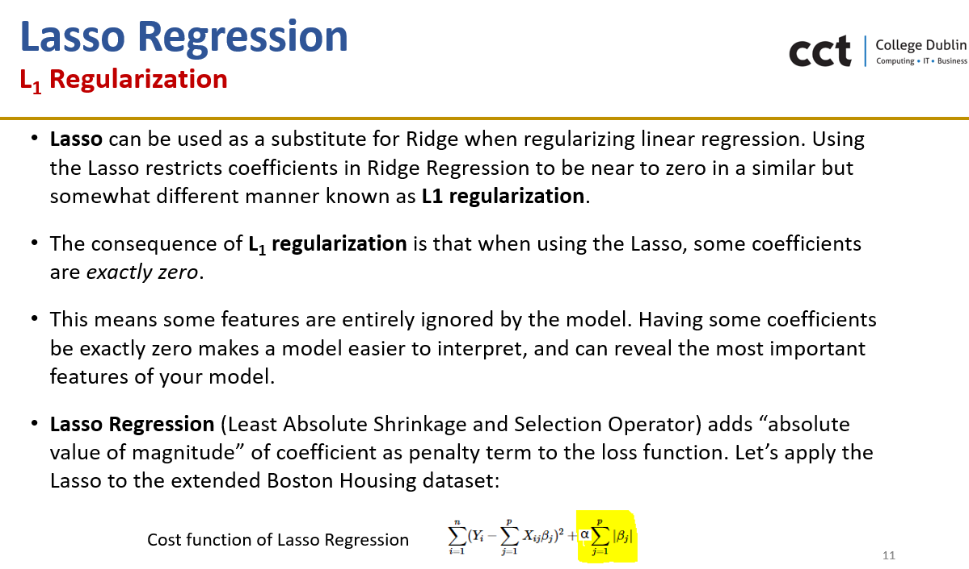

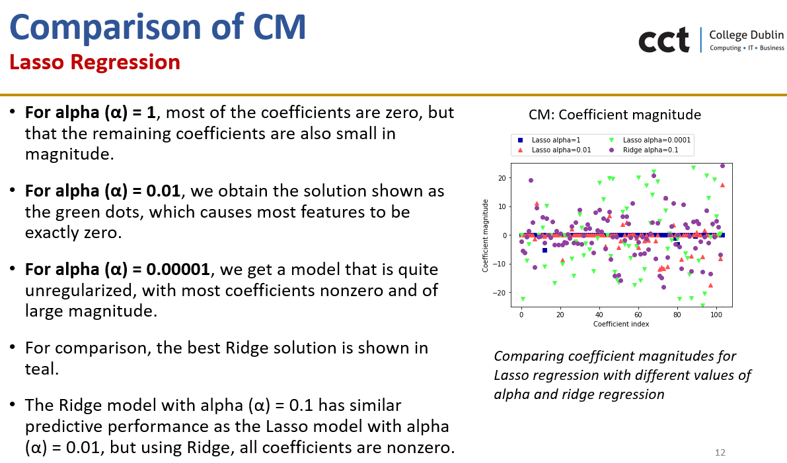

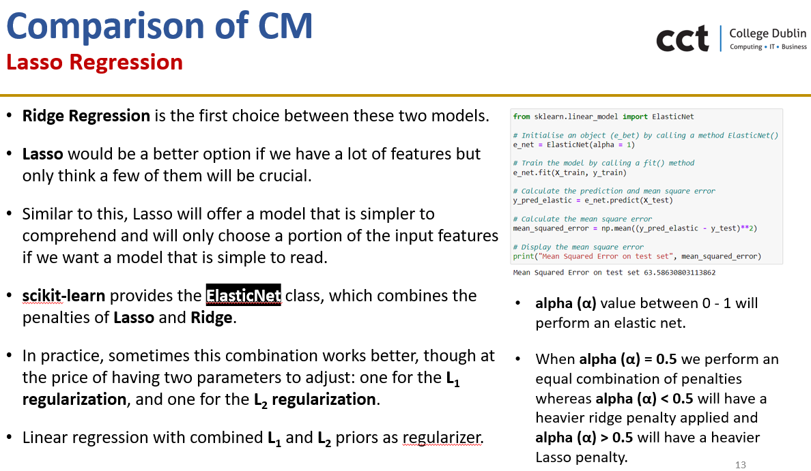

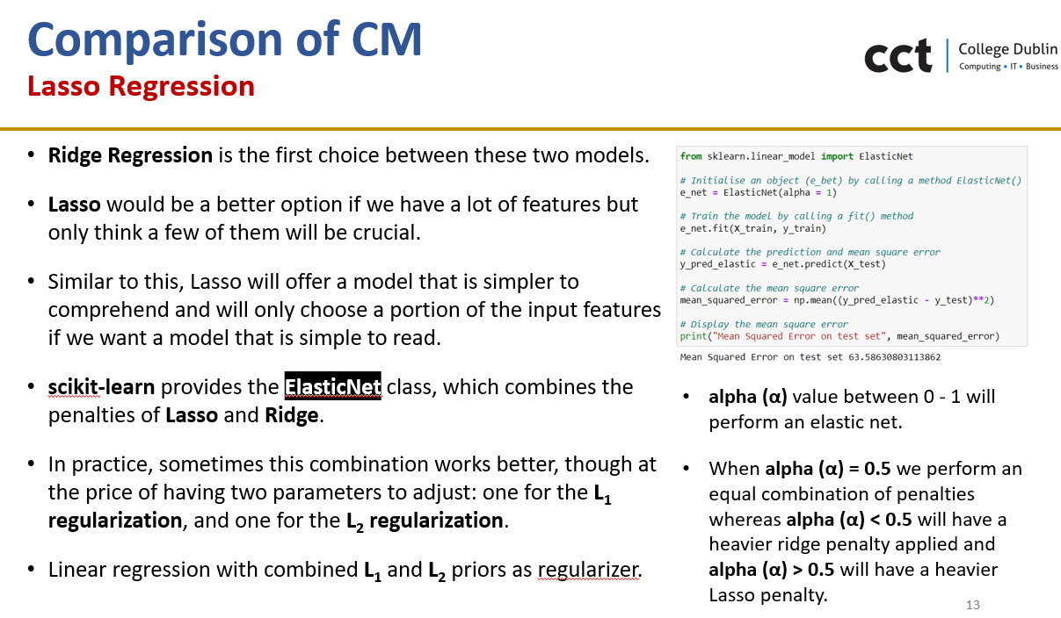

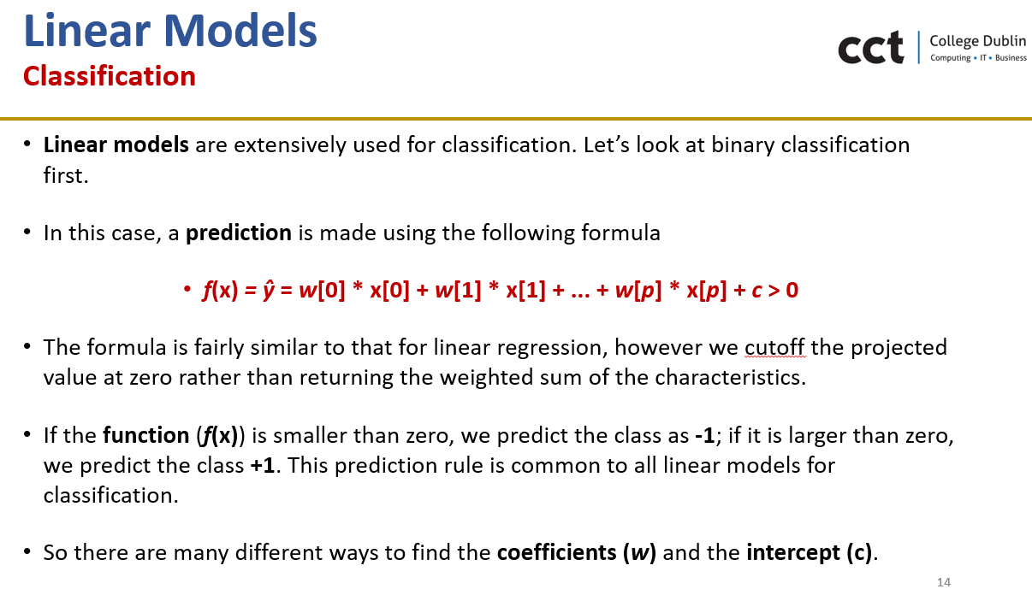

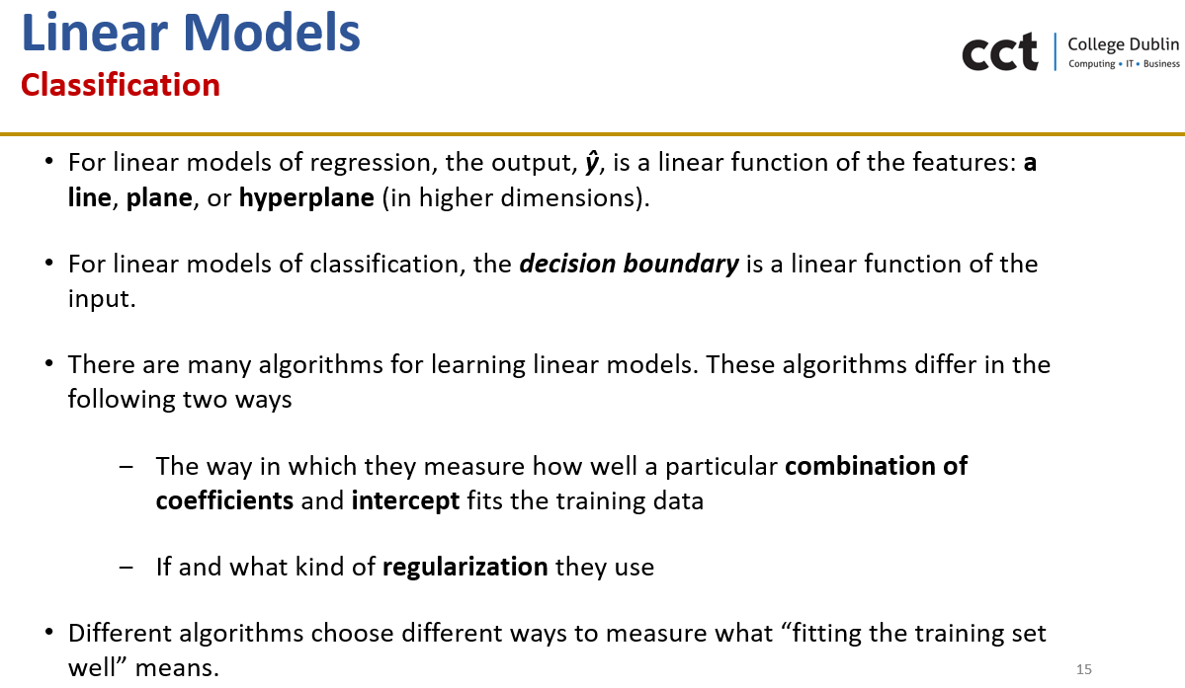

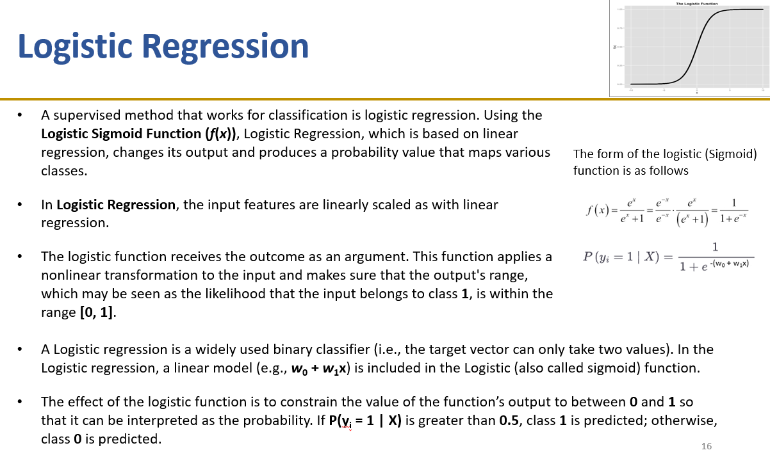

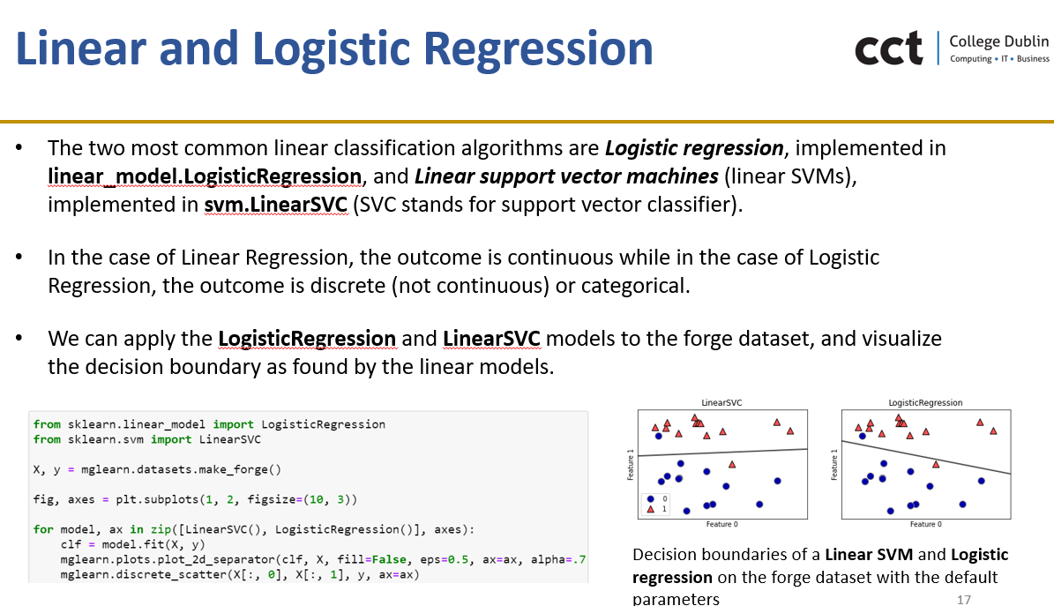

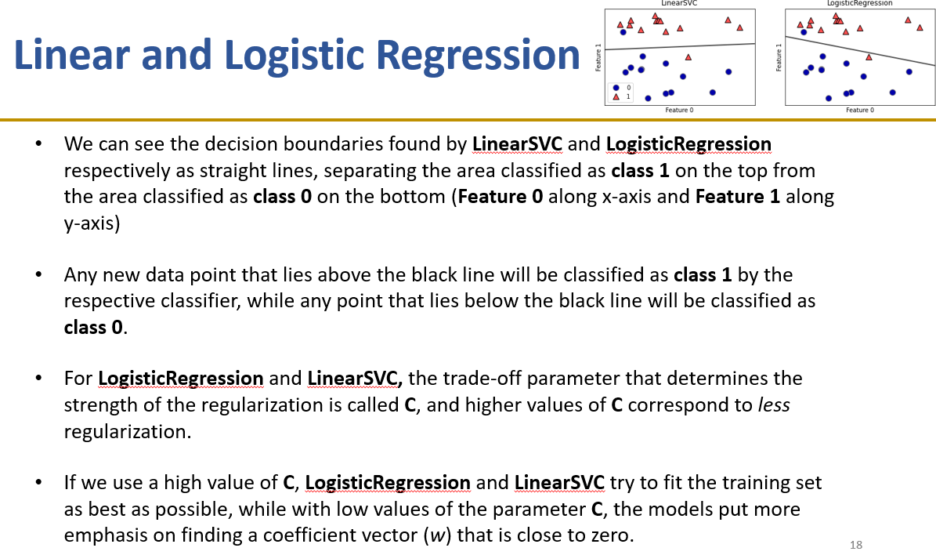

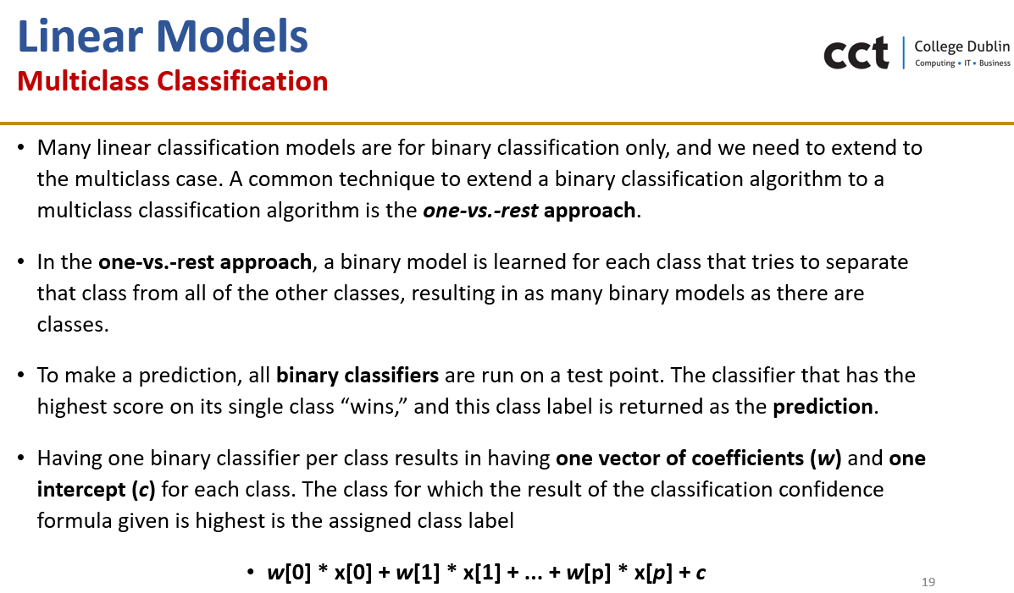

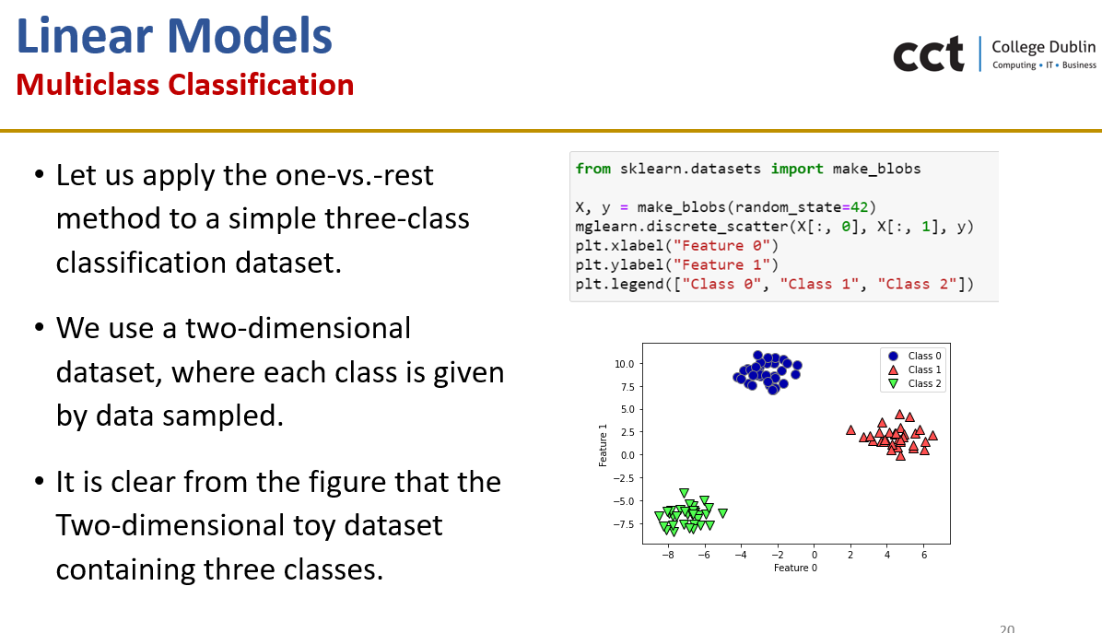

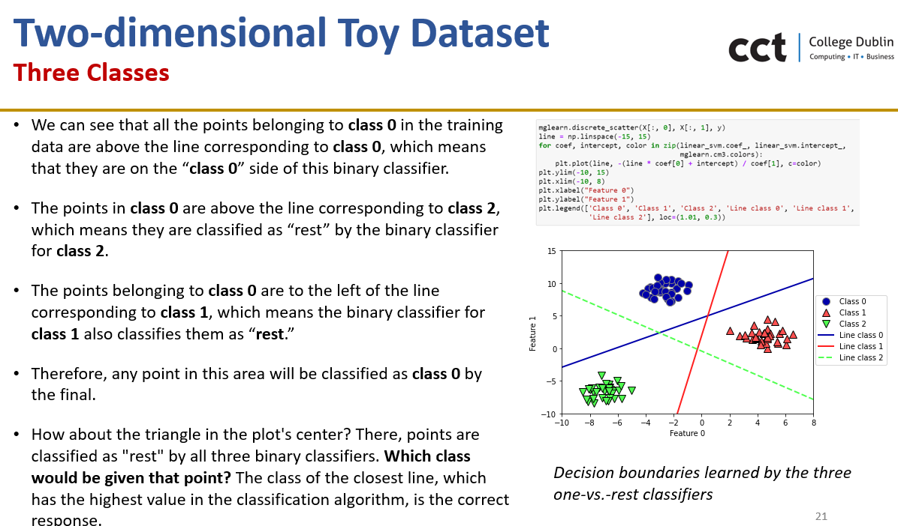

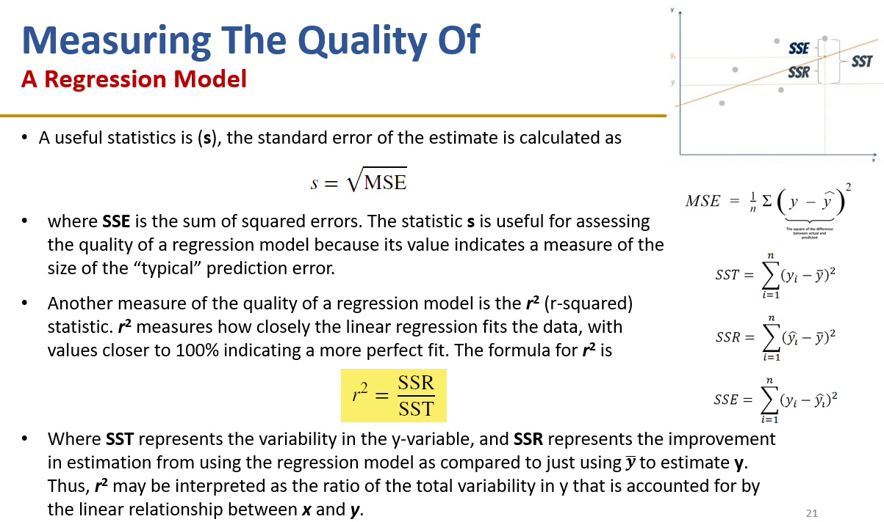

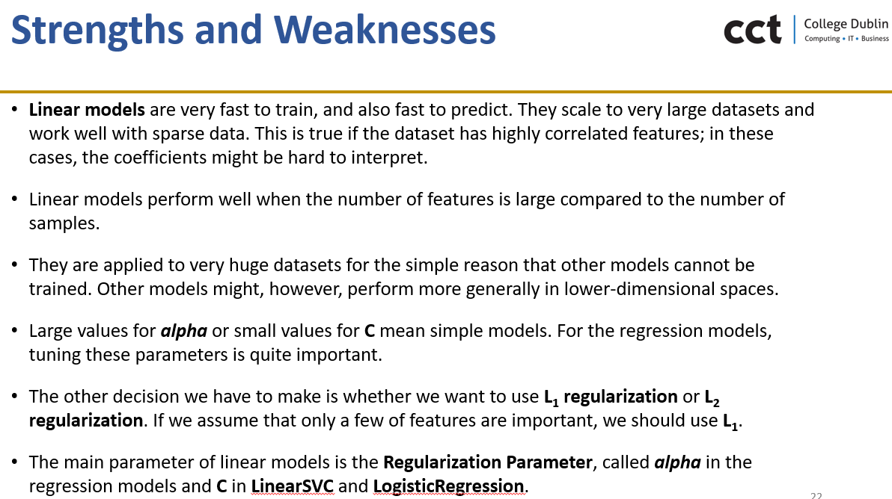

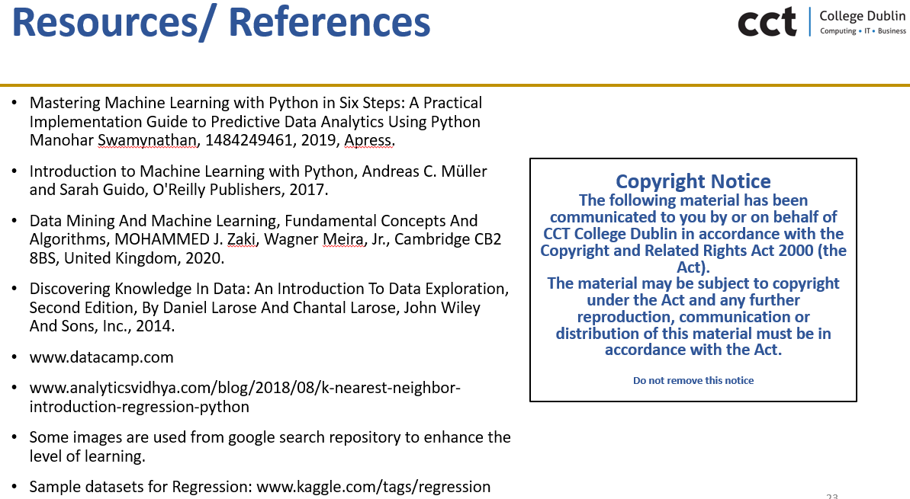

## Week 3 – Lasso

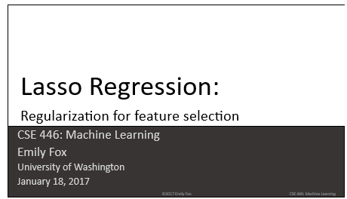

|  |
| --- |
| Feature selection task |
| ©2017 Emily Fox CSE 446: Machine Learning |

CSE 446: Machine Learning

3

E

ffi

ciency:

-

If size(

w

= 100B, each prediction is expensive

)

-

If

ŵ

sparse , computation only depends on # of non-zeros

Interpretability:

-

Which features are relevant for prediction?

Why might you want to perform

feature selection?

©2017 Emily Fox



many zeros

=



X

ˆ

*w*

*j*

6

=0

ŷ

i

=

ŵ

j

h

j

(

x

i

)

4

Sparsity

:

Housing application



$ ?

Lot size

Single

Family

Year

built

Last sold price

Last sale price/

sq?

Finished

sq?

Unfinished

sq?

Finished basement

sq?

# floors

Flooring types

Parking type

Parking amount

Cooling

HeaIng

Exterior materials

Roof type

Structure style

Dishwasher

Garbage disposal

Microwave

Range / Oven

Refrigerator

Washer

Dryer

Laundry locaIon

HeaIng type

JeVed Tub

Deck

Fenced Yard

Lawn

Garden

Sprinkler System

…

|  |
| --- |
| Option 1: All subsets or greedy variants |
| ©2017 Emily Fox CSE 446: Machine Learning |

Exhaustive approach: “all subsets”

…

…

…

…



Consider all possible models, each using a subset of features

How many models were evaluated?each indexed by features included

yi = εi [0 0 0 … 0 0 0]

yi = w0h0(xi) + εi [1 0 0 … 0 0 0] yi = w1h1(xi)+ εi [0 1 0 … 0 0 0]

yi = w0h0(xi) + w1h1(xi)+ εi [1 1 0 … 0 0 0]

yi = w0h0(xi) + w1h1(xi)+ … + wDhD(xi)+ εi [1 1 1 … 1 1 1]

6

28 = 256 230 = 1,073,741,824

21000 = 1.071509 x 10301 2100B = HUGE!!!!!!

2D

Typically, computationally infeasible

CSE 446: Machine Learning

7

Choosing model complexity?

Option 1: Assess on validation set

Option 2: Cross validation

Option 3+: Other metrics for penalizing model complexity

like BIC…

©2017 Emily Fox

8

Greedy algorithms

Forward stepwise:

Starting from simple model and iteratively add features most useful to fit

Backward stepwise:

Start with full model and iteratively remove features least useful to fit

Combining forward and backward steps:

In forward algorithm, insert steps to remove features no longer as

important

*Lots of other variants, too.*

|  |
| --- |
| Option 2: Regularize |
| ©2017 Emily Fox CSE 446: Machine Learning |

10

Ridge regression:

*L*

2

regularized regression

Total cost

=

measure of fit

+

λ

measure of magnitude of coe

ffi

cients

RSS(

w

)



||

w

||

2

w

=

0

2

+

…+w

D

2

2

Encourages

small weights

*but not exactly 0*

Using regularization for feature selection

Instead of searching over a discrete set of solutions, can we use regularization?

* Start with full model (all possible features)
* 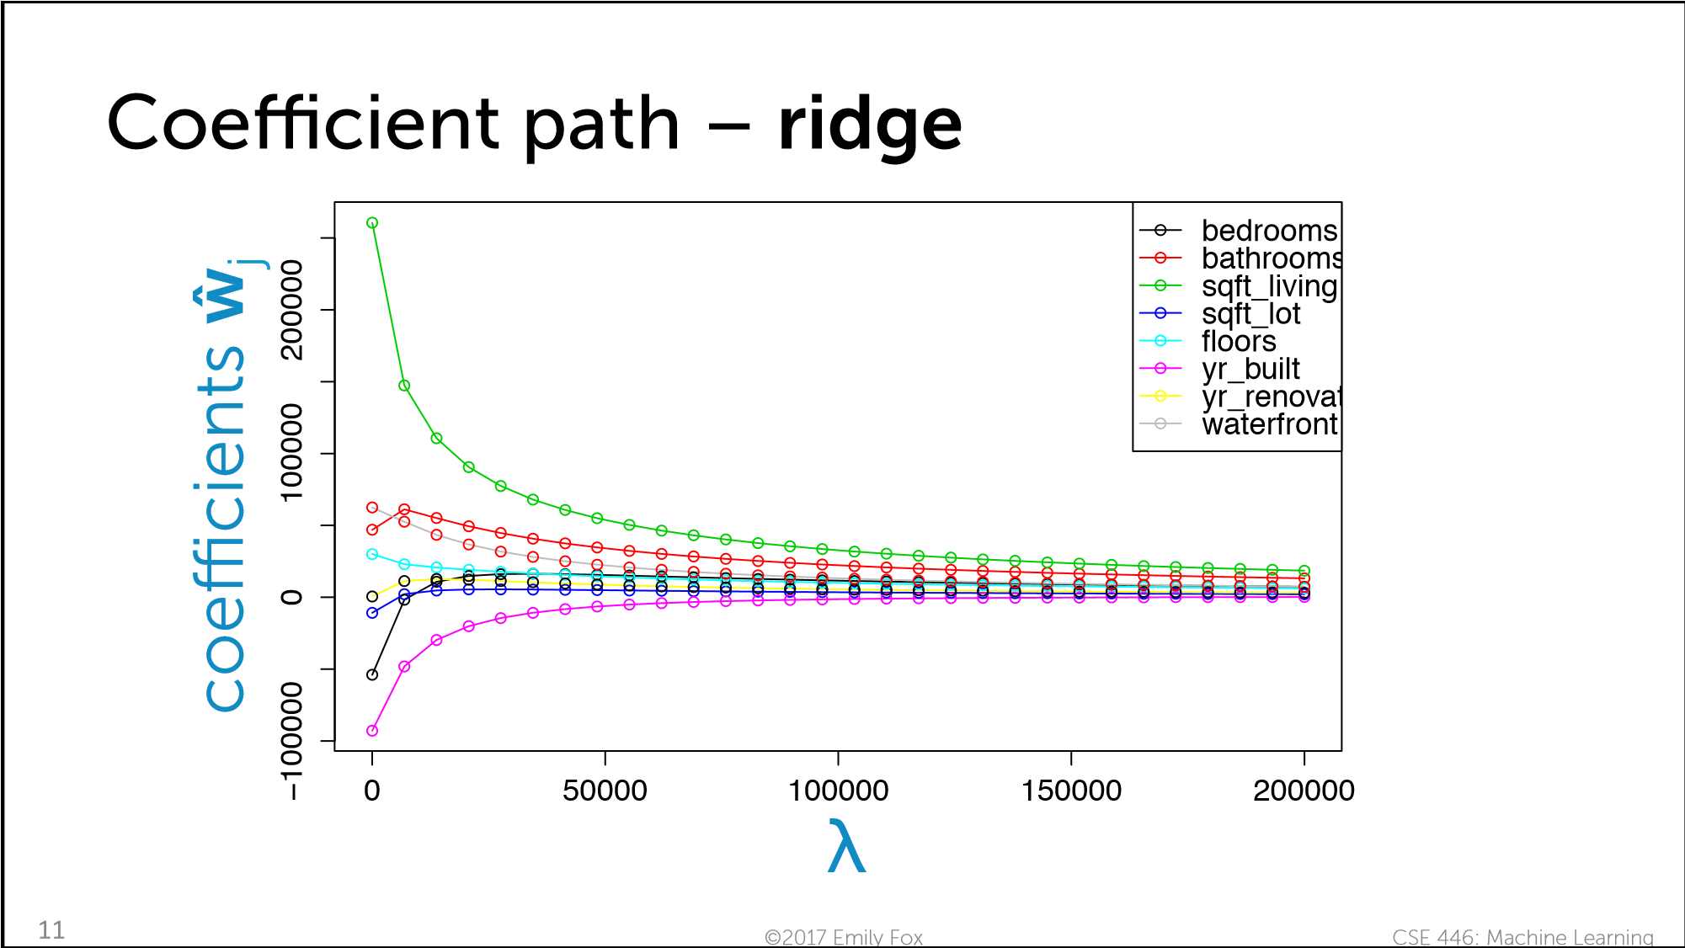“Shrink” some coefficients *exactly* to 0

•  i.e., knock out certain features

* Non-zero coefficients indicate “selected” features

12

CSE 446: Machine Learning

13

Thresholding

ridge coe

ffi

cients?

Why don’t we just set small ridge coe

ffi

cients to 0?

©2017 Emily Fox



# bedrooms

# bathrooms

sq.ft

. living

sq.ft

. lot

floors

year built

year renovated

last sales price

cost per

sq.ft

.

heating

# showers

waterfront



0



14

Thresholding

ridge coe

ffi

cients?

Selected features for a given threshold value



# bedrooms

# bathrooms

sq.ft

. living

sq.ft

. lot

floors

year built

year renovated

last sales price

cost per

sq.ft

.

heating

# showers

waterfront



0



CSE 446: Machine Learning

15

Thresholding

ridge coe

ffi

cients?

Let’s look at two related features…

©2017 Emily Fox



# bedrooms

# bathrooms

sq.ft

. living

sq.ft

. lot

floors

year built

year renovated

last sales price

cost per

sq.ft

.

heating

# showers

waterfront



0



Nothing measuring bathrooms was included!

16

Thresholding

ridge coe

ffi

cients?

If only one of the features had been included…



# bedrooms

# bathrooms

sq.ft

. living

sq.ft

. lot

floors

year built

year renovated

last sales price

cost per

sq.ft

.

heating

# showers

waterfront



0



CSE 446: Machine Learning

17

Thresholding

ridge coe

ffi

cients?

Would have included bathrooms in selected model

©2017 Emily Fox



# bedrooms

# bathrooms

sq.ft

. living

sq.ft

. lot

floors

year built

year renovated

last sales price

cost per

sq.ft

.

heating

# showers

waterfront



0



Can regularization lead directly to

sparsity

?

18

Try this cost instead of ridge…

Total cost

=

measure of fit

+

λ

measure of magnitude of coe

ffi

cients

RSS(

w

)



||

w

||

1

=

|w

0

|+…+|

w

D

|

Lasso regression

a.k.a.

(

*L*

1

regularized regression)

Leads to

sparse

solutions!



CSE 446: Machine Learning

19

Lasso regression:

*L*

1

regularized regression

Just like ridge regression, solution is governed by a

continuous parameter

λ

If

λ

=0:

If

λ

=

∞

:

If

λ

in between:

RSS(

w

+

)

λ

||

w

||

1

tuning parameter = balance of fit and

sparsity



©2017 Emily Fox

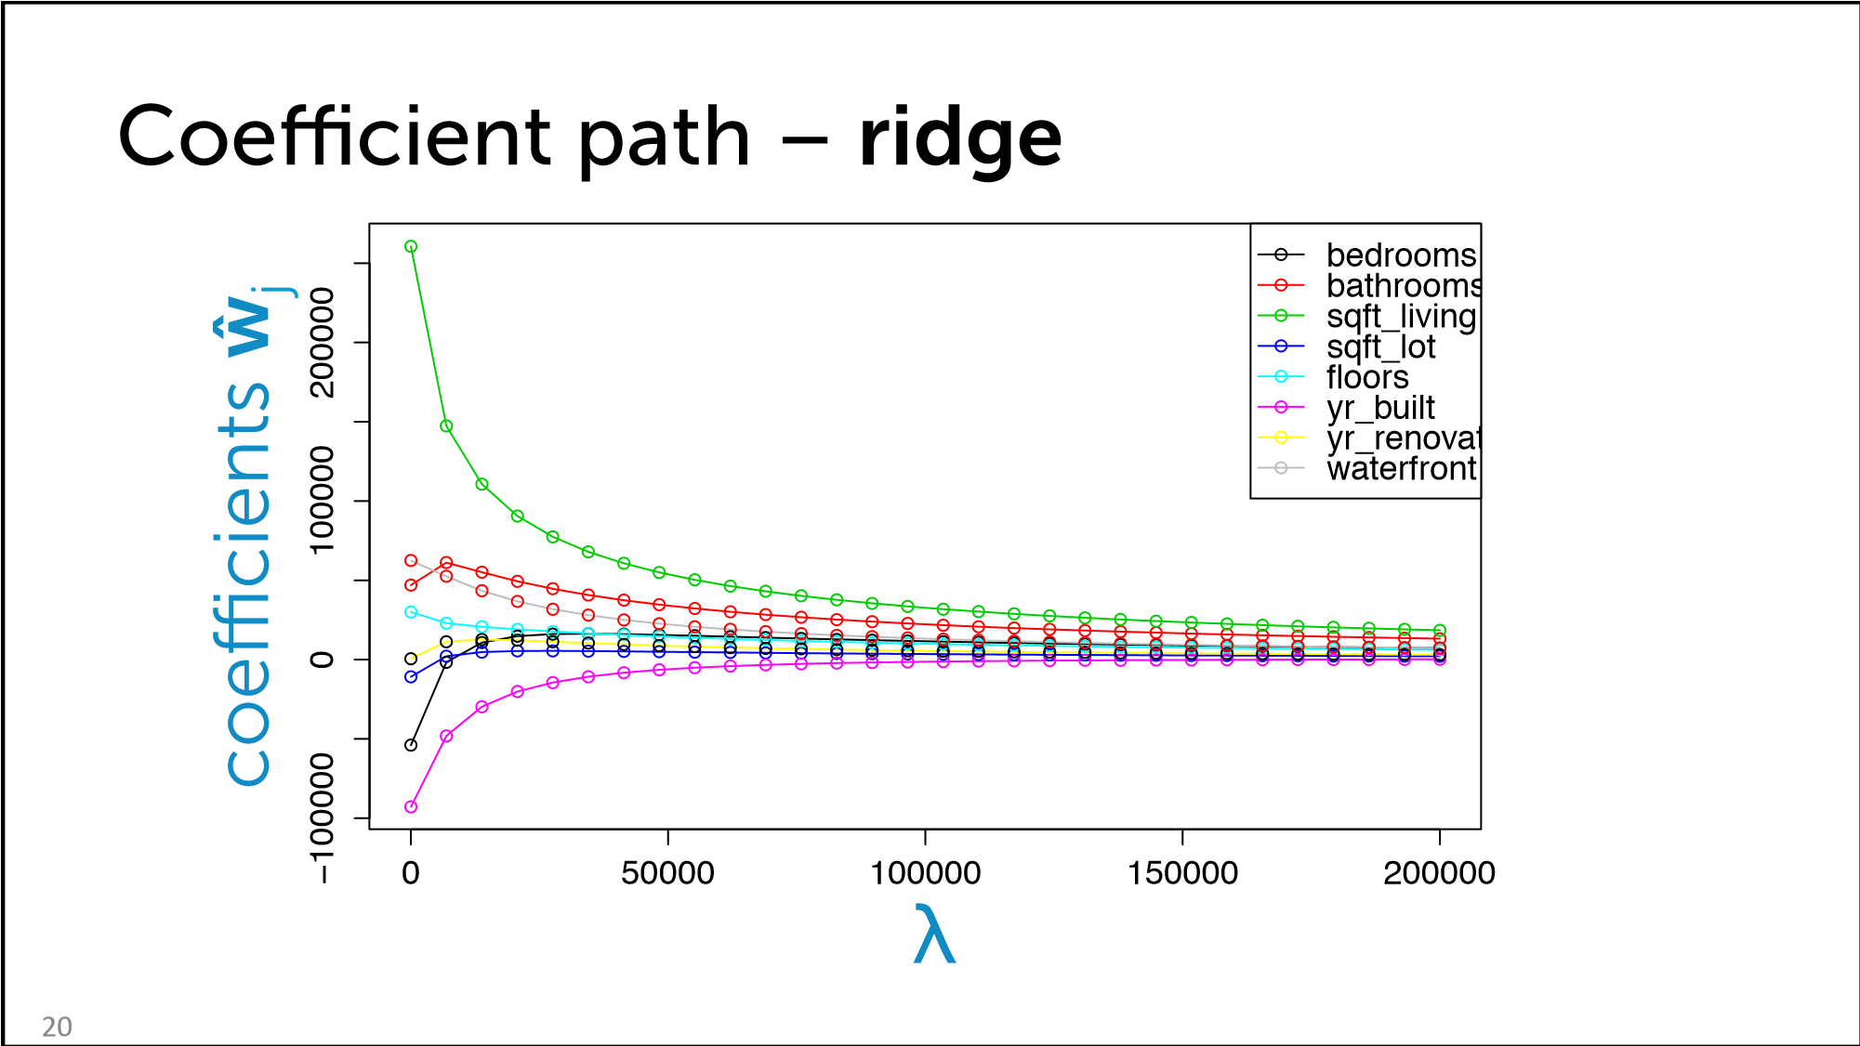

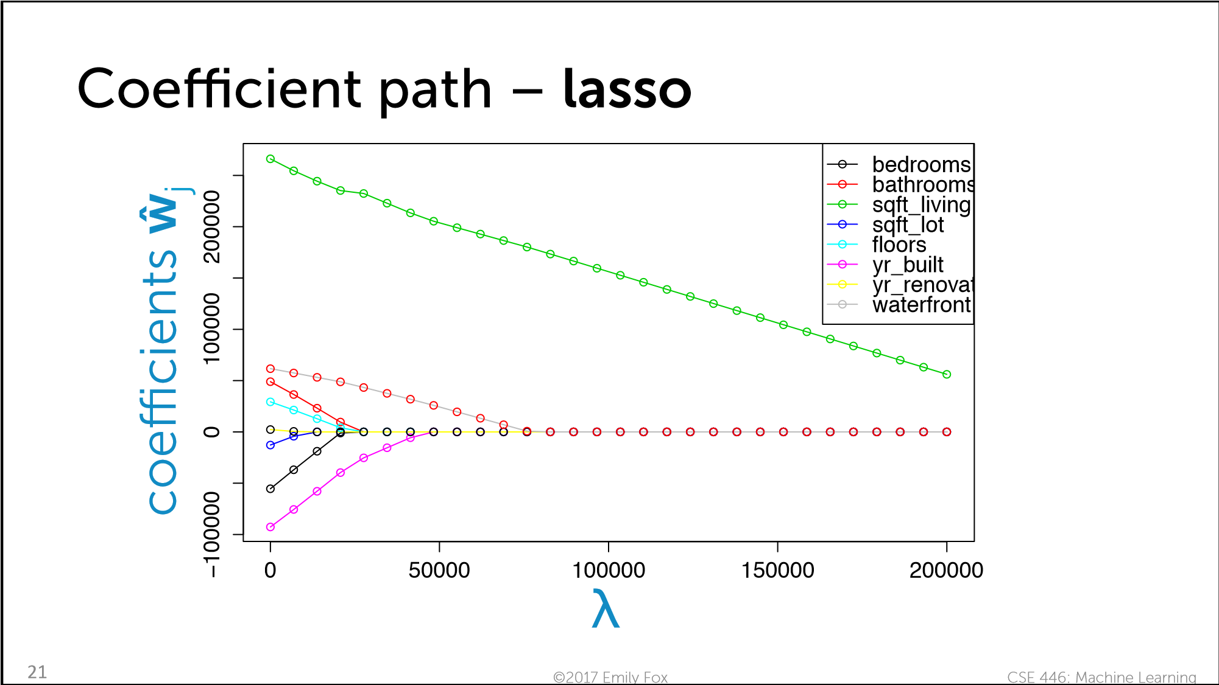

|  |
| --- |
| Fitting the lasso regression model (for given λ value) |
| ©2017 Emily Fox CSE 446: Machine Learning |

CSE 446: Machine Learning

23

How we optimized past objectives

To solve for

ŵ

, previously took gradient of total cost

objective and either:

1)

Derived closed-form solution

2)

Used in gradient descent algorithm

©2017 Emily Fox

24

Optimizing the lasso objective

Lasso total cost:

Issues:

1)

What’s the derivative of |

w

j

|?

2)

Even if we could compute derivative,

no closed-form solution

RSS(

w

+

)

||

w

||

1

λ

gradients

à

subgradients

can use

subgradient

descent

CSE 446: Machine Learning

Aside 1: Coordinate descent

©2017 Emily Fox

26

Coordinate descent

Goal:

Minimize some function

g

Often, hard to find minimum for all coordinates, but

easy for each coordinate

Coordinate descent:

Initialize

ŵ

= 0 (or smartly…)

while not converged

pick a coordinate j

ŵ

j

ß



CSE 446: Machine Learning

27

Comments on coordinate descent

How do we pick next coordinate?

-

At random (“random” or “stochastic” coordinate descent), round robin, …

No

stepsize

to choose

!

Super useful approach for

*many*

problems

-

Converges to optimum in some cases

(e.g., “strongly convex”)

-

Converges for lasso objective

©2017 Emily Fox

Aside 2: Normalizing features

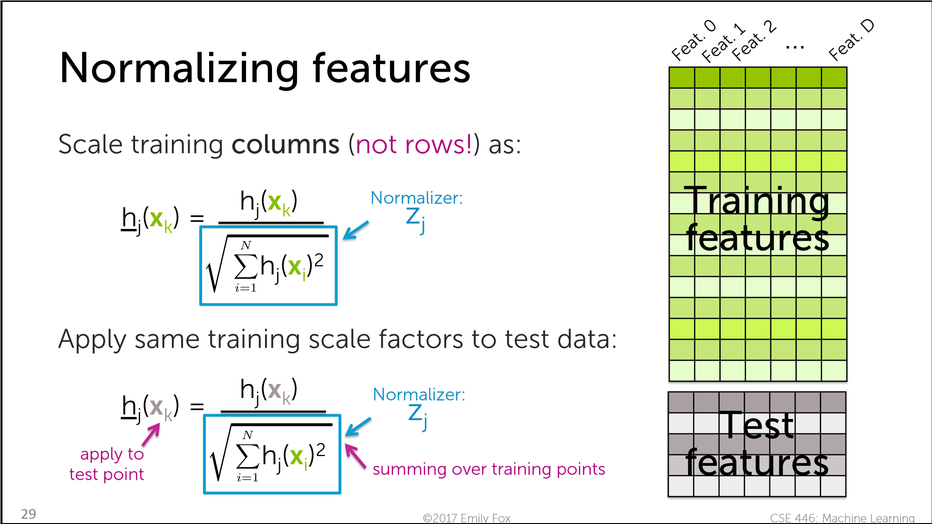

|  |
| --- |
|  |
| Aside 3: Coordinate descent for unregularized regression |
| (for normalized features) |

CSE 446: Machine Learning

31

Optimizing least squares objective

one coordinate at a time

Fix all coordinates

w

j

-

and take partial

w.r.t

.

w

j

©2017 Emily Fox

RSS(

w

)

=

(

y

i

-

w

j

h

j

(

x

i

)

)

2

*N*

X

*i*

=1

*D*

X

*j*

=0

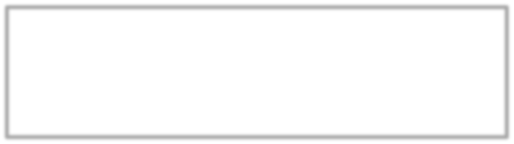

*N*

X

*i*

=1

RSS(

w

)

=

-2

h

j

(

x

i

)

(

y

i

–

w

j

h

j

(

x

i

)

)

∂

∂

w

j



*D*

X

*j*

=0

32

Optimizing least squares objective

one coordinate at a time

Set partial = 0 and solve

©2017 Emily Fox

RSS(

w

)

=

(

y

i

-

w

j

h

j

(

x

i

)

)

2

*N*

X

*i*

=1

*D*

X

*j*

=0



RSS(

w

)

-2

=

ρ

j

+ 2

w

j

=

0

∂

∂

w

j



CSE 446: Machine Learning

33

Coordinate descent for

least squares regression

Initialize

ŵ

= 0 (or smartly…)

while not converged

for j=0,1,…,D

compute:

set:

ŵ

j

=

ρ

j

©2017 Emily Fox

*N*

X

*i*

=1

ρ

j

=

h

j

(

x

i

)(

y

i

–

ŷ

i

(

ŵ

-

j

)

)

prediction

*without*

feature j



residual

*without*

feature j

|  |
| --- |
|  |
| Coordinate descent for lasso |
| (for normalized features) |
| ©2017 Emily Fox CSE 446: Machine Learning |

CSE 446: Machine Learning

35

Coordinate descent for

least squares regression

Initialize

ŵ

= 0 (or smartly…)

while not converged

for j=0,1,…,D

compute:

set:

ŵ

j

=

ρ

j

©2017 Emily Fox

*N*

X

*i*

=1

ρ

j

=

h

j

(

x

i

)(

y

i

–

ŷ

i

(

ŵ

-

j

)

)

prediction

*without*

feature j



residual

*without*

feature j

36

Coordinate descent for lasso

Initialize

ŵ

= 0 (or smartly…)

while not converged

for j=0,1,…,D

compute:

set:

ŵ

j

=

*N*

X

*i*

=1

ρ

j

=

h

j

(

x

i

)(

y

i

–

ŷ

i

(

ŵ

-

j

)

)



ρ

j

+

λ

/2 if

ρ

j

< -

λ

/2

ρ

j

–

λ

/2 if

ρ

j

>

λ

/2

0

if

ρ

j

in [-

λ

/2,

λ

/2]

CSE 446: Machine Learning

37

Soft

thresholding

©2017 Emily Fox



ŵ

j

ρ

j

ŵ

j

=



ρ

j

+

λ

/2 if

ρ

j

< -

λ

/2

ρ

j

–

λ

/2 if

ρ

j

>

λ

/2

0

if

ρ

j

in [-

λ

/2,

λ

/2]

38

How to assess convergence?

Initialize

ŵ

= 0 (or smartly…)

while not converged

for j=0,1,…,D

compute:

set:

ŵ

j

=

*N*

X

*i*

=1

ρ

j

=

h

j

(

x

i

)(

y

i

–

ŷ

i

(

ŵ

-

j

)

)



ρ

j

+

λ

/2 if

ρ

j

< -

λ

/2

ρ

j

–

λ

/2 if

ρ

j

>

λ

/2

0

if

ρ

j

in [-

λ

/2,

λ

/2]



CSE 446: Machine Learning

39

When to stop?

For convex problems, will start to take

smaller and smaller steps

Measure size of steps taken in a

full loop over all features

-

stop when

max step <

ε

Convergence criteria

©2017 Emily Fox



40

Other lasso solvers

Classically:

Least angle regression (

LARS

)

[

Efron

et al. ‘04]

Then:

Coordinate descent

algorithm

[

Fu ‘98, Friedman, Hastie, &

Tibshirani

’

08]

Now:

•

Parallel CD

(

e.g., Shotgun,

[

Bradley et al. ‘

11]

)

•

Other parallel learning approaches for linear models

-

Parallel stochastic gradient descent (

SGD

)

(

e.g.,

Hogwild

!

[

Niu

et al.

’

11]

)

-

Parallel independent solutions then

averaging

Zhang et al. ‘12]

[

•

Alternating directions method of multipliers (

ADMM

)

[

Boyd et al.

’

11]

|  |
| --- |
|  |
| Coordinate descent for lasso |
| (for unnormalized features) |
| ©2017 Emily Fox CSE 446: Machine Learning |

42

Coordinate descent for lasso

with normalized features

Initialize

ŵ

= 0 (or smartly…)

while not converged

for j=0,1,…,D

compute:

set:

ŵ

j

=

*N*

X

*i*

=1

ρ

j

=

h

j

(

x

i

)(

y

i

–

ŷ

i

(

ŵ

-

j

)

)



ρ

j

+

λ

/2 if

ρ

j

< -

λ

/2

ρ

j

–

λ

/2 if

ρ

j

>

λ

/2

0

if

ρ

j

in [-

λ

/2,

λ

/2]

|  |  |
| --- | --- |
| How to choose λ |  |
|  | ©2017 Emily Fox CSE 446: Machine Learning |

CSE 446: Machine Learning

43

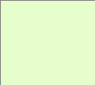

Coordinate descent for lasso

with

unnormalized

features

Precompute

:

Initialize

ŵ

= 0 (or smartly…)

while not converged

for j=0,1,…,D

compute:

set:

ŵ

j

=

©2017 Emily Fox

*N*

X

*i*

=1

z

j

=

h

j

(

x

i

)

2

*N*

X

*i*

=1

ρ

j

=

h

j

(

x

i

)(

y

i

–

ŷ

i

(

ŵ

-

j

)

)



(

ρ

j

+

λ

/2)/

z

j

if

ρ

j

< -

λ

/2

(

ρ

j

–

λ

/2)/

z

j

if

ρ

j

>

λ

/2

0

if

ρ

j

in [-

λ

/2,

λ

/2]

|  |
| --- |
| Summary for feature selection and lasso regression |
| ©2017 Emily Fox CSE 446: Machine Learning |

CSE 446: Machine Learning

45

If su

ffi

cient amount of data…

©2017 Emily Fox

Validation

set

Training set

Test

set

fit

ŵ

λ



test performance

of

ŵ

λ

to select

λ

*



assess

generalization

error of

ŵ

λ

*



Impact of feature selection and lasso

Lasso has changed machine learning, statistics, & electrical engineering

But, for feature selection in general, be careful about interpreting selected features

48

What you can do now…

•

Describe “all subsets” and greedy variants for feature selection

•

Analyze computational costs of these algorithms

•

Formulate lasso objective

•

Describe what happens to estimated lasso coe

ffi

cients as tuning

parameter

λ

is varied

•

Interpret lasso coe

ffi

cient path plot

•

Contrast ridge and lasso regression

•

Estimate lasso regression parameters using an iterative coordinate

descent algorithm

©2017 Emily Fox

* selection only considers features included
* sensitive to correlations between features
* result depends on algorithm used
* there are theoretical guarantees for lasso under certain conditions

47 ©2017 Emily Fox CSE 446: Machine Learning

|  |
| --- |
| Deriving the lasso coordinate  descent update  OPTIONAL |
| ©2017 Emily Fox CSE 446: Machine Learning |

50

Optimizing lasso objective

one coordinate at a time

Fix all coordinates

w

j

-

and take partial

w.r.t

.

w

j

RSS(

w

)

+

λ

||

w

||

1

=

(

y

i

-

w

j

h

j

(

x

i

)

)

2

+

λ

|

w

j

|

*N*

X

*i*

=1

*D*

X

*j*

=0

*D*

X

*j*

=0

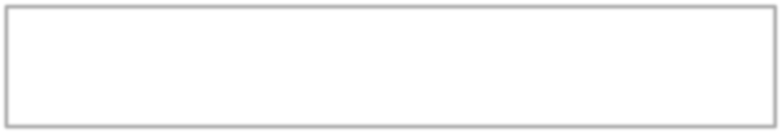

derive

*without*

normalizing features

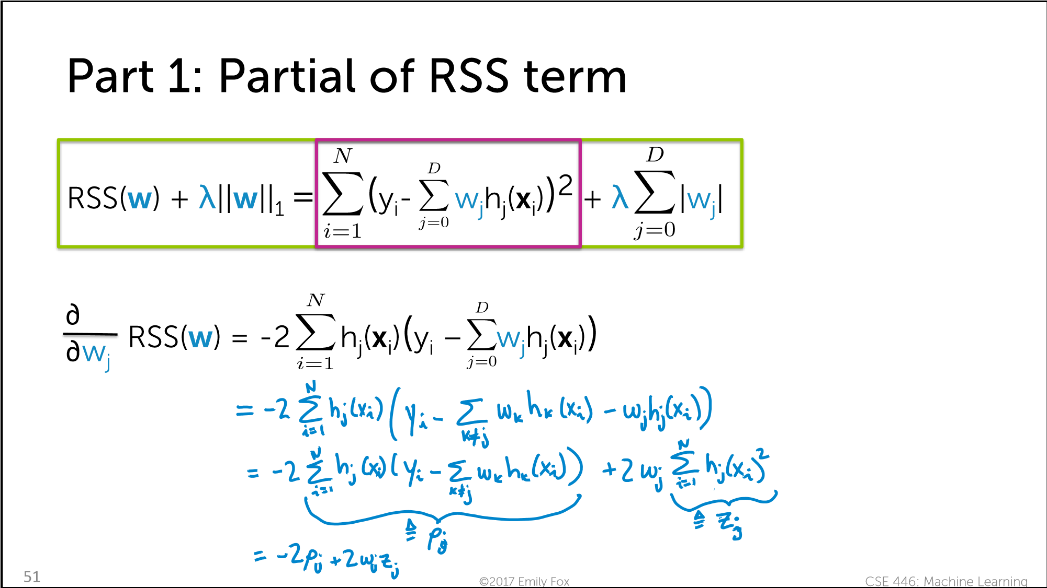

52

Part 2: Partial of L

1

penalty term

RSS(

w

)

+

λ

||

w

||

1

=

(

y

i

-

w

j

h

j

(

x

i

)

)

2

+

λ

|

w

j

|

*N*

X

*i*

=1

*D*

X

*j*

=0

*D*

X

*j*

=0



λ

|

w

j

| = ???

∂

∂

w

j



|

x

|

x

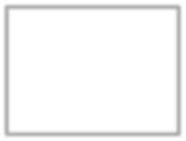

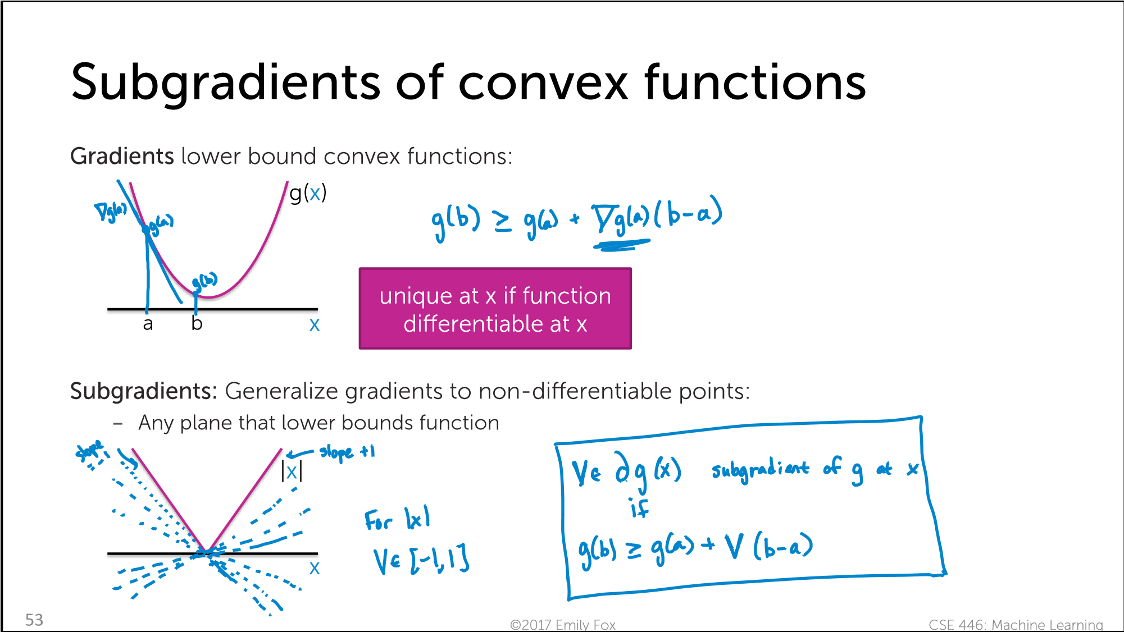

54

Part 2:

*Subgradient*

of L

1

term

RSS(

w

+

)

λ

||

w

||

1

=

(

y

i

-

w

j

h

j

(

x

i

)

)

2

+

λ

|

w

j

|

*N*

X

*i*

=1

*D*

X

*j*

=0

*D*

X

*j*

=0



λ

∂

|

w

j

| =

w

j



|

w

j

|

w

j



-

λ

w

hen

w

j

< 0

λ

when

w

j

> 0

[-

λ

,

λ

]

when

w

j

= 0



CSE 446: Machine Learning

55

Putting it all together…

©2017 Emily Fox

RSS(

w

+

)

λ

||

w

||

1

=

(

y

i

-

w

j

h

j

(

x

i

)

)

2

+

λ

|

w

j

|

*N*

X

*i*

=1

*D*

X

*j*

=0

*D*

X

*j*

=0



∂

[

lasso cost

]

= 2z

j

w

j

– 2

ρ

j

+

w

j



-

λ

when

w

j

< 0

λ

when

w

j

> 0

[-

λ

,

λ

]

when

w

j

= 0



2

z

j

w

j

– 2

ρ

j

–

λ

when

w

j

< 0

z

2

j

w

j

– 2

ρ

j

+

λ

when

w

j

> 0

[-2

ρ

j

-

λ

, -2

ρ

j

+

λ

]

when

w

j

= 0

=

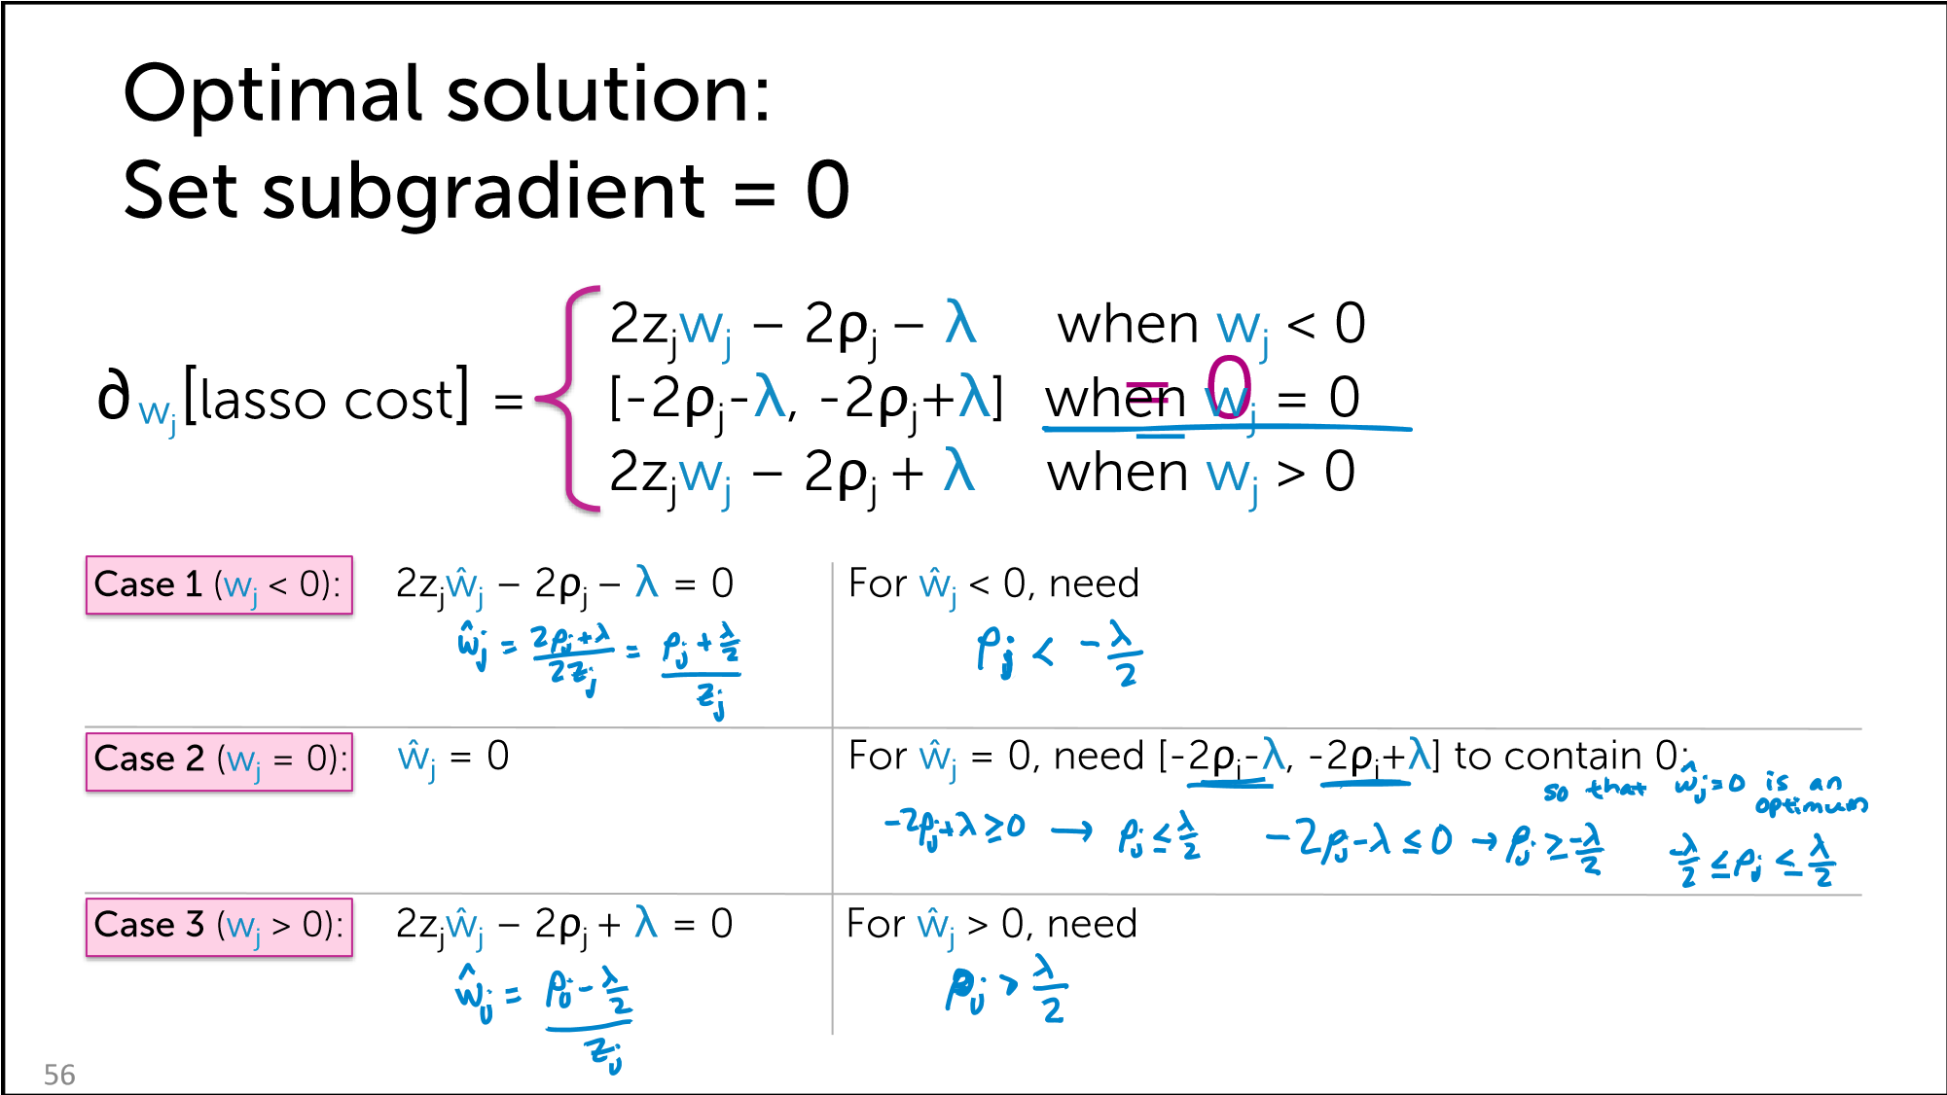

CSE 446: Machine Learning

57

Optimal solution:

Set

subgradient

= 0

©2017 Emily Fox

∂

[

lasso cost

]

=

0

=

w

j



(

ρ

j

+

λ

/2)/

z

j

if

ρ

j

< -

λ

/2

(

ρ

j

–

λ

/2)/

z

j

if

ρ

j

>

λ

/2

0

if

ρ

j

in [-

λ

/2,

λ

/2]

ŵ

j

=



z

2

j

w

j

– 2

ρ

j

–

λ

when

w

j

< 0

z

2

j

w

j

– 2

ρ

j

+

λ

when

w

j

> 0

[-2

ρ

j

-

λ

, -2

ρ

j

+

λ

]

when

w

j

= 0

58

©2017 Emily Fox



ŵ

j

ρ

j



(

ρ

j

+

λ

/2)/

z

j

if

ρ

j

< -

λ

/2

(

ρ

j

–

λ

/2)/

z

j

if

ρ

j

>

λ

/2

0

if

ρ

j

in [-

λ

/2,

λ

/2]

ŵ

j

=



Soft

thresholding



CSE 446: Machine Learning

59

Coordinate descent for lasso

Precompute

:

Initialize

ŵ

= 0 (or smartly…)

while not converged

for j=0,1,…,D

compute:

set:

ŵ

j

=

©2017 Emily Fox

*N*

X

*i*

=1

z

j

=

h

j

(

x

i

)

2

*N*

X

*i*

=1

ρ

j

=

h

j

(

x

i

)(

y

i

–

ŷ

i

(

ŵ

-

j

)

)



(

ρ

j

+

λ

/2)/

z

j

if

ρ

j

< -

λ

/2

(

ρ

j

–

λ

/2)/

z

j

if

ρ

j

>

λ

/2

0

if

ρ

j

in [-

λ

/2,

λ

/2]

# S1 Programming for Data Analytics

# S1 Statistics for Data Analytics

## Week 1 – Statistics & Probabilities

### What are Statistics?

* Statistics is a form of mathematical analysis that uses quantified models, representations and synopses for a given set of experimental data or real-life studies.
* Statistics include numerical facts and figures.
  + For example: Compared to women, men are three times more likely to die by suicide.
* Statistics is NOT only numbers and figures. The numbers may be right, but the interpretation may be wrong.
  + For example: The more churches in the city, the more crime there is. Thus, churches lead to crime.
* Statistics refer to a range of techniques and procedures for collecting, analysing, interpreting, displaying and making decision based on data.

**Flow**

1. Collect
2. Analyse
3. Interpret

#### Deterministic Events

* This is when an experiment could tell us precisely what will happened under certain conditions. For instance, if we put in a jar with one litre of water in it on the fire at 100 degrees Celsius, we know that it will boil after 3 minutes, and if we repeat this experiment many times, we will always get the same result.
* Can be replicated without a change in the result outcome

#### Probabilistic Events

* This is when an experiment depends on chance, and therefore we could get always different results even though we repeat it under the same conditions. For instance, we can roll a dice several times and although we shake the glass three times and roll it on the same surface, we can get always different results.
* Replication won’t produce the same results

### Probabilities **

* Probabilities are behind every ML model that we’ll use
* Probabilities can take values between 0 and 1

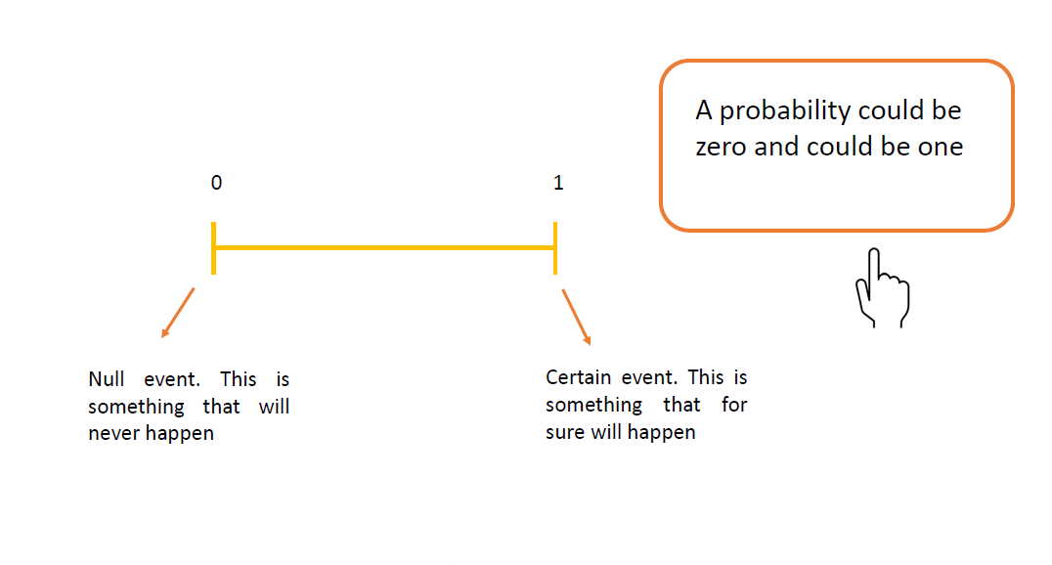

* Events are named with a capital letter: A, B, C, D …
* E.g.
  + A = picking a white ball from a bag
  + B = pass an exam

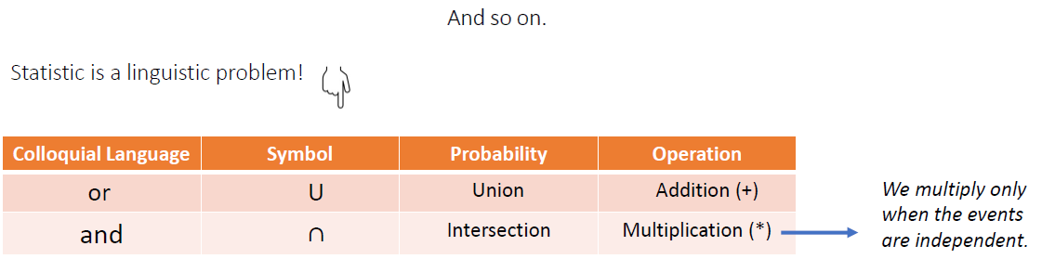

#### Mutual Exclusive Events

* These are those events that cannot happen at the same time
* For example, if I am an English speaker, I cannot be a non-English speaker

#### Independent Events

* This happen when the existence of an event does not affect at all the existence of the other one.
* For example, the fact that it is sunny in Thailand is not connected to the event of having an accident at home.

#### Probability Calculation

* Basic formula to calculate probability
* P = Probability, P(A) = the Probability of A

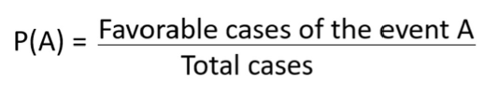

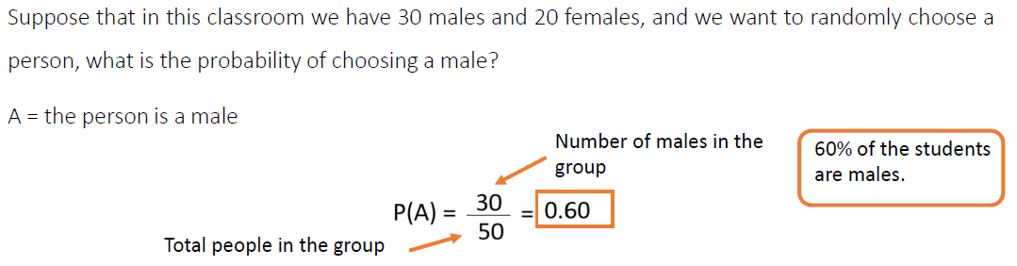

#### Axioms of Probability

* Axioms help us solve problems related to probabilities.
* An axiom in the context of probability refers to a foundational principle or rule that serves as a starting point for reasoning or logical derivation. We don't need to prove it
* There are 3 basic Axioms commonly used:

##### Complementary Probability

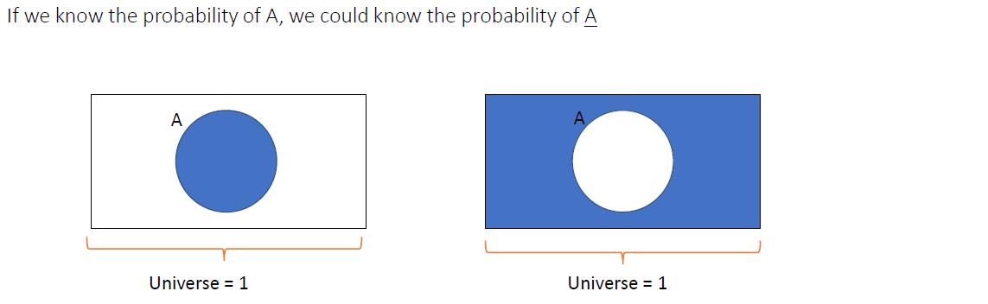

##### Axiom of the Addition

* The axiom of addition is a foundational rule or assumption in arithmetic and algebra that specifies the properties and behavior of the addition operation.

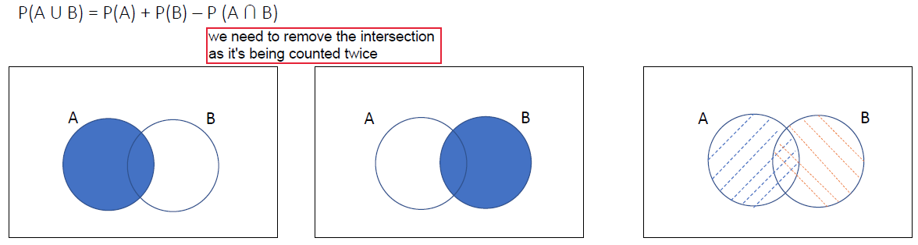

* Formula states the probability of A or B is equal to the probabilities of A + B, minus the probability of the intersection of A + B

##### Conditional Probability

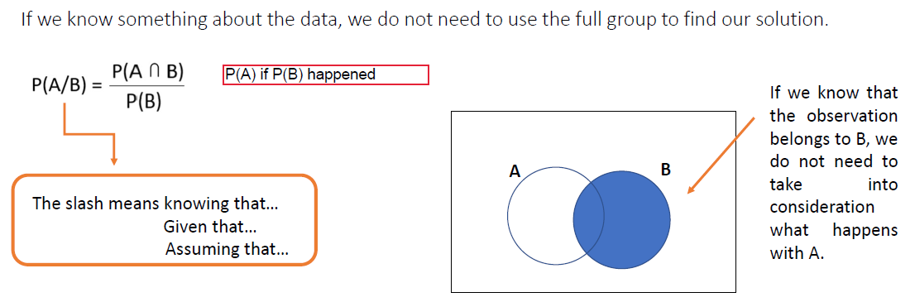

### Probability Methods/Tools (see lecture notes for examples)

#### Contingency Tables

* We use them when there is an idea of simultaneity (the fact of something happening or being done at the same time as something else) in our data.
* “Contingency tables are matrices used in statistics to display the frequency distribution of variables. They help in understanding the relationship between categorical variables, often aiding in hypothesis testing.”

#### Tree Diagrams

* We use them when there is an idea of consecutiveness in our data.
* “Tree diagrams are graphical representations used to describe hierarchical structures or probabilities. They visually display possible outcomes or decisions, aiding in problem-solving and decision-making.”

#### Others

* When we reach to this point is because none of the previous methods is applicable and we need to use the logic and our knowledge to solve the problem.

## Week 2 - Descriptive Statistics

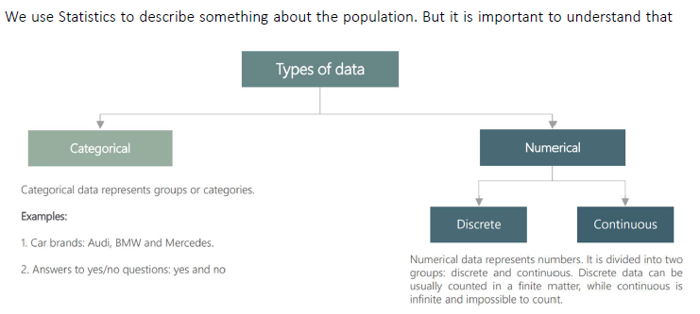

**Descriptive Statistics is a group of numeric and graphic techniques that describe and analyse certain population, usually through samples.**

The main goal could be:

* Transform the data in information.
* Organise the data
* Obtain concrete information to resume the main characteristics of the variables.
* Offer us an input for Inferential Statistics.

### Samples

To be able to get insights about a population we need to take a sample from that population:

* **Random Sample (most common):** In a random sample, the probability of ending up in the sample is the same for each element of a population. An example of a simple random sample is the drawing of a ball from a drum or tombola, such as the weekly lottery draw.
* **Stratified:** In a stratified random sampling, the elements of a population are divided into groups based on a previously determined attribute. Subsequently, a simple random sample is performed within each of those groups.
* **Cluster sample:** Different to simple random selection, individuals are not selected at random, rather entire groups. The cluster analysis is randomly drawn up from all clusters, and all characteristic attributes are examined within any given cluster.

#### Representative Sample

A representative sample is a sample that accurately represents the characteristic (or characteristics) of a population.

It is vital to take the sample randomly, otherwise the data would be biased, which means that a sample was collected in such a way that some members of the intended population had a lower or higher probability to be chosen than others. It results in a biased sample of a population, and sometimes the results can be erroneously attributed or influenced by the person in charge of taking the sample.

### Example

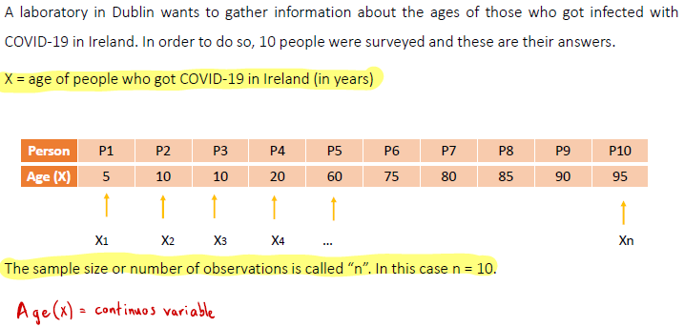

### Central Tendency Measures

These measures will allow us to get values that resume in one number all the values that the sample provides.

#### Mean

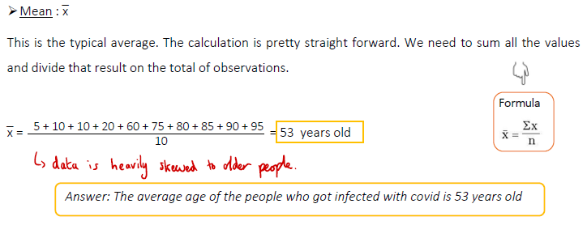

##### Advantages

* It is easy to calculate it
* It is easy to interpret it
* Existence property: there is always a result
* Its result is always unique
* Sufficiency property: it is necessary to use all the values to calculate it.

##### Disadvantages

* It is affected by extreme values
* e.g., Imagine that by a miracle we had a person who is 120 years old, our result would be different and not representative. Those non representative values are known as “outliers”.

#### Mode

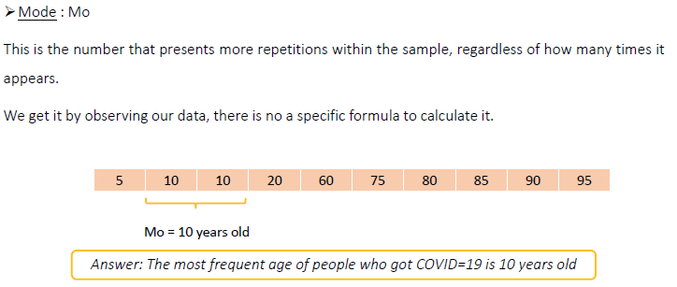

##### Advantages

* It is easy to get it (no calculation involved)
* It is easy to interpret it
* It is not affected by extreme values
* Useful e.g., in marketing / business

##### Disadvantages

* It is not necessary to use all the values to calculate it
* There could be more than one result or event none
* Potentially not unique
* If there’s no repetition then there’s no mode
* Mode itself isn’t enough on its own

#### Median

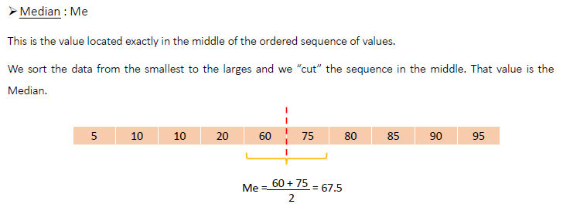

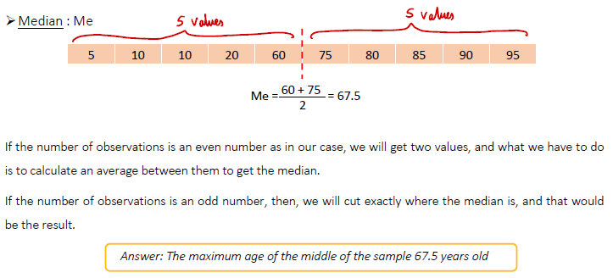

##### Advantages

* It is easy to get it (no real calculation involved)
* Existence property: there’s always a result
* Its results are always unique
* It is not affected by extreme numbers
* If data isn’t evenly distributed ‘median’ is potentially more useful

##### Disadvantages

* It is not so easy to interpret. Sometimes the interpretation of the median creates confusions
* There is a debate to decide whether or not the median uses all the values of the sample to be calculated

### Variation Measures

These measures help us to get values that determine the level of homogeneity within the observations. In other words, we can see through the variation measures how similar/different the values are.

#### Variance

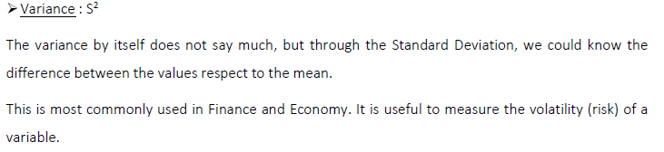

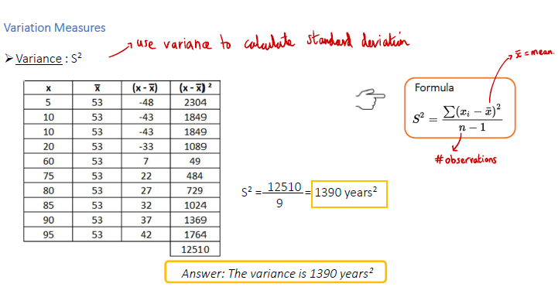

#### Standard Deviation

#### VC – Variation Coefficient

The coefficient of variation (CV) is defined as the ratio of the standard deviation to the mean.

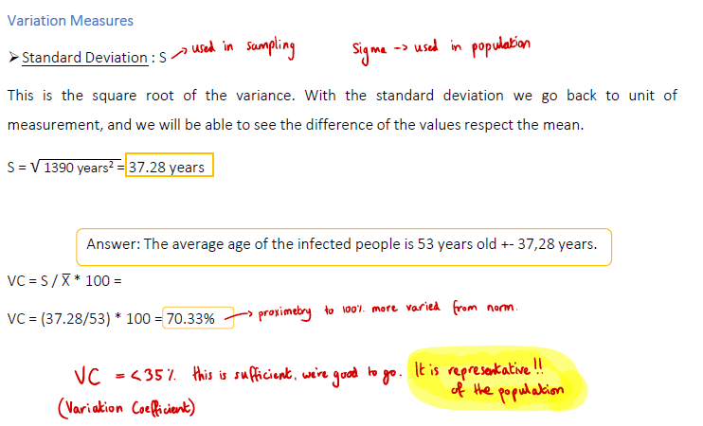

## Week 2 – Box-and-Whisker Plots (Box Plot)

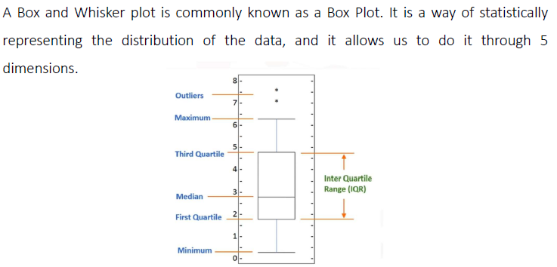

### Minimum

### First Quartile

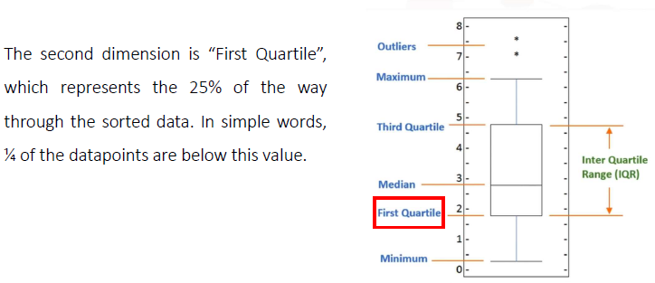

### Median

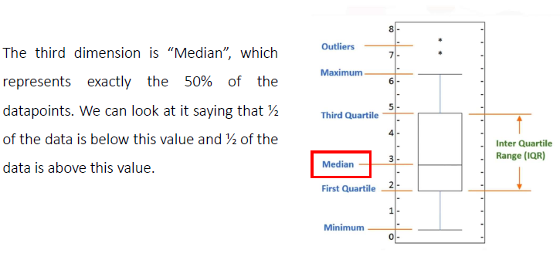

### Third Quartile

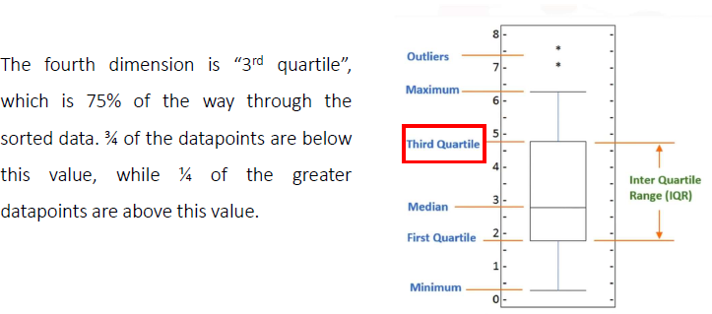

### Maximum

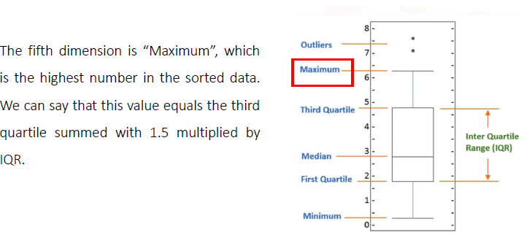

### Outliers

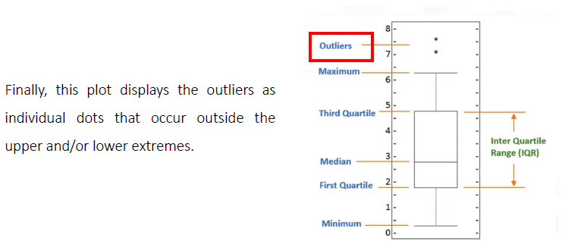

**Poisson Distribution Slides**

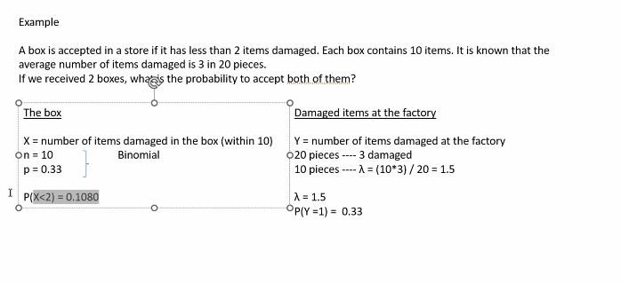

# Other Resources

## Concepts

### Data Mining

Data mining is the process of discovering patterns, correlations, and insights within large sets of data through the use of various algorithms and techniques. The primary aim is to transform raw data into valuable information for making better decisions. Data mining encompasses a range of activities, including:

1. Data Preprocessing: Cleaning and organizing data to prepare it for analysis.
2. Pattern Recognition: Identifying regularities or trends in the data.
3. Clustering: Grouping similar data points together.
4. Classification: Assigning predefined labels to new data based on patterns learned from existing data.
5. Association Rule Learning: Discovering interesting relationships between variables in datasets.
6. Regression Analysis: Predicting numerical outcomes based on variables.
7. Anomaly Detection: Identifying outliers or exceptions within a dataset.

Data mining finds applications in various fields, such as finance, healthcare, marketing, and even sports analytics, to make predictions or improve operational efficiencies.

### 10-Fold Cross-Validation

10-fold cross-validation is a statistical technique used in machine learning and data analysis to assess the performance of a predictive model. It aims to provide a more reliable evaluation compared to using a single train/test split. Here's how 10-fold cross-validation works:

1. Data Splitting: The original dataset is randomly partitioned into 10 equally (or nearly equally) sized subsets or "folds."
2. Training and Testing: The model is trained and tested 10 times, each time using a different fold as the test set and the remaining 9 folds combined as the training set.
3. Performance Metrics: After each iteration, performance metrics like accuracy, precision, or F1-score are computed for the test set.
4. Aggregation: The 10-performance metrics from the 10 iterations are then averaged to produce a single, more robust performance estimate.

The primary advantages of 10-fold cross-validation include:

1. Reduced Bias: Using multiple train-test splits reduces the chance of the results depending on a single random split.
2. Better Generalization: The averaged performance metric is often a better indicator of how well the model will perform on unseen data.

However, 10-fold cross-validation can be computationally expensive, as it requires training and testing the model 10 times.

# CA Preparation

## Useful Notes

### Data Preprocessing

#### Missing Values

*ReplaceMissingValues filter was applied to handle missing values then, another filter was applied, which is known as the Interquartile Range (IQR), to detect outlier and extreme values at the phase of pre-processing. The IQR is a method to measure the variability about the median of a dataset. The outlier is a data point that does outside the expected range of the data and can be assumed for the purposes of the analysis to be due to recording errors or other irrelevant phenomena* [1]

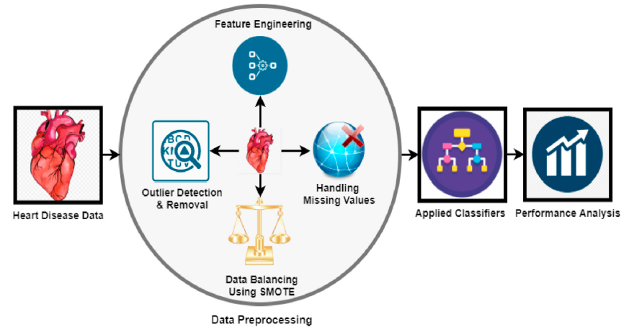

#### EDA Methods

*Thus, some exploratory data analyses (EDA) was performed (such as box plot) to confirm that the dataset is free of outliers, and the data was represented as IQR and heatmap to detect correlations among the features, and a KDE lot for both diseased and non-diseased individuals according to age distribution*. 1

#### Data Imputation Methods

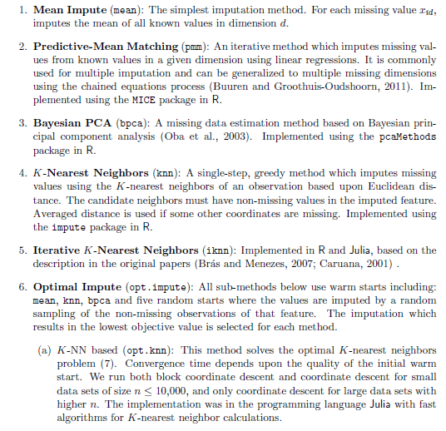

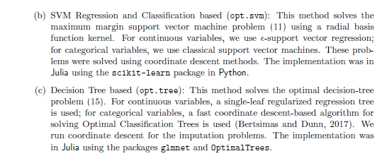

Machine Learning

random forest

helps remove overfitting

helps with determining feature importance

Explain methodology

I have selected 16/20 columns based on using random forest

Different fields require different ML predication numbers

e.g. healthcare would require high 90’s e.g 98%

sales / marketing might be closer to 80% etc

Very important to understand Lasso & Ridge regression

## CA Notes

We pick a dataset

We can also use any other data that we want

Has to be related to Irish population – not any other country

No expectation or limit

Expectation is roughly 4,000 words

Crisp-dm??

Use literature to point in a direction

Within Jupyter you need to Harvard methodology

Use markdown to explain the code – notes!!!

**If you comment on code, it’s for yourself**

**Missing values** – understanding for individual values the nature and distribution of that data will be key in determining what the best / or appropriate values are best used in replacing those values, or if even replacing / dropping is appropriate or not, there are general rules of thumb but each will have to checked. We need to check how e.g., dropping columns affects data before and after the change. This is not a linear process. We need to experiment at each stage to see the affect of what we’re doing and how that affects the data. It matters about what the data is in front of us, not where it comes from, just what we have to work through at the moment

What are the techniques that I can minimise the loss / randomness in the data

With extremely large datasets, we can use specific values such as:

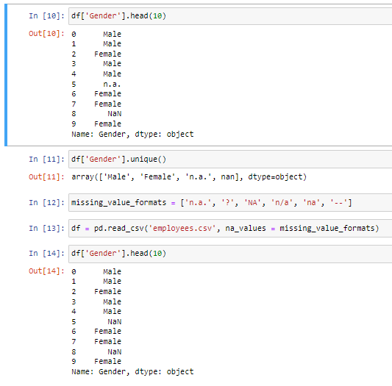

We need to experiment when reviewing the specific context of the data

The decisions made initially will have massive implications with ML later on

1. Md Mamun Ali et al., ‘Heart Disease Prediction Using Supervised Machine Learning Algorithms: Performance Analysis and Comparison’, *Computers in Biology and Medicine* 136 (September 2021): 104672, https://doi.org/10.1016/j.compbiomed.2021.104672.